The Potential Reuse of Sewage Sludge for Agriculture Purposes

(Case Study: North Gaza Emergency Sewage Treatment Plant (NGEST))

Mahmoud W. Nasman1 & Hussam Al-Najjar2

1Master's degree of Civil Engineering Department, Islamic University of Gaza (IUG), Palestine.

2Civil and Environmental Engineering Department, Faculty of Engineering, Islamic University of Gaza (IUG), Palestine.

* Corresponding author's e-mail address: [nasmanm@hotmail.com](mailto:nasmanm@hotmail.com)

**Abstract—**This paper identified the potential use of sewage sludge protected from the emergency sewage treatment plant in north Gaza (NGEST) for agricultural purposes and studied its effect on plant growth and soil properties. The sludge was dried in sunlight, and the plant tissues were cleaned and ground to an appropriate size. The results of the analysis showed that sludge can be used as soil fertilizer and can add nutrients for plant growth. The parameters were tested as pH, EC, TDS, FC, O.M, N, P, CI, ammonia N, E. coli, faecal streptococcus, salmonella, faecal coliforms, total coliforms, SAR, magnesium, sodium chloride, and potassium. A practical experiment was conducted using agricultural containers to grow corn. Five treatments (0-10-20-25-30% sludge) were used. Each experiment has three replicates. Sludge-amended soil affects corn growth. The best treatment was when sludge was amended with the soil at a rate of 25% of the dry weight of the soil.

**Index Terms—**Sewage Sludge, Partial use, Improvement, Soil, Agricultural soil.

# I Introduction

Gaza Strip (GS) is located in the southwest corner of historical Palestine, along the coast of the Mediterranean Sea. It also shares a border with Egypt to the south. It has a 40 km seaside at the Mediterranean sea with fine weather conditions. GS includes a total area of 365 square kilometers. Moreover, 2,166,269 people are living there [1]. Safe disposal of human waste is essential to prevent the spread of fecal-oral diseases. Large population centers such as the GS (Rafah, Khan Unis, Gaza City, Jabalya) are particularly at risk to public health (Ashour et al., 2009). The concentration of chloride in water up to more than (2000 mg/L) in several areas in the Gaza Strip, and nitrate reaches (300 mg/L), due to pollution caused by wastewater intrusion and agricultural pesticides. However, the permissible percentage, according to the World Health Organization, is (250 mg/L) Cl, and (40 mg/L) NO3- [2]. The residual, semi-solid material that is created as a byproduct during the sewage treatment of industrial or municipal wastewater is referred to as sewage sludge (also known as biosolids) [3]. Sewage sludge SS, or more precisely, the by-product of the multiple stages of treating domestic household wastewater, which occasionally also includes industrial and commercial effluents, is a by-product [4]. According to table 1, we can expect the quantities of sludge, the quantities of sewage, and the population density in the year 2025 to consider them.

**TABLE 1**

Sewage sludge and wastewater quantities within the GS by 2025

|  |  |  |  |  |
| --- | --- | --- | --- | --- |
| **Total** | **Khan Younis and**  **Rafah** | **Gaza and Middle Area** | **Northern Area** |  |
| 2,910,428 | 1,205,676 | 1,385,860 | 318,892 | **Population** |
| 325,968 | 135,036 | 155,216 | 35,716 | **Wastewater m3/d** |
| 55,740 | 23,091 | 26,542 | 6,107 | **Sludge kg dry solids/day** |

Source: Assessment of current and future SS characterization in the GS (Nassar & Afifi, 2006).

The results demonstrate that sludge is rich in nutrients like nitrogen and phosphorus and is essentially free of heavy metals. The sludge is predicted to include 1-2% dry solids [5]. The researchers studied the physical and chemical properties of sewage sludge that samples were collected from the Gaza Wastewater Treatment Plant. They dried the sludge in the sun and air and sieved through to 2 mm. The sludge density, sludge particle distribution, proportion, water holding capacity, void volume, pH, and conductivity were calculated. According to the findings, the bulk density is approximately 1.18 g/cm3, but the real density is 2.12 g/cm3, and the void volume is 50%. The grain size distribution shows that the most important sludge size was the sand-like size (630-200 µm) as well as the small silt-like size (200-20 µm) and the clay-like volume which does not exceed 20 µm. Sludge has an acidic pH (6.78 ± 0.02) reaction with an electrical conductivity capable of (2.49 ± 0.04) mS∙cm−1[6]. The researchers studied the physicochemical analysis to show that the sludge will be an effective tool if used as a compost or soil optimizer. Moreover, this may supply all the macro- and micronutrients required for plant development. The concentration of Cr, Zn, Cu, Pb, and Cd is less than the maximum allowed level according to international standards [7]. According to a study on farmers' attitudes about the usage of sludge in the targeted area, the local output of fertilizer within this geographic region is 66,800 m3/year, which represents just 8.5% of the specified quanti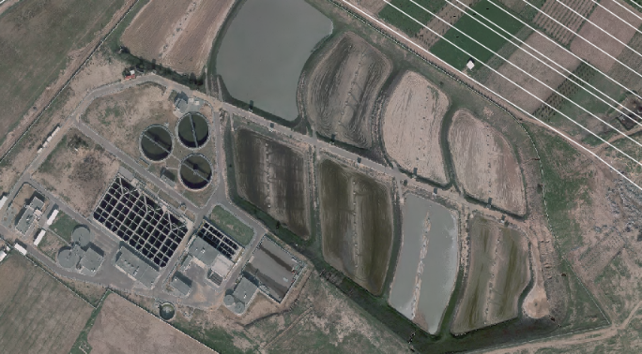ties. This implies that farmers must import 728,000 m3 of fertilizer annually, at a cost of almost 10.2 million US dollars. The social survey conducted among nearly 300 farmers in Gaza reveals that the scarcity and high cost of organic fertilizers may motivate farmers to employ treated sewage instead of importing organic fertilizers. Farmers who have never applied sludge are willing to do so if it is handled properly and yields favorable results. If sludge is composted with domestically made and imported compost, it will also be used as a soil conditioner [8]. Most contaminants' concentrations in sewage sludge were discovered to be below the acceptable level. Surfactant and Toluene concentrations were higher than the standard values [9]. Due to the potential for recycling vital components including organic matter, N, P, and other plant nutrients, sewage sludge application to the soil is growing in popularity [10]. Application of sewage sludge to soil allows nutrient recycling and may result in not needing commercial fertilizers in farmland [11]. Sludges are organic fertilizers, therefore over time, the soil's fertility increased [12]. However, it is unwise to amend sludge. It may affect the soil's characteristics, particularly if it contains significant levels of metals and harmful substances. The amount of accessible P in the soil was enhanced due to ongoing SS applications. It was confirmed that compared to soil that received simply mineral fertilizer, there was an increase of almost 100%, even in soil that had a lower amount of SS (50 Mg ha-1). Tropical climate soils typically have limited P availability for plants [13]. Despite the ongoing use of SS in tropical agriculture for ten years, the studied biogeochemical variables responded similarly to the planted areas with mineral fertilizers. In this study, a set of biogeochemical characteristics are used to evaluate how agricultural practices affect the environmental areas because these factors alone can produce results that are challenging to interpret. The alterations brought on due to SS use in agriculture were effectively assessed by the biogeochemical parameters utilized in this paper. According to the agronomic study, the SS was effective at supplying the corn crop with total P, partial N, and micronutrients [14]. Previous data and researches on sewage sludge in the Gaza Strip are very limited. Therefore, this study aimed to determine the feasibility of using sludge in soil, assess its impact on plants, and determine the optimal percentage of sludge to add to the soil and use as an alternative source of fertilizer where possible.

# II Materials and Methods

## A Study area

The source of the sludge is the North Gaza sewage treatment facility. The samples were taken from the sludge accumulated in the store located in the east of the Treatment Plant.

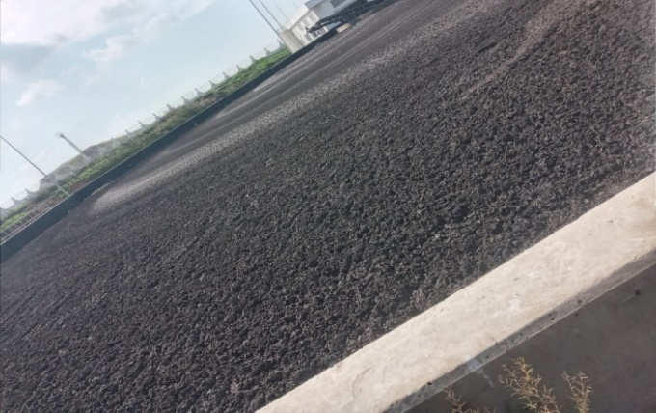Figure 1 North Gaza Emergency Sewage Treatment Plant (NGEST)

Figure 2 Drying beds of sludge at NGEST

## B Analytical methods

The sludge used in the experiment was air dried and cleaned of impurities and stones, the sludge was manually ground, and then the sludge passed through a filter of 2 mm. At the start of the experiment, soil samples were taken from each container, and sludge ratios were introduced for each experiment. Physical, biological, and chemical characteristics of the sludge were inspected before the experiment as (pH, EC, TDS, Chloride, Sodium, Potassium, Magnesium & Calcium, SAR, Total Coliform, Fecal Coliform, E. coli., Salmonella, Fecal Strept., Ammonia N, P, N, Dry matter and O.M) and Heavy metals as (Zinc, Iron, lead, Copper, Chromium, and Cobalt). Then (mixtures of soil with sludge in different proportions) were examined through the length of the plants and the amounts of (pH, Bulk density, Particle density, sodium, potassium, calcium and magnesium, and chloride) added to the soil were calculated. The tests were compared with parameters analyzed for soil and sludge. Values are given as the mean ± standard deviation (n = 3).

## C Experimental setup

The experiment was conducted on a farm owned by the Al-Attar family located in Beit Lahia in the northern Gaza Strip and the soil used in the project was from the land on which the experiment was conducted. Random samples were taken from the soil at a depth of 30 cm. The seeds were planted in the soil and transferred to the agricultural basins to experiment. The sludge source was taken from the NGEST. The sludge was treated by drying using sunlight to reach the appropriate quality. The dried sludge samples were sieved through a 2 mm sieve and mixed again to ensure sludge homogeneity and corn seed was obtained based on the recommendations of the farmer and owner of the land. Corn seeds are shown in Figure (4-1). The corn was planted by hand using three seeds per hole in April 2022, then after the growth of these seeds, the best ones were selected for study by looking at and comparing the plants.

Planting the crop was carried out using locally produced plastic, 15 containers are needed to cover the experiments and to repeat the experimental part. The pots were filled with the intended amount of sludge/soil mixtures as designed in TABLE 2

Corn was grown in pots with a capacity of 20 liters, and the first experiment was soil without sludge, and sludge was added to the soil by 10, 20, 25 and 30%, and each experiment had three replicates, see TABLE 2

**TABLE 2**

Experimental design

|  |  |  |
| --- | --- | --- |
| Number of Repetitions | The percentage of sludge to the total volume | Trial |
| 3 | 0% of sludge (Control) | T1 |
| 3 | 10% | T2 |
| 3 | 20% | T3 |
| 3 | 25% | T4 |
| 3 | 30% | T5 |

## D Statistical analysis

Using Excel, the data was statistically examined, and use three repetitions of each sample were used to compute the mean, standard deviation, and T-test. The significant differences are those with P-values less than 0.05.

# III Results and discussion

To evaluate sludge, three NGEST samples were taken from more than one site in the sludge storage location. Parameters such as (pH, EC, TDS, FC, O.M, N, P, ammonia N, E. coli, salmonella, faecal coliforms, faecal strept, total coliforms, SAR, magnesium and calcium, sodium, chloride, and potassium). The table below summarizes the overall results for the mean of the samples test.

**TABLE 3**

Properties of sludge from NGEST

|  |  |  |
| --- | --- | --- |
| **Result** | **Analysis** | **NO** |
| 6.8 | pH | 1 |
| 6.8 | EC ms/cm | 2 |
| 4350 | TDS mg/l as TDS | 3 |
| 140 | Chloride meq/l as Cl- | 4 |
| 80 | Sodium meq/l as Na+ | 6 |
| 1580 | Potassium mg/l as K+ | 7 |
| 80.5 | Magnesium + Calcium meq/l as Ca+2 +Mg+2 | 8 |
| 35 | SAR | 9 |
| 1x104 | Total Coliform | 10 |
| 3x103 | Fecal Coliform | 11 |
| Neg | E. coli. | 12 |
| Neg | Salmonella | 13 |
| 2x104 | Fecal Strept. | 14 |
| 7100 | Ammonia N mg/kg | 15 |
| 13500 | P mg/kg | 16 |
| 8850 | N mg/kg | 17 |
| 12.1 | Dry matter % | 18 |
| 51 | O.M % | 19 |

Note: The results are based on the dry weight.Note: The test is based on Palestinian technical Instructions 2015-59 composting sludge intended for agricultural use.

It is clear that, in general, the sludge sample tested is viable and usable by comparison with typical values and with sludge samples used globally. The results correspond with Fytili, according to stabilization methods, dewatered sewage sludge (dry) typically contains 50–70% organic matter, (30–50%) mineral components including (1-4%) inorganic carbon, (3.4–4% N), (0.5-2.5% P), and significant amounts of other nutrients, including micronutrients [15] [16]. However, the exact percentages vary depending on the (2013).

## A Distribution of the particles in size of the Sludge sample

The hydrometer method was used to determine the dispersion of particle sizes of the sludge samples, as seen in figure 3.

Figure 3 Distribution of sludge samples' particle sizes

The major-size particles (630-200 µm) have a percent ratio of 85%, which is the highest, followed by the second-size particles (200-20 µm), which have the second-highest percent size ratio (11%), and the smallest size particles (<20 µm), which have the third-lowest percent size ratio (4%).

The results indicate that most parts of the sludge are relatively large compared to most of the other particles, and this indicates the interconnection of the parts of the sludge to become large.

The result can be explained by the possibility that enormous size particles are sand-sized. These findings can be explained by the possibility that the big-size fraction is composed of small-size particles that agglomerate in cementing materials, making them stable despite fractionation. The results provided are consistent with those of [17], which investigated the development of particle size in aerobic granular sludge systems and found that granules did equilibrate toward a common critical size of roughly 600-800 µm.

**B Concentrations of sodium**

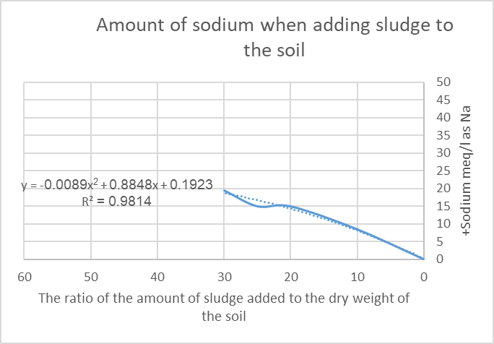At the studied quantities, there is a curve in the relationship between the amounts of sludge injected and the sodium concentrations. See figure 4

Figure 4 The relationship between the amounts of sludge added and sodium

The relationship curve between the amounts of sludge injected and the sodium concentrations shown in Fig. 4 isn't a linear relationship.

Rather, it is a relationship of the second degree, and it is considered the best trend line and can be predicted for the amounts of sodium (Sodium meq/l as Na+) expected to be added to the soil when adding sludge through the existing graph or equation that is accurate (because the coefficient of determination R= 98%). The various salts, of which sodium is more common, participate in the salinity, and high levels of sludge also participate in the salt accumulation.

The sludge contains quantities of absorbable sodium, but it does not necessarily have to be high in total salts. It is said that sodium is high when the percentage of exchanged sodium is more than 15%, and sodium is considered harmful when the amount of exchangeable sodium is about 5%, and this is the highest level of sodium, and alkaline soils are harmful to plants.

**C Concentrations of potassium**

At the studied quantities, there is a curve in the relationship between the amounts of sludge injected and the potassium concentrations. See figure 5

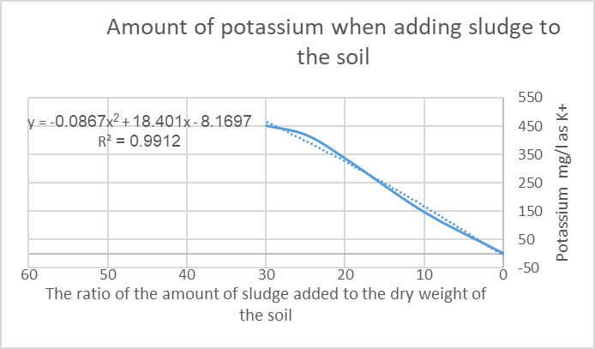

Figure 5 The relationship between the amounts of sludge added and potassium

The relationship curve between the amounts of sludge injected and the potassium concentrations shown in Fig. 5-6 isn't a linear relationship. Rather, it is a relationship of the second degree, and it is considered the best trend line and can be predicted for the amounts of potassium (potassium mg/l as K+) expected to be added to the soil when adding sludge through the existing graph or equation that is accurate (because the coefficient of determination R= 99%).

Because it is absorbed by plants more readily than any other element and because it is the major cation in plants, potassium is a crucial and significant element for soil and plants. Luxury Spending Like other elements, potassium does not penetrate the chemical makeup of plants; instead, it exists as an inorganic salt as well as a potassium salt of organic acids.

Potassium is essential for the movement of protein and glucose throughout the plant, and it has an impact on how well carbohydrates are stored in the storage organs.

**D Concentrations of calcium and magnesium**

At the studied quantities, there is a curve in the relationship between the amounts of sludge and the calcium and magnesium concentrations. See the Figure 6.

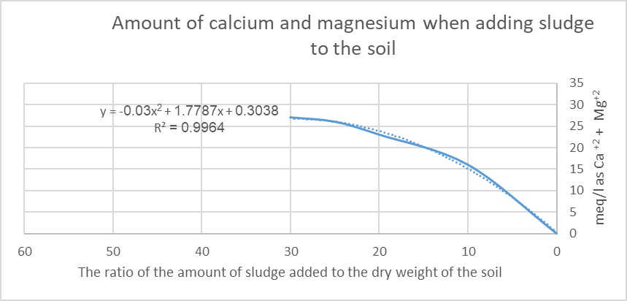

Figure 6 The relationship between the amounts of sludge added and calcium and magnesium

The relationship curve between the amounts of sludge injected and the calcium and magnesium concentrations shown in Fig. 6 isn't a linear relationship.

Rather, it is a relationship of the second degree, and it is considered the best trend line and can be predicted for the amounts of calcium and magnesium (meq/l as Ca +2 & Mg+2) expected to be added to the soil when adding sludge through the existing graph or equation that is accurate (because the coefficient of determination R= 99%).

Magnesium is a crucial component of photosynthesis because it creates the core atom of chlorophyll. Without enough magnesium, a plant would start to extract chlorophyll from decomposing leaves. The pallor of the leaves, or yellowing between the veins of the leaves, with the veins maintaining their green color, results from this, giving the leaves a marbled appearance.

Calcium is an important factor in plant growth. It is one of the essential secondary fertilizer components that is crucial for both soil and plant nutrition. It is a stationary component within the plant. The plant obtains the calcium it needs from soil rocks, sludge, or fertilizers.

**E Effect of Sludge/soil mix on the Growth of Corn**

Figures (7) and (8) show the application of sludge to the field experiment and its graphic representation. see the Figures.

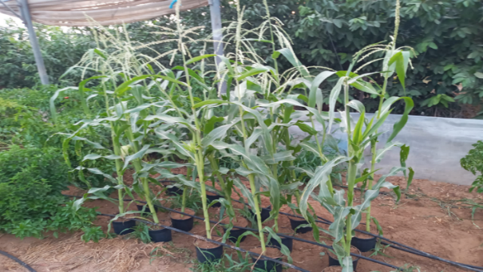

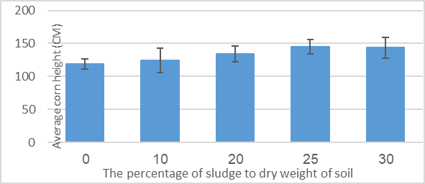 Figure 7 Growth of corn plants during the experiment

Figure 8 Average height of plants compared to the ratio of sludge to soil

The addition of sludge in different proportions enhanced the growth of corn plants. But the percentage of sludge (10 and 20%) increased the percentage of (EC, Total Coliform, and Cl) and this negatively affects the growth of plants, but in return, a percentage of nutrients phosphorous, potassium, sodium, calcium, and magnesium were added to the soil.

But the added percentage (10 and 20%) was useless compared to the percentage of adding sludge by 25% because it added (greater quantities of nutrients to phosphorus, potassium, sodium, calcium, and magnesium compared to the percentage of additive EC, Total Coliform and Cl), which had a positive impact on plants.

It is clear that the percentage of sludge (30%) increased the percentage of (EC, Total Coliform, and Cl) and this negatively affects the growth of plants, but in return, the highest value was added to the percentages approved in the experiment of nutrients phosphorus, potassium, sodium, calcium, and magnesium. However, the amounts of (EC, Total Coliform, and Cl) increased, which led to the ineffectiveness of the quantities of nutrients compared to the amounts of inhibitors.

Statistically, the results were 25%, and the increase in the height of corn plants was greater. While the growth rate of corn has slowed only by 30%.

As can be seen, the maximum application rate (30%) did not result in a high level of production while the treatment (25%) produced the corn with the highest average length-height (cm), which was 145 cm, and statistical analysis shows that the null theory is incorrect by analyzing the data of a standard sample with a 25% sample. While the result of statistical analysis is that the null theory is correct by analyzing the data of the normative sample with a 10-20-30% sample.

**F Statistical analysis results**

Each sample was tested and compared to the average; the results showed that there is no statistical difference in the addition of sludge to the soil except in the addition of 25% of the sludge.

**G The results of the statistical analysis of 25% of the sample.**

The result of the analysis for the 25% sample was compared with the control sample. Seen the Table 4

**TABLE 4**

NGEST T test for control sample with sample (25%)

|  |  |  |
| --- | --- | --- |
| t-Test: Paired Two Sample for Means | | |
|  | 25 | 0 |
| Mean | 145.3333 | 119 |
| Variance | 122.3333 | 57 |
| Observations | 3 | 3 |
| Pearson Correlation | 0.508954 |  |
| Hypothesized Mean Difference | 0 |  |
| Df | 2 |  |
| t Stat | 4.696062 |  |
| P(T<=t) one-tail | 0.021238 |  |
| t Critical one-tail | 2.919985 |  |
| P(T<=t) two-tail | 0.042476 |  |
| t Critical two-tail | 4.302652 |  |

The T-test tested the average corn height for the control sample with the average corn height sample (25%) sludge; The results were as follows (the mean of corn height for the control sample and corn height sample (25%) sludge the value respectively (145.3, 119) and the variance of corn height for control sample and corn height sample (25%) sludge the value respectively (122.33, 57) and the number of observations in two samples (2) and the Pearson correlation(0.508) and the (Hypothesized Mean Difference =0) and the degree of freedom (n-1=2 and the T-test (t Stat= 4.69) > (t Critical two-tail =4.3) and the ( (P(T<=t) two-tail = 0.042) < (P-values =0.05)), This means that there is statistical significance.

This means that there is a difference between the height average of corn plants for the control sample compared to that sample of 25% sludge. This indicates that there is a feasibility to using 25% of sludge because it affects the height of corn plants significantly.

This indicates that higher amounts of nutrients were obtained in the soil compared to the original soil and that the added sludge affected the soil by increasing the EC ratio, increasing the amount of TDS, increasing the amount of Cl, increasing the SAR ratio, and increasing the amount of Total coliform, Faecal coliform, and Faecal Strept. This negatively affects the soil and plants' growth, but the amount of added nutrients is greater than the amounts of added inhibitors, which led to an increase in the height of plants and the feasibility of adding sludge by 25%.

**H The optimum Sludge/soil Mixture**

The optimum ratio of the sludge/soil mixture was 25% according to the results of plant formation and chemical, physical, and biological examinations. So this study focused on this ratio to assess the impact of sludge use on the chemical and physical characteristics of soil in parallel with the soil 0% were studied as control samples.

The only percentage (25% of the sludge), which was the result of the statistical analysis of the data, was that there was a statistical significance for the average height of corn plants compared to the control sample.

It was observed that the increase in weight is directly proportional to 25% of the sludge/soil mixture, and this could be due to the nutrients present in the sludge [18]. Then a decrease in weight was observed, and it could be due to the higher salinity present in sludge.

The Ben M'hidi University Center ran a greenhouse pot experiment in 2002–2003 to investigate the results of various SS concentrations on the soil characteristics and yield of the Jaidor variety of barley [19]. The treatments included 20, 40, and 60 t ha1 of sewage sludge as organic fertilizer, 35 and 70 kg/ ha of urea as mineral fertilizer, and a check (without fertilization). The outcomes demonstrated that at the application rate of 40 t /ha of sewage sludge, the crop's reaction to the majority of variables was extremely effectively represented [20].

Sludge increases biological activity in the soil and contains a high amount of organic matter that can help preserve soil organic matter [21]. Sludge application thereby enhances soil quality as a substrate for plant growth and reduces soil erosion.

Plant productivity is increased by adding sewage sludge (SS) to the soil. The crop's above-ground biomass is significantly affected by the SS. It is therefore appropriate to use it to produce fodder crops. The physical, chemical and biological aspects of the soil are also positively impacted by the SS. It supplies macro- and microelements to the soil, which enhances the structure and water-holding ability of the soil and meets the needs of various crops [22].

# CONCLUSION

Based on the results of this research, sludge can be considered a suitable alternative to soil and fertilizers, because it does not change the main characteristics of soil and improves its properties. Sludge adds to the soil quantities of phosphorous, potassium, sodium, and many other elements. In our experiment, it was the optimal amount of sludge that positively affects plant growth. When the sludge was added at 25% of the soil's dry weight, the concentrations of the elements that were examined in the sludge were less than the maximum allowable according to the Palestinian and international standards for agricultural use.

**Acknowledgment**

The authors wish to thank Innovation Initiative Research Grant Program 2022 for funding and supporting the research project (MEDRC project No.: 22-IN-05).

**References**

1. Palestinian Central Bureau of Statistics (2022) Population in Palestine, Household Budget. <http://www.pcbs.gov.ps/site/881/default.aspx#Population>.
2. Qrenawi, L. I., & Shomar, R. A. (2020). Health risk assessment of groundwater contamination case study: Gaza Strip. Journal of Engineering Research and Technology, 7(1).‏
3. Kumar, V., & Chopra, A. K. (2016). Agronomical performance of high-yielding cultivar of eggplant (Solanum melongena L.) grown in sewage sludge amended soil. Research in Agriculture, 1(1), 1-24.
4. Williams, P. T. (2005). Waste treatment and disposal. John Wiley & Sons.‏
5. Nassar, A. M., Smith, M., & Afifi, S. (2006). Sludge dewatering using the reed bed system in the Gaza Strip, Palestine. Water and Environment journal, 20(1), 27-34.‏
6. El-Nahhal, I. Y., Al-Najar, H. M., & El-Nahhal, Y. (2014). Physicochemical properties of sewage sludge from Gaza. International Journal of Geosciences, 5(06).‏
7. Meghari, A. R., & Omar, R. K. (2017). Physicochemical Characterization of Sewage Sludge of Gaza Wastewater Treatment Plant for Agricultural Utilization. IUG Journal of Natural Studies.‏
8. Nassar, A., Tubail, K., & Afifi, S. (2009). Attitudes of farmers toward sludge use in the Gaza Strip. *International Journal of Environmental Technology and Management*, *10*(1), 89-101.‏
9. Schnaak, W., Küchler, T., Kujawa, M., Henschel, K. P., Süßenbach, D., & Donau, R. (1997). Organic contaminants in sewage sludge and their ecotoxicological significance in the agricultural utilization of sewage sludge. *Chemosphere*, *35*(1-2), 5-11.‏
10. Delgado Arroyo, M. M. (2014). Mirralles De Imperial Hornedo R., Alonso Peralta F., Rodriguez Almestre C., Martinez Sanchez JV, Heavy metals concentration in soil, plant earthworm and leachate from poultry manure applied to agricultural land. *Rev. Int. Contam. Ambie*, *30*(1), 43-50.‏
11. Sommers, L. E. (1977). *Chemical composition of sewage sludges and analysis of their potential use as fertilizers* (Vol. 6, No. 2, pp. 225-232). American Society of Agronomy, Crop Science Society of America, and Soil Science Society of America.‏
12. Archie, S. G., & Smith, M. I. L. T. O. N. (1981). Survival and growth of plantations in sewage sludge treated soil and older forest growth study. *municipal sludge application to Pacific North-West forest lands.* Bledose CB (ed)pp105–113 Univ of Washington, College of Forest Resources, Washington, DC.‏
13. Teles, A. P. B., Rodrigues, M., Bejarano Herrera, W. F., Soltangheisi, A., Sartor, L. R., Withers, P. J. A., & Pavinato, P. S. (2017). *Do cover crops change the lability of phosphorus in clayey subtropical soil under different phosphate fertilizers*? Soil Use and Management, 33(1), 34-44.‏
14. Melo, W., Delarica, D., Guedes, A., Lavezzo, L., Donha, R., de Araújo, A., ... & Macedo, F. (2018). Ten years of application of sewage sludge on tropical soil. A balance sheet on crops and environmental quality. *Science of the total environment*, *643*, 1493-1501.‏
15. Fytili, D., & Zabaniotou, A. (2008). Utilization of sewage sludge in EU application of old and new methods—A review. *Renewable and sustainable energy reviews*, *12*(1), 116-140.‏
16. Samolada, M. C., & Zabaniotou, A. A. (2014). Comparative assessment of municipal sewage sludge incineration, gasification, and pyrolysis for a sustainable sludge-to-energy management in Greece. *Waste management*, *34*(2), 411-420.‏
17. Verawaty, M., Tait, S., Pijuan, M., Yuan, Z., & Bond, P. L. (2013). Breakage and growth towards a stable aerobic granule size during the treatment of wastewater. *Water Research*, *47*(14), 5338-5349.‏
18. Bozkurt, M. A., & Yarilgaç, T. (2003). The effects of sewage sludge applications on the yield, growth, nutrition, and heavy metal accumulation in apple trees growing in dry conditions. *Turkish Journal of Agriculture and Forestry*, *27*(5), 285-292.‏
19. Boudjabi, S., Kribaa, M., & Tamrabet, L. (2008). Contribution of Sewage Sludge to the Fertility of the Soil and the Growth of Barley (Hordium Vulgare L) Variety Jaidor. In *Efficient Management of Wastewater* (pp. 227-235). Springer, Berlin, Heidelberg.‏
20. Boudjabi, S., Kribaa, M., & Tamrabet, L. (2008). Contribution of Sewage Sludge to the Fertility of the Soil and the Growth of Barley (Hordium Vulgare L) Variety Jaidor. In *Efficient Management of Wastewater* (pp. 227-235). Springer, Berlin, Heidelberg.‏
21. Stamatiadis, S., Werner, M., & Buchanan, M. (1999). Field assessment of soil quality as affected by compost and fertilizer application in a broccoli field (San Benito County, California). *Applied Soil Ecology*, *12*(3), 217-225.‏
22. Boudjabi, S., Kribaa, M., & Tamrabet, L. (2008). Contribution of Sewage Sludge to the Fertility of the Soil and the Growth of Barley (Hordium Vulgare L) Variety Jaidor. In *Efficient Management of Wastewater* (pp. 227-235). Springer, Berlin, Heidelberg.‏