**The Dynamics of Composite Tubes Including Internal Damping**

**Sara Salim Al-Esawy 1, Ahmed Abdullah Alrajihy *2*, Basim Raheem Sadiq *3***

2University of Babylon, Automobile Engineering Department, Iraq

1, *3*University of Karbala, Mechanical Engineering Department, Iraq

(1 Corresponding author’s e-mail: [sara.s@s.uokerbala.edu.iq](mailto:sara.s@s.uokerbala.edu.iq))

**Abstract**

One of the important influences on the composite tube is the internal damping force, this force is opposite to the fluid force inside the composite tube. In this paper, the dynamics of the effect of internal damping on the composite tube carrying the fluid was studied using the analytical method to find the equation of motion for the composite tube with the effect of internal damping. Some external influences, such as temperature and the viscous damping coefficient between the surrounding surface of the tube and the composite tube resulting from internal friction between them were neglected. Taking the effect of internal damping on the individual types of support: simply support, clamped support, clamped - pinned support, and intermediate support. It was found that internal damping reduces the natural frequency of the composite tube with values ​​less than the general limit of the natural frequency without taking the effect of internal damping. Based on the foregoing, internal damping has been determined to be inversely related to the installed tube's natural frequency with constant tumble speed. When the rate changes without consideration for external effects, the internal damping effect is enhanced, and the inherent frequency value is spread.

**Keywords**: Composite tube, internal damping, intermediate support

**الملخص**

أحد التأثيرات المهمة على الأنبوب المركب هي قوة التخميد الداخلية، وهذه القوة معاكسة لقوة السائل داخل الأنبوب المركب. في هذا البحث تمت دراسة ديناميات تأثير التخميد الداخلي على الأنبوب المركب الناقل للسائل باستخدام الطريقة التحليلية لإيجاد معادلة الحركة للأنبوب المركب مع تأثير التخميد الداخلي. تم إهمال بعض التأثيرات الخارجية مثل درجة الحرارة ومعامل التخميد اللزج بين السطح المحيط للأنبوب والأنبوب المركب الناتج عن الاحتكاك الداخلي بينهما. أخذ تأثير التخميد الداخلي على أنواع الدعم الفردية: ببساطة الدعم، الدعم المثبت، الدعم المثبت، والدعم المتوسط. وجد أن التخميد الداخلي يقلل من التردد الطبيعي للأنبوب المركب بقيم أقل من الحد العام للتردد الطبيعي دون أخذ تأثير التخميد الداخلي. بناءً على ما سبق، تم تحديد أن التخميد الداخلي يرتبط عكسيًا بالتردد الطبيعي للأنبوب المثبت بسرعة تقليب ثابتة. عندما يتغير المعدل دون اعتبار للتأثيرات الخارجية، يتم تحسين تأثير التخميد الداخلي، وتنتشر قيمة التردد المتأصلة.

**الكلمات المفتاحية:** أنبوب مركب، تخميد داخلي، دعامة وسيطة

**Introduction**

The use of composite materials has a wide range of uses in the present time in many practical and industrial applications because of their good mechanical properties compared with their low specific weight [1]. The use of these materials in tubes led to further studies related to the dynamics of these composite fluid-carrying tubes. On the other side, the field of dynamical behavior has received important attention over the last decades because of its wide applications or because it is an interesting point of research to many authors.

Because of the importance of studying the dynamical behavior of tubes, metallic or composite, conveying flowing fluid, a large number of researches studied were pointed to this field. M. P. Paidoussis and N.T. [2] studied the dynamics and methods of stabilization of flexible fluid-carrying tubes and it was found that at high flow velocity the conservative tubes are subjected to torsion and affect the stability of the vibration. It is addressed to calculate the value of the internal damping force of the tubes when the speed is variable, as the internal damping works to dissipate the frequency and the extent of instability areas. The study presented by Matsushita et al., [3] dealt with the effect of internal friction and Young's modulus of composite materials reinforced with glass cloth material at a temperature measured in Kelvin between 130 and 350. It was found that the temperature significantly affects the internal friction so that the difference between the arrays of the material appears. D. Kroisová [4] worked on the calculation of internal damping of composite systems made of epoxy resins, they consist of two components of materials in addition to fillings consisting of ferrous oxide particles, lead particles, hollow issues of alloys, cork, and titanium dioxide particles, in addition to carbon fibers in the form of pieces. The tests were carried out for internal damping of the installed systems at specific conditions of 22 ° C with a frequency of (50-100) Hz and atmospheric pressure. As Wang, Dai and Qian [5] dealt with a study of simply support tube dynamics, with engineering defects, as it was found that the tube arrives at equilibrium when the velocity is low, as each defect has a clear effect on the values ​​of the natural frequency and internal damping of the fluid conveyor tube. Internal cantilever support using two parts to solve the problem. N. Al – Raheimy [6] studied the effect of different types of support; clamped - free, clamped – clamped and clamped - pinned, on the cross-sectional frequency of composite pipes having properties of 1 m length, 1 mm thickness, and inner radius of 1 cm. The tube consists of fiberglass which is the polyester resin of the hardened matrix. The fibers are of different lengths, the first type is short, but not connected, while the second type is opposite, long, and continuous, and that was for a specific part of the fiber. When its flow velocity increases from zero to its critical velocity, the natural frequency will decrease. The frequency increasement depends on the length of the unconnected fiber. When a specific quantity of flow velocity is enforced, the natural frequency value becomes changeable. In the end, the researcher concluded that the glass tubes will have a low critical speed, and also the natural frequency will be small compared to the tubes containing Kevlar fiber. Colakoglu [7] showed the most important factors that affect the internal damping of the tube significantly, such as temperature, frequency, stress, and strain value, and that the internal damping varies according to the type of material and the type of alloy of the aluminum and its alloys. Khudayarov et al. [8] studied pipes made of composite materials that carry liquids and gases. They considered the structure's viscous characteristics, internal pressure, and axial strength. The impact of the viscosity characteristics of the pipeline base on critical velocity relies on the rate of critical velocity. Reduce the pulse flow and the internal pressure parameter value to raise the critical flow. S. Karic [9] gave a presentation of the results of the values ​​of the internal structural damping coefficient of the flexible structures of free bending, it was assumed that the internal damping force is proportional to the flow velocity of the structure directly, and by using the finite element method. The motion equation was estimated for the structure to calculate the time response of the vibration structure.

This work sheds light on the dynamical behavior of composite tubes taking into account the effect of internal damping, as well as the other effects of flow velocity. The tube was assumed uniform and was supported using clamped-clamped, pinned-pinned, clamped-pinned, or a third support as an intermediate support.

**Materials and methods**

A tube composed of a composite material with uniform cross-section A, length L, thickness t, mass per unit length of $m_{p}$, and mass per unit length of $m_{f}$ is used in this study to transport Incompressible mass fluid per unit length of $m_{f}$. Both ends of the tube are held up.

The equation of motion of the tube considering the effect of internal damping is written as [10]:

$$E^{*}I \frac{∂^{5}y}{{ ∂x}^{4 }∂t}+ E I \frac{∂^{4}y}{{∂x}^{4}} - \left[ \left(m_{f}V^{2}+P_{i}A \right) \right]\frac{∂^{2}y}{{∂x}^{2}}$$

$+ 2 m_{f}V \frac{∂^{2}y}{∂x∂t}+m_{f}\frac{∂V}{∂t}\frac{∂y}{∂x}+\left( m_{f}+m_{p}\right)\frac{∂^{2}y}{{∂t}^{2}} =0$ (1)

The modulus of elasticity of the composite materials in which is given by [6].

$E_{c }= E_{f }V_{f }+ E_{m }V_{m}$ (2)

Where, ${V_{f } ,V}_{m}$ are volume fractions of the fiber and matrix respectively, and the relation between these volume fractions is

$( V_{m} + V_{f }) = 1$ (3)

Substituting equation (3) into equation (2) gives,

$E_{c }= E_{f }V_{f }+ E_{m }(1 - V_{F})$ (4)

Where, $E_{f },E_{m }$ are the modulus of elasticity of fiber and matrix respectively.

By substituting $E_{eq}$ = $E_{c}$ into equation (1) yields,

${E^{*}}_{eq} I \frac{∂^{5}y}{{ ∂x}^{4 }∂t}+ E_{eq} I \frac{∂^{4}y}{{∂x}^{4}} -\left[ \left(m_{f}V^{2}+P_{i}A \right) \right]\frac{∂^{2}y}{{∂x}^{2}}$ $+ 2 m_{f}V \frac{∂^{2}y}{∂x∂t}+m_{f}\frac{∂V}{∂t}\frac{∂y}{∂x}+\left( m_{f}+m_{p}\right)\frac{∂^{2}y}{{∂t}^{2}} =0$ (5)

Where ${E^{*}}_{eq}$ is the composite tube's effective modulus of elasticity, incorporating internal damping?

It's easier to put equation (5) in a dimensionless version like this:

$μ\frac{∂^{5}η}{{∂ξ}^{4}∂τ}+ \frac{∂^{4}η}{{∂ξ}^{4}}+ \left(U^{2} + γ\right)\frac{∂^{2}η}{{∂ξ}^{2}}+2 β U\frac{∂^{2}η}{∂ξ∂τ}+\frac{∂U}{∂τ}\frac{∂η}{∂ξ}+\frac{∂^{2}η}{{∂τ}^{2}} = 0$ (6)

the above dimensionless variables are given by

$ξ=\frac{x}{L}$, *η* = $\frac{y }{L}$, *U* = VL $\sqrt{\frac{m_{f}}{EI}}$, *γ* = $\frac{\text{P}\text{i}\text{ A L}\text{2}}{\text{EI}}$, *β* = $\sqrt{\frac{m_{f}}{m_{f}+m_{p}}}$, *τ* = $\frac{t}{L2}\sqrt{\frac{E I}{m_{f}+m_{p}}}$

The partial differential equation (6) solution, which includes the spatial and time-independent terms, is expressed as

$ω(x) = η(ξ, τ) =\sum_{j=1}^{4}{ c_{j} { e}^{{iλ}_{j}ξ } e^{iΩτ}}$ (7)

Substituting equation (7) into equation (6) results in a fourth-order polynomial equation for as

$μ {Ω λ}^{4}+λ^{4} -\left(U^{2}+ γ \right) λ^{2} -2 β U Ω λ - Ω^{2} =0$ (8)

Where $ω$ $is$ Natural frequency, Ω is the dimensionless circular frequency of oscillation, $Ω= ωL^{2} \sqrt{\frac{\left( m_{f}+m_{p}\right)}{EI}}$, and $λ$ is the four eigenvalues of the tube.

The following boundary conditions are considered to support the tube under investigation.

**Simply support:**

$\left\{\begin{aligned}At x=0 , η \left(0 , τ\right) = 0 , η'' \left(0 , τ\right) = 0 \\ At x=L , η \left(L , τ\right) = 0 , η'' \left(L , τ\right) = 0 \end{aligned}\right\}$ (9)

**clamped support:**

$\left\{\begin{aligned}At x=0 ; η \left(0 , τ\right)=0 , { η}^{'}\left(0 , τ\right)=0 \\ At x=L ;η \left(1 , τ\right) = 0 , η' \left(1 , τ\right) =0\end{aligned}\right\}$ (10)

**clamped – pinned:**

$\left\{\begin{aligned}At x=0 ; η \left(0 , τ\right)=0 , η^{'}\left(0 , τ\right)=0 \\ At x=L ; η \left(1 , τ\right) = 0 , η'' \left(1 , τ\right) = 0\end{aligned}\right\}$ (11)

An intermediately supported tube's (multi-span tube's) boundary conditions are:

$\left\{\begin{aligned}At x=0 , η \left(0 , τ\right) = 0 , η^{'}\left(0 ,τ\right)= 0 \\ At x=L , η \left(L , τ\right) = 0 , η^{'}\left(L, τ\right) = η^{'}\left(0, τ\right) \\ , η^{''}\left(L, τ\right) = η^{''}\left(0 , τ\right) , η \left(0 , τ\right) = 0 \\ At x=L , η (L ,τ) = 0 , η' (L ,τ) = 0 \end{aligned}\right\}$ (12)

Substituting equation (7) into any set of boundary conditions result in a matrix equation as:

$\left[\begin{matrix}a_{11} & a_{12} & a_{13} & a_{14} \\ a_{21} & a_{22} & a_{23} & a_{24} \\ a_{31} & a_{32} & a_{33} & a_{34} \\ a_{41} & a_{42} & a_{43} & a_{44}\end{matrix}\right]\left\{\begin{matrix}c_{1} \\ c_{2} \\ c_{3} \\ c_{4}\end{matrix}\right\} =\left\{\begin{matrix}0 \\ 0 \\ 0 \\ 0\end{matrix}\right\}$ (13)

The elements of this equation depend on the type of boundary conditions. The value of natural frequency under the effect of any parameter can be determined by equating the determinant of equation (13) to zero.

**Results and discussion**

The impact of various characteristics and boundary conditions is discussed in this section. on the dynamics of the tube under discussion are discussed. The results are calculated according to equation (13) and are taken for the first mode. All the results are presented in a dimensionless form.

Figure (1) shows various types of boundary conditions, the influence of flow velocity on natural frequency. This figure shows that the fluid flow velocity negatively affects the values of the natural frequency in some range of the vibration, whereas the speed increases, the values of the natural frequency decrease and it varies from one type to another and from one phase to another. If the flow speed is of some value, the natural frequency fades away and the pipe gets buckled and loses its stability. The velocity at which the tube lost its stability is known as critical flow velocity.

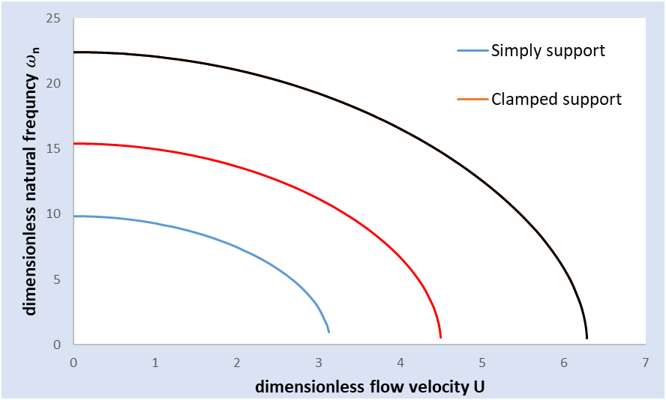

**Figure 1:** For four different forms of supports, the effect of flow velocity on the tube's first mode natural frequency (β=0.6336 & γ =0)

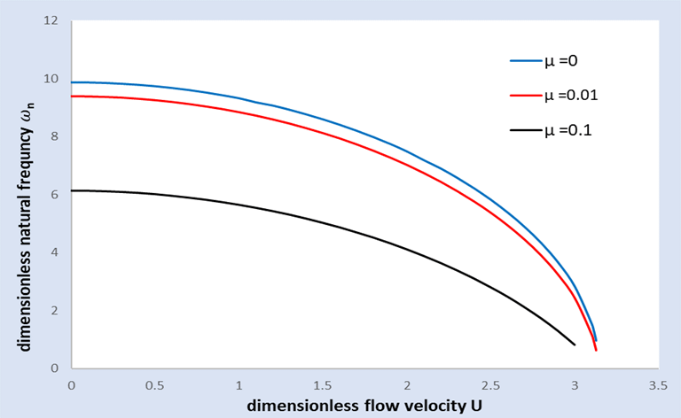

**Figure 2**: Effect of damping value on the natural frequency of the first mode of a simply supported tube carrying fluid at various velocities

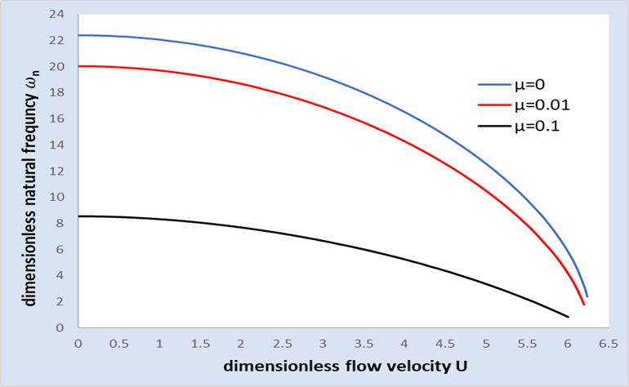

**Figure 3**: Effect of damping value on the natural frequency of the first mode of a clamped support tube carrying fluid at various velocities

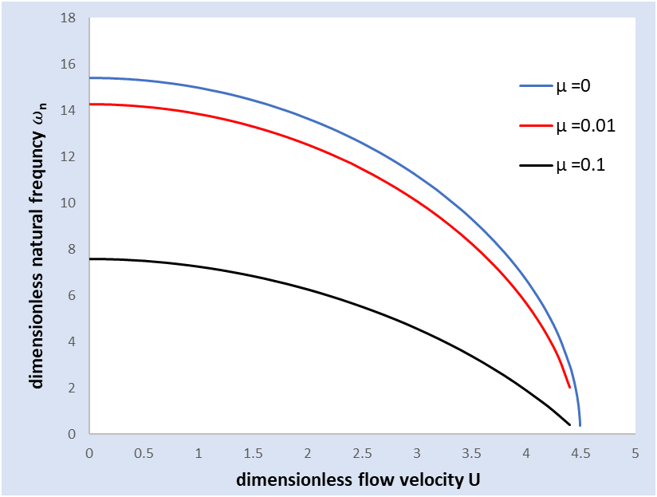

**Figure 4**: Effect of damping value on the natural frequency of the first mode of a clamped-pinned tube transporting fluid at various velocities



**Figure 5:** Effect of damping value on the natural frequency of the first mode of a clamped-clamped tube with a simple intermediate support tube transporting fluid at varied velocities

The effects of the tube's internal damping on the natural frequency of clamped-clamped, simply-support, clamped-simple, and clamped-clamped with simple intermediate support are shown in figures (2-5) correspondingly. From these figures, one concludes that increasing the internal damping has the effect of decreasing the natural frequency. Also, it is seen that the effect of internal damping at the low-velocity range is more than that at the high-velocity range. This behavior is attributed to the fact that at high flow velocities the damping due to flowing fluid is dominant.

The relation between the natural frequency and the internal damping of the tube is presented in figures (6-9) for different types of support. These data demonstrate that the influence of internal damping on the tube natural frequency is nonlinear and that when the internal damping is greater than 0.3, the natural frequency fluctuation is reduced.

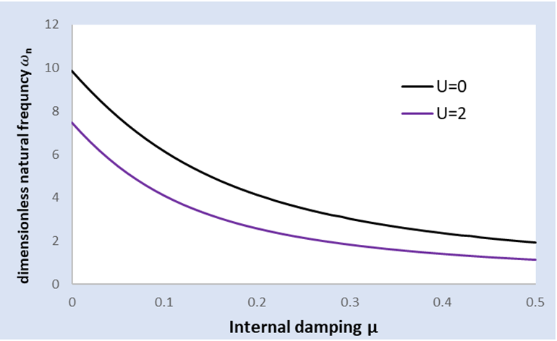

**Figure 6**: The effect of internal damping on a simply supported tube carrying fluid with two velocities at its natural frequency.

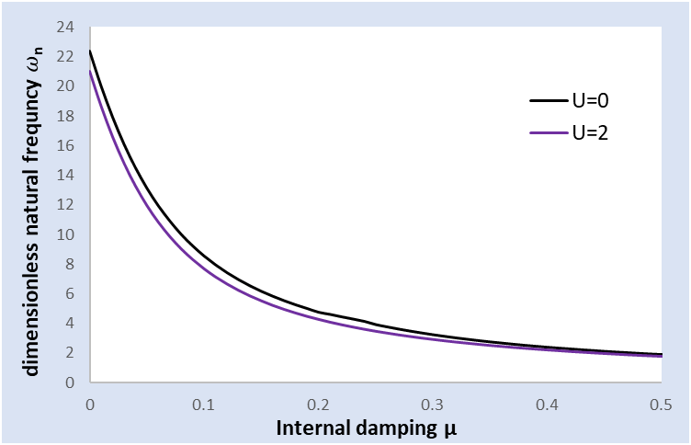

**Figure 7**: The effect of internal damping on a clamped supported tube carrying fluid with two velocities at its natural frequency

­

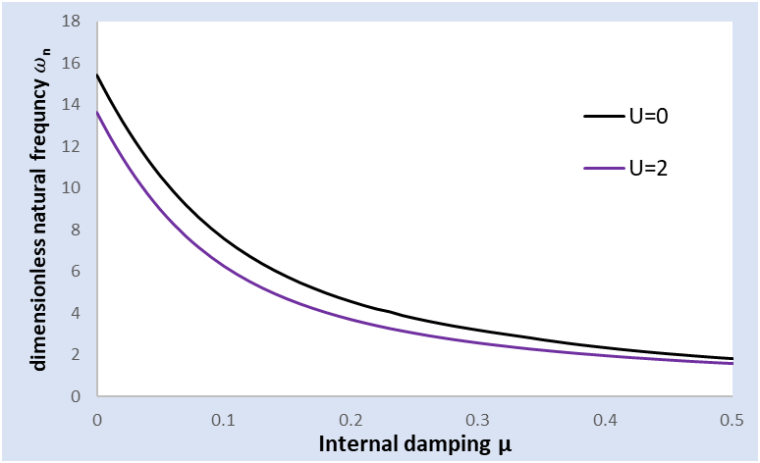

**Figure 8**: The effect of internal damping on a clamped–pinned supported tube carrying fluid with two velocities at its natural frequency

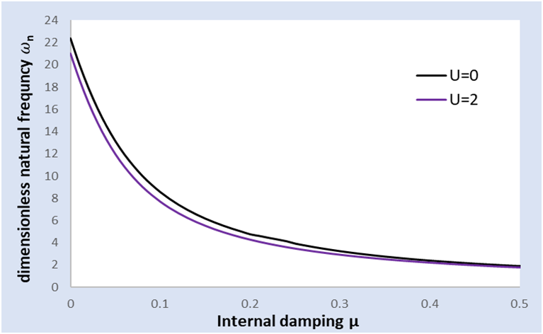

**Figure 9**: The effect of internal damping on a clamped-clamped tube with simple intermediate support supported tube carrying fluid with two velocities at its natural frequency.

**Conclusions**

From the results discussed above, the following conclusions can be drawn:

1- The flow velocity is the main factor that causes the tube to lose its stability by buckling phenomenon. Also, its main effect presents near the critical values while its effect is light at low flow speeds.

2 – The main effect of internal damping on the tube natural frequency lies in the low range of flow velocity and it is dying out at high flow velocity ranges.

**References**

**[1]** W. A. Oke and Y. A. Khulief, “Effect of Internal Surface Damage on Vibration Behavior of a Composite Pipe Conveying Fluid,” *Compos. Struct.*, 2018, DOI: 10.1016 /j. compstruct .2018.03.098.

**[2]** “M. P. Paidoussis and N. T.,” Dynamic stability of pipes conveying fluid. Journal of Sound and Vibration vol. 33, pp. 267–294, 1974.

**[3]** K.Matsushita, *et al.* (1985) ‘INTERNAL FRICTION AND YOUNG ’ S MODULUS IN COMPOSITE MATERIALS, to cite this version : HAL Id : JPA-00225330’.

**[4]** D.Kroisová, (2010) ‘An internal damping in epoxy composite systems’, pp. 1207–1218.

**[5]** L. Wang, H. L. Dai, and Q. Qian, “Dynamics of simply supported fluid-conveying pipes with geometric imperfections,” *J. Fluids Struct.*, vol. 29, pp. 97–106, 2012, DOI: 10.1016/j.jfluidstructs.2011.12.013.

**[6]** N. H. Al Raheimy, (2016) ‘Free Vibrations of Uniform Pipes Made from Composite Materials at an Internal Flow Under Effect of Additional Boundary Conditions’, (3).

**[7]** M. Colakoglu, (2017) ‘Factors affecting internal damping in aluminum’, (September).

**[8]** B. A. Khudayarov, KH. M. Komilova and F. ZH. Turaev, (2019) ‘Numerical Simulation of Vibration of Composite Pipelines’, 11(9). DOI: 10.1142/S175882511950090X.

**[9]** S.Karic, (2020) ‘Determination of the internal damping coefficient in an elastic clamping beam Određ ivanje koeficijenta unutrašnjeg’, (January 2012).

**[10]** R.W.Gregory and M.P.Paidoussis , I.Theory, (1966) ‘Unstable oscillation of tubular cantilevers conveying fluid II. Experiments’, *Proceedings of the Royal Society of London. Series A. Mathematical and Physical Sciences*, 293(1435), pp. 528–542. DOI: 10.1098/rspa.1966.0188.