

Assessment #lll

Missing Children Reports

Dr. Young Joo

Shoug alaskar 201601240



**Introduction:**

**Missing child law in Kingdom of Saudi Arabia:**

The issuance of the Child Protection Law by Royal Decree M/14 dated 25/11/2014, represents a comprehensive legal framework for the protection of children under 18 years from kidnapping, abuse and abduction. Several acts constitute abuse or neglect of the child, including causing of education interruption, mistreatment, harassment, or exposing to exploitation, using words offensive to his dignity, and discrimination against him for any reason. Article (9) of the law states that “A child may not be kidnapped and sexually exploited nor exposed to any form of sexual exploitation, nor shall he be subject to trafficking for purposes of criminal activities or beggary.” In order to ensure the proper upbringing of the child, the law has prohibited the production, publication, display, circulation and possession of any work directed at the child, addressing his instinct or encouraging him to engage in any behavior in violation of the law. (Almihdar, 2009)

The Ministry of Human Resources and Social Development of SaudiArabia has adopted a strategy for protection from kidnapping, abduction, violence and child protection. The strategy seeks to achieve and provide security for children and support them and support families as a safe and supportive environment for children, free from violence and achieving psychological and social security.( AlJasser M, Al-Khenaizan S)

**Missing child law in United States:**

The National Child Search Assistance Act, 42 U.S.C. §§ 5779-5780, requires each federal, state, and local law enforcement agency to enter information about missing children younger than age 21 into the FBI's National Crime Information Center (NCIC) database within two hours of missing-child report (Al-Haidar FA. Munchausen) The Missing Children Act requires the Attorney General to seek information assisting in the location of any missing persons, including children. The Act also gives parents, guardians, or next of kin access to the information in the FBI National Crime Information Center's Missing Person File. Inquiries can be made with physical descriptors alone, but the possible inquiry route has been expanded through the creation of forms for detailed medical data on a missing person. Voluntary programs in which parents have their children fingerprinted further increase the depth of information available for entry and/or inquiry.  (Barriage & Hicks, 2020)

**CHILD MISSING REPORT:**

When a child is reported missing to law enforcement, federal law requires that child be entered into the FBI's National Crime Information Centre, also known as NCIC. There is a report which needs to fill all the information related to missing child with his or her clear picture.Many of the questions are about the identity and description of the missing person. So many of the questions will be concerning the person’s name, aliases, date of birth, height and weight, scars marks and tatts, clothing last seen in, eye color, hair color and length, hair style, wears braces, hearing aids, glasses or contacts and the like. The informant’s information will be collected…how is the informant related to the missing person, and their contact information.other questions will concern the missing persons mental state, any medical problems, possible reason for leaving, possible destination,last person to see the person, date and time last seen, known friends and associates, vehicle used , previous history (if any) of being missing and so on.The missing child report should be submitted immediately after happening this strategy. The example of missing report is given below:

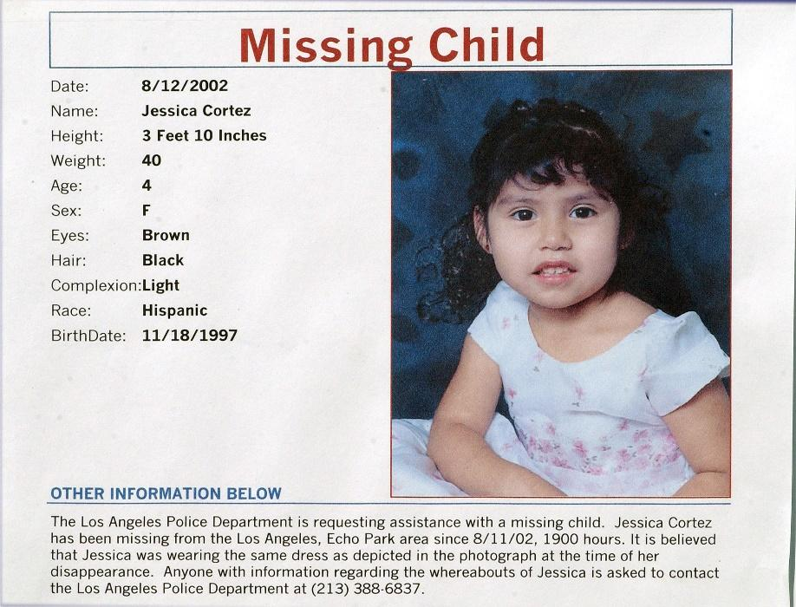

**History of missing child in Saudi Arabia:**

The most popular case of missing child happened in the historical year of 2000. Saudi authorities are holding a woman in her fifties on charges of having kidnapped three baby boys from a hospital more than 20 years ago. The arrest comes after Naif Al-Qaradi was reunited with his birth family, who refused to give up hope after he was taken from Qatif hospital hours after his birth. Al-Qaradi’s paternal uncle, Yehia Al-Kahlani, from Jazan, told reporters that the young man’s identity had been confirmed by a DNA result that matched his mother’s. Al-Kahlani said that the boy had been kidnapped about six hours after his birth. His mother was visited by a woman dressed as a nurse who said she was going to take him for a check-up. “We suffered for a long time, 26 years or even more searching for him. His father suffered the most with psychological stress, resulting in a heart condition that led to his passing,” the uncle said. “Naif’s joy is indescribable at this revelation,” the uncle added. “We pray that he is always happy to have met his real family. He is still recovering from the shock and coming to terms with what has happened to him.” Al-Kahlani said that the family hopes to press charges because of the involvement of other kidnapped children. (Griffin et al., 2022)

* **What is the effect of not reporting missing child?**

The missing child is the immediate action which should be taken by parents or relatives. Without informing police and Federal law of security department, the child could be abducted, sexually raped or murdered by the kidnappers. The guardians should take immediate actions and report the missing child case file.

* **Saudi Arabia police dealing with missing reports:**

In Saudi Arabia, the emergency numbers for the police are 999 or 911. Reporting a missing child report is now also possible on a smartphone application. The *Kollona Amn* app enables citizens and expatriates to help maintain security and reports filed online reach 39 centers across the Kingdom. Saudi Arabia’s ministry of interior is responsible for all matters relating to security and kidnapping which deals with the children protection agency. There are three police departments in the country: the regular police, the secret police (*mabahith*), and the religious police (*mutawa*). While the regular police are responsible for law enforcement and general security, and for issuing good conduct certificates, the *mabahith* handles domestic security and counterintelligence, while the *mutawa* enforces Islamic codes of behavior. The law enforcement system of police in Saudi Arabia is very active and determined. They are very honest with their work.(Raboei et al 2019)

* **Amber Alert and its working phenomena:**

AMBER alerts are used by law enforcement to notify the public about missing children thought to have been abducted. AMBER Alerts are only used for the most serious child abduction cases, when authorities believe a child is in imminent danger of serious bodily injured or death. it was created in reference to Amber Rene Hagerman, a girl who was abducted and later found murdered in 1996. (Pinheiro PS. Geneva)

AMBER Alert has also teamed up with internet to relay information regarding an AMBER Alert to an ever-growing demographic: AMBER Alerts are automatically displayed if citizens search or use map features on Google or Bing. With the Google Child Alert (also called Google AMBER Alert in some countries), citizens see an AMBER Alert if they search for related information in a particular location where a child has recently been abducted and an alert was issued. This is a component of the AMBER Alert system that is already active in the US (there are also developments in Europe). Those interested in subscribing to receive AMBER Alerts in their area via SMS messages can visit Wireless Amber Alerts, which are offered by law as free messages. In some states, the display scroll boards in front of lottery terminals are also used. (Al owain ET AL, 2011)

* **Kulumun AMN app and usage of this app:**

Under the direction of the Ministry of the Interior, the SADAI and Elm Company created the security application "KOLLONA AMN" on March 13, 2017. Saudi Arabia's Public Security Department, the Sectors Departments, and the Saudi Arabian telecommunications authority.

It is a multipurpose tool that allows citizens and expatriates to report any lawbreaker or minor criminal act. During the occurrence of any crime, a photo might surely be bound. Additionally, they may attach video or audio messages to his emergency message.

In addition to these functions, the map tool allows users to include the location of the crime scene in their messages. These incidents are routed to 39 activity centers based on the kind and geographical location of the crime correspondent (Send by user). By accepting pop-up notifications or instant messaging, a user of this adaptable program should be able to get a report about the specific incidence.

* **Recommendations to solve the problems:**

we can see how Amber Alert in USA is helping to save children lives and how it is have a positive effect, so i suggest to have a plan like Amber Alert plan which going to help the families and the police and of course missing children, also as we have a good app like kollona amn app i suggest to add a missing person report option to the app when we can report and add information and pics to the report which will save alot of time for the police and increases the chance of finding the person.

also experts recommend teaching your child the following tips to help prevent abduction:

* Stay away from strangers. Explain what makes a person a stranger. Note that even someone with a familiar face is a stranger if you do not know him or her well.
* Stay away from anyone who is following you on foot or in a car. Don't get close to them or feel as though you must answer any questions they ask you.
* Run and scream if someone tries to force you to go somewhere with them or tries to push you into a car.
* Memorize a secret code word. Tell your child not to go with anyone under any circumstances unless that person also knows this code word.
* Adults shouldn't ask children for help. For example, a child shouldn't trust grown-ups who ask kids for directions or for help finding a puppy or kitten. A child who is approached in this way should tell the person, "Wait here and I'll check with my mom or dad," and then find his or her parents right away.
* Ask for help when you are lost. If you get lost in a public place, immediately ask someone who works there for help.
* Always ask for permission before going anywhere with anybody. Ask a parent or the grown-up in charge before leaving the yard or play area, or before going into someone's home. Do not accept **any** unplanned offers for a ride—from someone known or unknown.
* Always tell a parent where you are going, how you will get there, who is going with you, and when you will be back. Be home at the agreed-upon time or else find a way to contact home directly.( Felitti VJ, Anda RF, Nordenberg D, Williamson DF, Spitz AM, Edwards V, et al.)

**Conclusions**:

If your child is lost or missing, being able to provide information quickly to the authorities will save them valuable time in searching for your child. The parents should be prepared with a good description of your child. Have a close-up photograph of your child taken every 6 months. Keep track of and write down details about your child's appearance, such as height and weight, eye colour, birthmarks, scars, and identifiable mannerisms (such as hair-twisting).Have your child fingerprinted. Check with your local police department for instructions.Stay calm. You are more likely to remember helpful details if you can remain calm.

**References:**

1. *Report and Identify Missing Persons*. (2014, September 16). Report and Identify Missing Persons. Retrieved October 15, 2022, from <https://www.justice.gov/actioncenter/report-and-identify-missing-persons>
2. *AMBER Alert*. (n.d.). AMBER Alert. Retrieved October 15, 2022, from <https://amberalert.ojp.gov>
3. Carr, D., Muschert, G. W., Kinney, J., Robbins, E., Petonito, G., Manning, L., & Brown, J. S. (2009, June 25). *Silver Alerts and the Problem of Missing Adults with Dementia. The Gerontologist*, 50(2), 149–157. <https://doi.org/10.1093/geront/gnp102>
4. هيئة التحرير. (2016). نظام حماية الطفل صدر بالمرسوم الملكي رقم م / 14 بتاريخ 3 / 2 / 1436هــ. *العدل، ع75* ، 109 - 118. مسترجع من <http://search.mandumah.com.library.pmu.edu.sa/Record/932945>

1. المنصة الوطنية الموحدة في السعودية، حقوق الانسان - مجلد شامل تاريخ٢٧ ذو الحجة،١٤٤٣ ، مسترجع من <https://www.my.gov.sa/wps/portal/snp/careaboutyou/humanright/!ut/p/z1/jdDLDoIwEAXQr2HLTCtgdVc1mqCIgg_sxqCplQSowSq_73Nj4mt2Mzk3uRkQkIAo03OmUpPpMs2v-0p4a0qCwYAgDVmELZzO6Nzp4hj9PoXlHfgT5hCOJAwbbgen3aAZ8nhBEF0Q_-Txw3D8nRevBL3FjURx1PMCfziiT_Ct4h186eCDULnePP7By02DKRCV3MlKVvapup73xhyObQstrOvaVlqrXNpbXVj4LrLXRwPJq4RYlnAo5glmk2LJDLsAswHW7A!!/dz/d5/L0lHSkovd0RNQU5rQUVnQSEhLzROVkUvYXI!/>
2. gov.sa. (2021, March 7). Police Declaration (Kollona Amn). Police Declaration (Kollona Amn). Retrieved October 23, 2022, from <https://www.my.gov.sa/wps/portal/snp/servicesDirectory/servicedetails/10262/!ut/p/z0/04_Sj9CPykssy0xPLMnMz0vMAfIjo8zivQIsTAwdDQz9LQwNzQwCnS0tXPwMvYwN3A30g1Pz9L30o_ArAppiVOTr7JuuH1WQWJKhm5mXlq8fYWhgZGakX5DtHg4AxEoEfg!!/>
3. What to Do if Your Child Goes Missing. (2015, April 2). Child Find of America. Retrieved October 23, 2022, from <https://childfindofamerica.org/my-child-is-missing/>
4. (2021, June). Reporting Missing Children to the Police: A Qualitative exploration of the Factors associated With Contactingor Not Contacting The police. <https://www.researchgate.net/publication/352259449_Reporting_missing_children_to_the_police_A_qualitative_exploration_of_the_factors_associated_with_contacting_or_not_contacting_the_police>

1. LA W-ENFORCEMENT POLICY AND PROCEDURES FOR REPORTS OF MISSING AND ABDUCTED CHILDREN. (2011). <https://www.missingkids.org/content/dam/missingkids/pdfs/Law%20Enforcement%20Missing%20Child%20Policy.pdf>
2. Janos . (2020). Why Parents Don’t Always Tell Police When Their Child Goes Missing. <https://www.aetv.com/real-crime/why-parents-dont-report-missing-children>

1. Lost’ Saudi boy reunited with family two decades after hospital kidnap | Arab News. (2020, February 20). Arab News. Retrieved October 23, 2022, from <https://www.arabnews.com/node/1630886/saudi-arabia>
2. Missing and Abducted Children | Child Crime Prevention & Safety Center. (n.d.). M. Retrieved October 23, 2022, from <https://childsafety.losangelescriminallawyer.pro/missing-and-abducted-children.html>
3. Children who Run Away / Go Missing from Home and Care. (2019). Children Who Run Away / Go Missing From Home and Care. Retrieved October 23, 2022, from <https://hullscb.proceduresonline.com/chapters/p_ch_run_home.html>

1. Search Missing Posters. (n.d.). National Center for Missing & Exploited Children. Retrieved October 23, 2022, from <https://www.missingkids.org/search>
2. Kidnappings & Missing Persons. (n.d.). Retrieved October 23, 2022, from <https://www.fbi.gov/wanted/kidnap>