**Simulation the ad hoc wireless network to search of routing protocol with minimal energy consumption**

**Assistant Professor Nada Badr Jarah**

**University of Basra ,Collage of management and economic,**

**Statistics department**-IRAQE-mail: [**nadabadrjarah@yahoo.com**](mailto:nadabadrjarah@yahoo.com)

**Abstract**

     Ad hoc networks have spread clearly in many applications because of independent nature, decentralized network management, secure communication between different nodes or mobile devices, Where the host is no longer a final system but can also be works as an intermediary system, as well as access to many services through internet connectivity, which are indispensable in our daily lives. One of the priorities of continued communication is the provision of electrical power. It was necessary to solve this problem by designing a routing protocol to build a special wireless network with low power consumption of batteries, which achieved a 60% reduction in power consumption compared to conventional protocol.

**Key words** : Ad hoc , AODV, Gossip , Power Consumption , Routing Protocol.

**1.Introduction**

Ad hoc networks are a multi-hop decentralized wireless network consisting of a number of nodes or mobile devices. Each node directs data to other nodes using a medium nodes. It is one of the networks that do not need a Infrastructure its generated dynamically generated and temporary connects different types of mobile terminals, It is the ideal solution if not the only one to secure provide telecommunications services in some areas and situations such as military uses, earthquakes and hurricanes, as well as, access to many services through internet connection, which is indispensable in our daily lives. On the other hand, These networks face many challenges for continued communication in the provision of energy electrical.

It is necessary to consider the power consumption at the time of the construction of the terminal, and not to allow the low-level party to participate in building the road as much as possible. This is because if a relay station has a small residual battery level, there is a fear that the battery will run out of power during the connection.

Then we must an interested to research for low power consumption protocols in private networks [14], [4] where the non-power consumption methods were previously reported as rejecting the low-power terminal required to relay or avoid the communication path including a low-battery station. Either way Power consumption is excluded in the entire system and high reliability is achieved in the network.

 In this research we aim to propose a routing protocol that prevents battery consumption, successful communication using the Sleep Principle, predicting the wake of the receiving nodes, comparing power consumption and estimation, and the possibility of connection in road construction with current routing protocols.

**2. Routing protocols**

Several routing protocols have been developed in ad hoc networks:

(1) **OSLR** (Optimized Link State Routing Protocol): which is a proactive routing protocol in which each node maintains a path to the other nodes in the network at any time through a set of periodic updates consisting of inter-node routing information. The main negativity of these protocols is periodic updates Networks with fast moving nodes that make up an extra load that consumes energy sources and affects the bandwidth.[15]

(2) **DSDV** (Destination Sequenced Distance Vector routing protocol): which is also one of the proactive routing protocols. This type of protocol keeps new lists of routers and routes by periodically distributing routing tables over the network. It has a slow reaction to restructuring and failures . It suffers from the problem of using invalid routing paths, which reduces the delivery rate of data packets.[8]

(3) **AODV** (AD HOC ON-DEMAND DISTANCE VECTOR): Is an interactive routing protocol on demand designed for mobile private networks. This protocol provides multicast dynamic routing.[9]

his type of protocol finds a customized path by flooding the network with routing request packets. When you want a source node to send data to a target node, it examines its routing table to determine if it has a path to the target. It has a drawback in High latency time in route finding and Floods can lead to grid clogging [10]

The AODV protocol uses the number of hops to choose the best route and does not take into account the quality of the connections or the network congestion, which causes an increase in the packet neglect rate and an end to end delay when focusing on a set of nodes in the data flow process

(4) **DSR** (Dynamic Source Routing) : Is the Protocol for Multi-Hop Wireless Ad Hoc Networks[6]to avoid over-flooding the network, exponential back-off is used between Route Request sending intermediate node is allowed to reply with Route Reply if it has a route to destination in cache, and if the link is broken the Route Error is sent to the sender by node adjacent to a broken link.[11]

**2. Communication in ad hoc networks**

  The information in ad hoc networks is connected from the source transmission station to the destination station via terminal on roads for multiple jumps, depending on whether the connection is established or not based on the size of the area where the terminals are located and the communication capacity or range of communication in the device. The probability of successful communication is probability that the road construction may succeed to the destination when a connection request is generated from the source terminal to the destination station. Many studies have been conducted on the relationship between the number of mobile devices within the communication range and Poisson distribution when the size of the area is large enough [3] ,In addition, the authors attempted to follow a mathematical approach to the relationship between the size of the region and the distance of communication, and to obtain empirical and logical expressions [4].

In this research, the tracks are created between the nodes or mobile devices specified, Among the few number of execution in which successful paths are connected between the nodes (10, 50, 100, 150) and as shown in Figures (1) respectively, where:

Connection success probability= $\frac{the number successful times in build path}{execution number times }$

And then rely on an important indicator to design the routing algorithm to continue communication with less energy consumption.

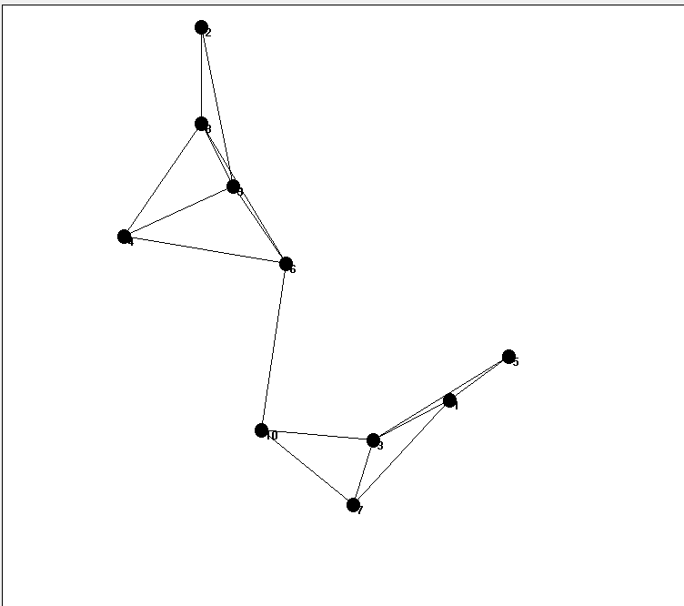 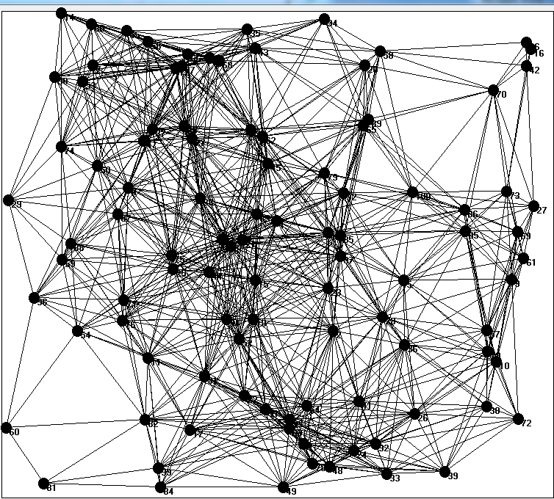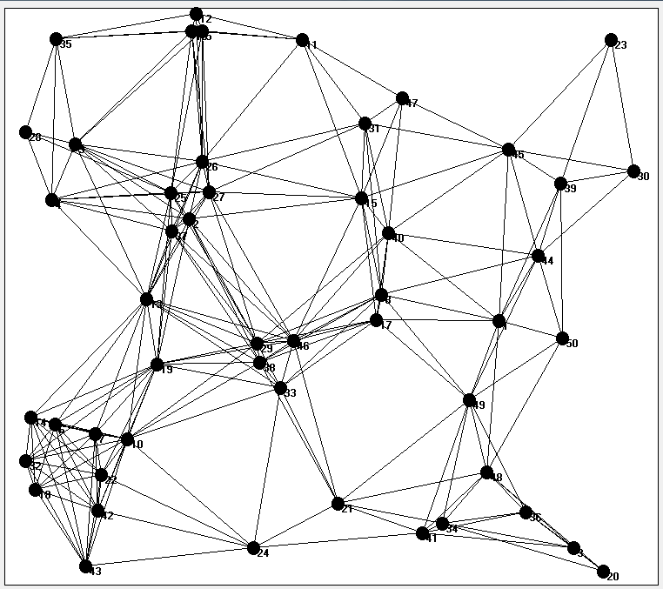 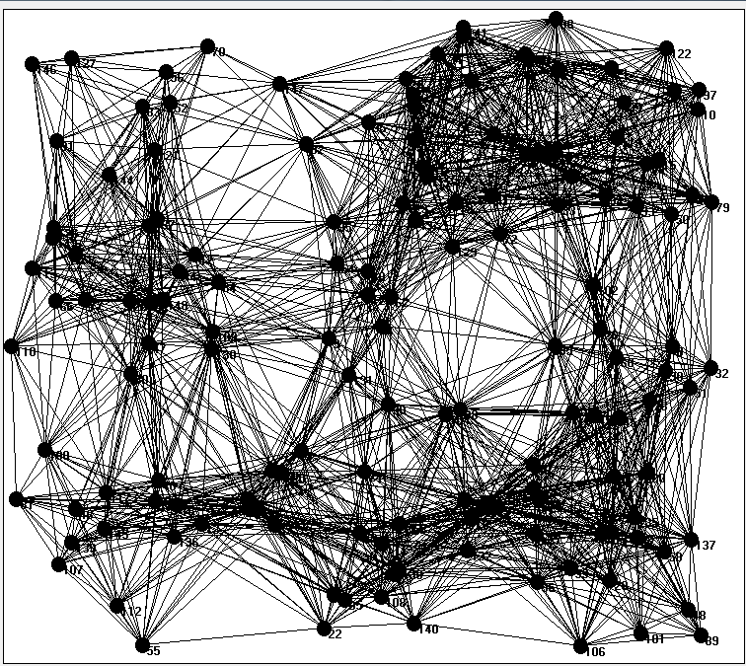

(d) 150nodes (c) 100nodes (b) 50nodes (a) 10nodes

Figure(1) Successful connection paths

**4. Challenges in ad hoc networks**

An ad hoc networks are characterized by less expensive because a set of devices or nodes are used to connect freely without an infrastructure or additional devise network connection devices where the host is no longer a permanent system but can be an intermediate system. This shows the difficulty in managing the ad hoc network nodes and achieving successful communication. Ad hoc networks have shown many challenges and there is a lot of research that dealt with a solution to those challenges, which find some of them in the sources mentioned figures:

**(1) Overlap and congestion**

    represented ad hoc Networks to connected a number of nodes that represent terminals together wirelessly, and the spread of ad hoc network devices that occupy the same frequency spectrum or the formation of temporary loops due to an error in the operation of the operating algorithm and this leads to one of the challenges in Overlap and congestion in the network and thus disrupt the performance of the network.[1]

**(2) change of topology**

Network topology is the architecture through the work to connect the nodes and Network links. Planning network topology and performance analysis are critical challenges for network designers. Coverage in ad hoc networks is a key issue and a measure of quality of service. We may find a change in network topology over time. and the mobile nodes may be go out the range.[12]

**(3) Security**

A major concern is the wireless connection between the nodes and the risk of penetrating important information circulating in an ad hoc network created for special and important purposes. Authentication and encryption of data between sent and receive nodes has been used as well as the use of a firewall to protect ad hoc networks from penetration.[13]

**(4) Energy**

The energy needed to continue processing and communication in the private network is the most important limitation to prolong the life of the network, and the exhaustion of energy leads to the interruption of more private network devices and disconnecting, the technologies for the battery do not develop as in the memory or CPU technology, and since the transmission and reception and re-transmission in Private networks consume energy, it is necessary to search for protocols to reduce energy consumption and search for better energy management techniques.[2]

In this research, the simulation done of a special routing protocol design ad hoc network that results in continuous communication between the nodes of the network using the dormancy principle of the nodes not included in the current network connection to maintain the consumption of addition to test the low-power node and prevent it from connecting and switching to another contract

**5. Energy consumption algorithm**

RREQ (Route Request) messages are broadcast privately to the adjacent nodes and RREQ maintains an ordered list of all the nodes it passes, so each host node gets a RREQ message path until the RREQ message reaches its destination, a RREP (Routing Reply) message, Will be immediately passed to the original where the RREP message can simply reproduce the way you took the RREQ message And the structure is:

<src_addr, src_sequence_ #, broadcast_id, dest_addr, dest_sequence_ #, hop_cnt>

src_addr and broadcast_id definitely identifies a RREQ

 broadcast_id is incremented whenever source node issues a RREQ

  RREQ, RREP is described for the package used in this research, where a new algorithm is applied to focus on energy consumption in the device, and new fields such as "self-IP address", "number of execution times"and" number of hops times" have been added. [7]

AODV discovers the path in the networks allocated by RREQ / RREP. Where each node sends a welcome message and the source node broadcasts the REQest REQ packet to all the nodes of the neighbor, which is one hop TTL = 1,The RREP package returns to the source, where the neighbor node sends a routing path to the target and returns the path, and then each intermediate node between the source and the destination to stores path which created. and may be The failure to detect the path, or wait for the source node for a certain period (3 * TTL * hop count) and then spread the RREQ package with TTL incremented by one, and continue until the target reaches TTL = 0, then the result of the simulation that this This technique is to improve the function of AODV using different numbers of nodes and It is necessary not to re-send the same RREQ packet as the same station, and in this research we also decided to use this function. [5] and The proposal of a new simulation technique "SWANS"

**6. The proposed algorithm**

     We use a number of concepts to reduce battery power consumption in private networks as follows:

**First: SWANS (Stateless Wireless Ad-Hoc Network)**

Is a complete library for simulation in private wireless networks and needs a model for the environment and for the nodes. In SWANS, the Field Entity provides mobility in the node and determines the accuracy required by updating the position of the nodes. The contract consists of a number of entities implementing different protocol layers.

As a special feature, SWANS allows Java network applications to run as part of simulations , The SWANS computes site updates that not only rely on precomputed trace files but usually compute the demand mobility during simulations. SWANS employs a method called binder hierarchical binning to reduce the number of nodes

**Second : Gossip**

In the Gossip protocol, Stochastically determines whether the received RREQ information will be retransmitted. When a path is created over a relatively low battery terminal, the terminal is likely to become out of battery because of the connection being made there. If the connector is not connected during the connection, it is necessary to re-create the path, which means loading the entire system. In addition, it is difficult to build a path unless there are some connection stations on the network, so it is recommended that mobile devices with low battery level do not participate in creating the path as much as possible.

In Gossip-Based Ad Hoc Routing [18] all nodes do not necessarily have to broadcast the RREQ packet even if the RREQ packet from the neighboring node has not been received in the past. In Gossip, whether the story should be told to a third party or not depends on the listener's rule (the receiving station), the device decides to "transmit" or "not transmit" with the probability of p .. This method has a disadvantage in that it reduces the energy consumption of the entire system, Reduces the likelihood of a successful connection. However, when the number of terminals in the area is large, that is, when the terminal density is high, it is an effective way to reduce overall power consumption and increase age while sacrificing the likelihood of a successful communication to some extent.

**Third: Sleep mode that prevents energy consumption**

It is a more expansive concept for Gossip which is completely dormant for a certain period. However, this does not mean that the device is fully extinguished; it is a technology to reduce power consumption by the CPU where it operates at extremely low speeds. It is often used in private networks and sensor networks.

Power is also provided using the GSP protocol [17]. It is similar to the concept of Gossip with a difference in time where each node goes randomly to sleep for some time with the possibility of sleeping P, which when P is as small as possible, the network remains connected and there is no need for a wireless node to maintain Other contract cases.

In ad hoc networks, routing strategy based on gossip routing by proactive guidance is a better way. Flood control can be controlled by adapting the rumor routing technique. Conserves network power and reduces network load [16].

**7. Simulation of the proposed algorithm**

Simulations are used in the evaluation of private network protocols because they easily allow for a large number of nodes and required and repeatable environmental conditions.

For simulations, a two-dimensional format was drawn from 9000 × 10,000 pixels. The simulation was applied to a number of terminals from 10 to 150 nodes and randomly distributed by coordinates (x, y). Each node was given an IP address, See figure(2)

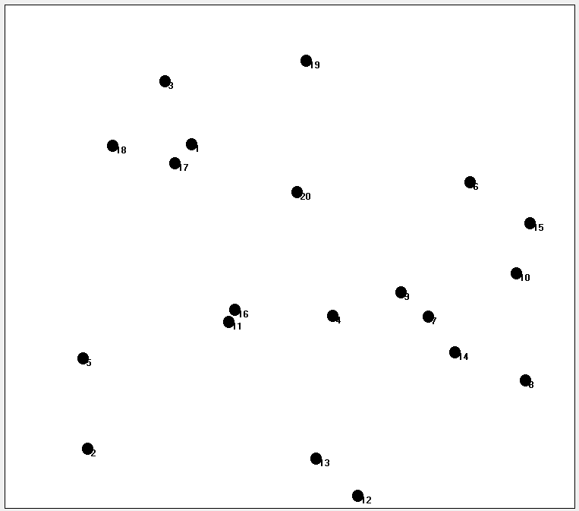 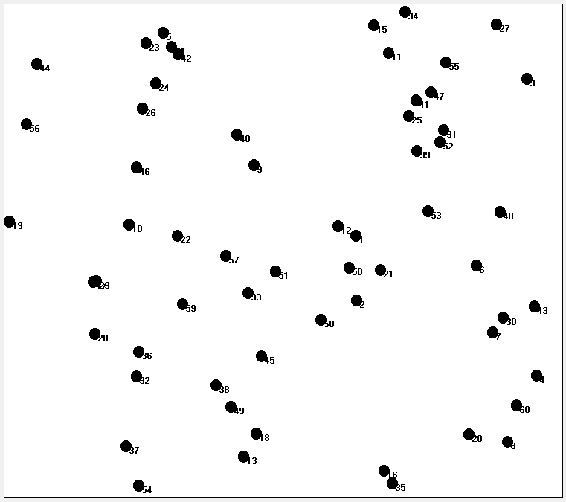 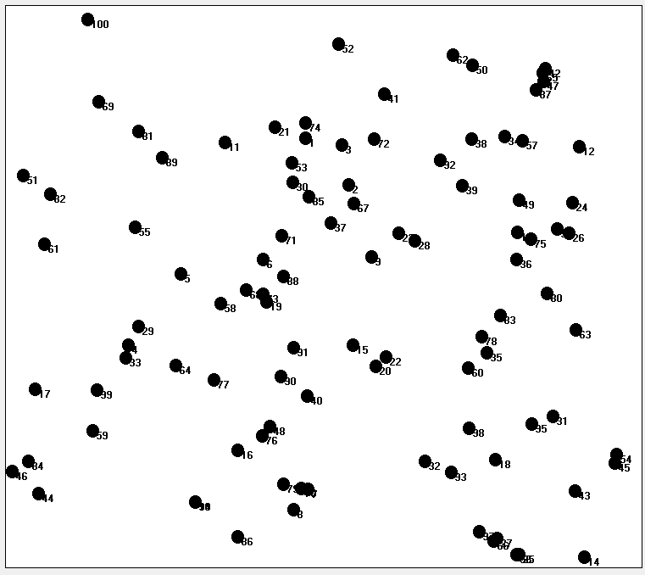 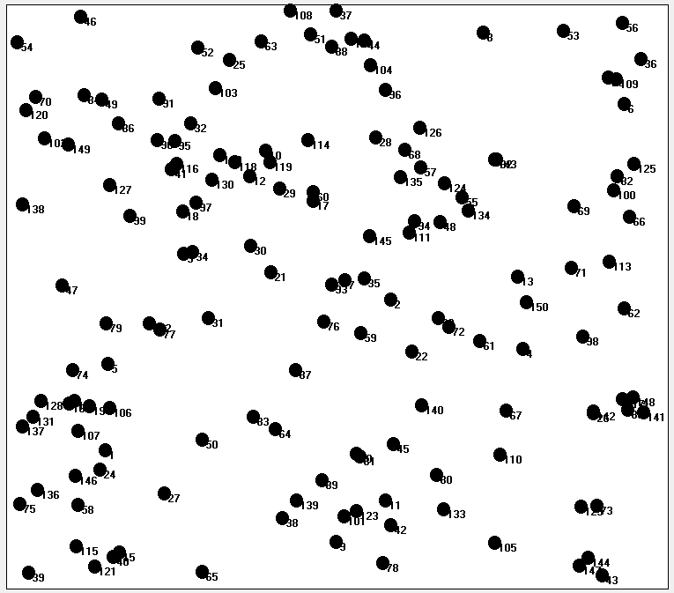

(d) 150nodes (c) 100nodes (b) 60 nodes (a) 20nodes

Figure(2) Successful connection paths

The implementation was random between the nodes ,then the sent station and destination was arbitrarily selected and the path between the nodes was calculated according to distance law as follow l:

1) After the initial execution , the full connected in the network may be not done , so the nodes become red in color which is in the connection range , the black-colored nodes are out of range, as in Figure (3):

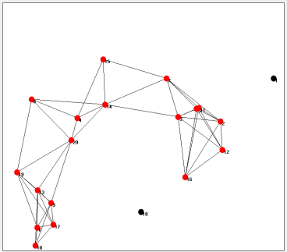 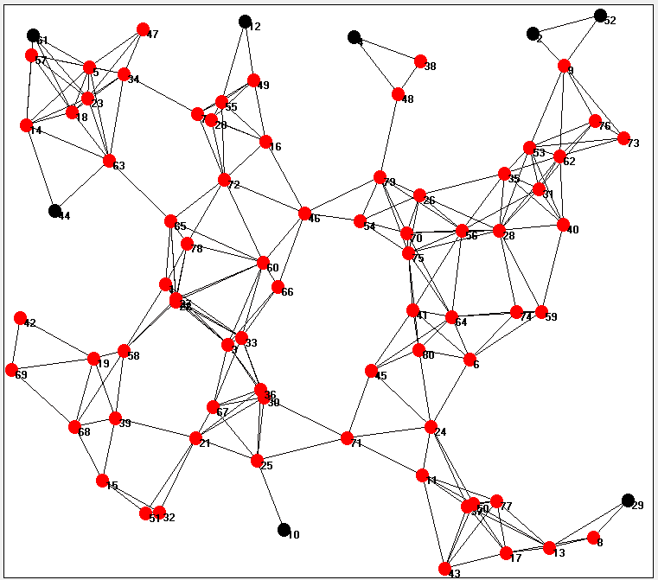

(b) 80 nodes (a) 20 nodes

Figure (3) After the initial execution

2) On the other hand, the amount of energy is setting first for each node randomly, and after each send that the node Shared charge the power ratio is reduced in a certain way. As a result, the station with relatively high residual battery power is involved in road construction, and vice versa.

Transport energy derived from the theoretical formula was used. In this case, the power loss number must be given for propagation loss, but it is usually set to 2 to 3, and this time uses 2.5. We also considered the efficiency of the transmitter this time ν = 20%.

The following shows the amount of energy needed for a single message when the distance in the connection range is l (n).

$$Plc_t= \frac{\left(\frac{C}{N}\right).{(\frac{4πl}{λ})}^{2.5}.kTB}{Gtx.Grx.ν}$$

The power (Plc_r) was adjusted at the reception time uniformly at 10 MW (constant) this time. This is because it needs a certain amount of power for routing tables, And writing Stores Interim , etc., although the power at the time of receiving the wireless signal is negligible. In both cases, the transmission capacity is smaller enough.

  It is possible to avoid a station with a low battery level, so that the entire system life can be extended. See figure (4) where the contract is green color with high battery power while the red color contract has a low battery level and does not share the transmitter.

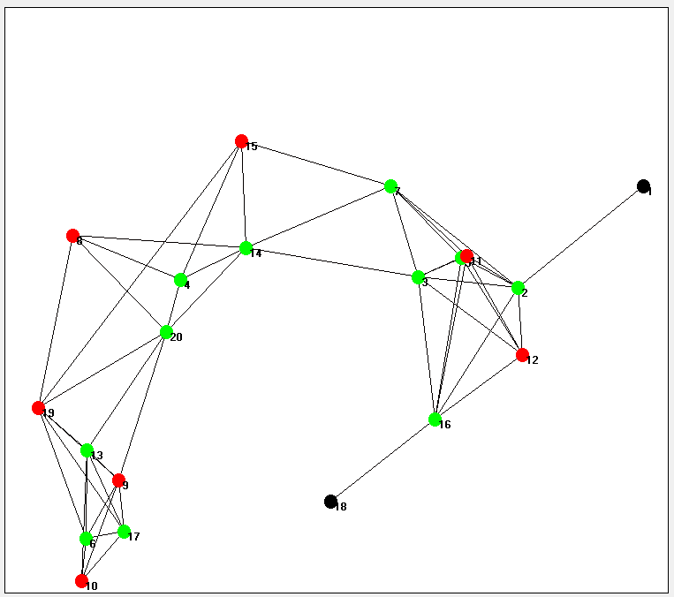 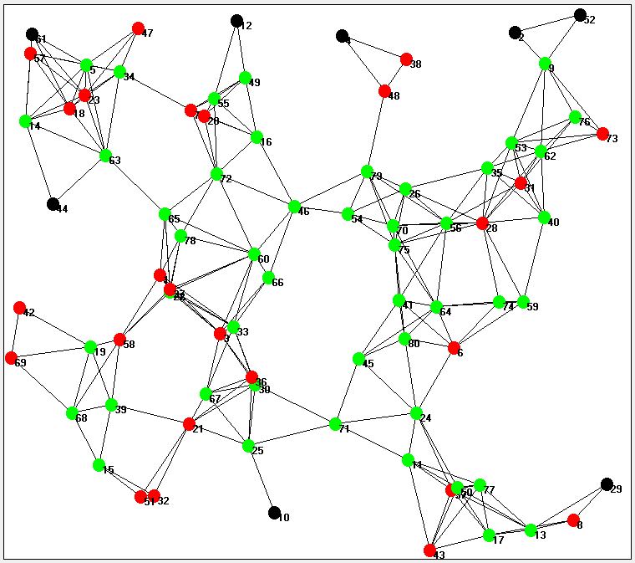

(b) 80 nodes (a) 20 nodes

Figure (4) Avoid low-battery nodes

After that, the remaining battery level will be described for each station. Batteries vary in a variety of applications from high to low power depending on the application.

3) The number of jumps per node is compared to choose the best track

4) The sleep approach is improved when the station broadcasts the RREQ packet, it always receives the next RREQ from the terminal next door. For this reason, energy is needed to process the information possessed by the received packet. To avoid this, consider introducing a temporary hibernation after sending its RREQ packet. It is possible to prevent reception of the RREQ packet that will be received back from the adjacent terminal, and the power consumption can be reduced at reception time. See figure (5) where the nodes are blue and the remaining green nodes are temporarily dormant.

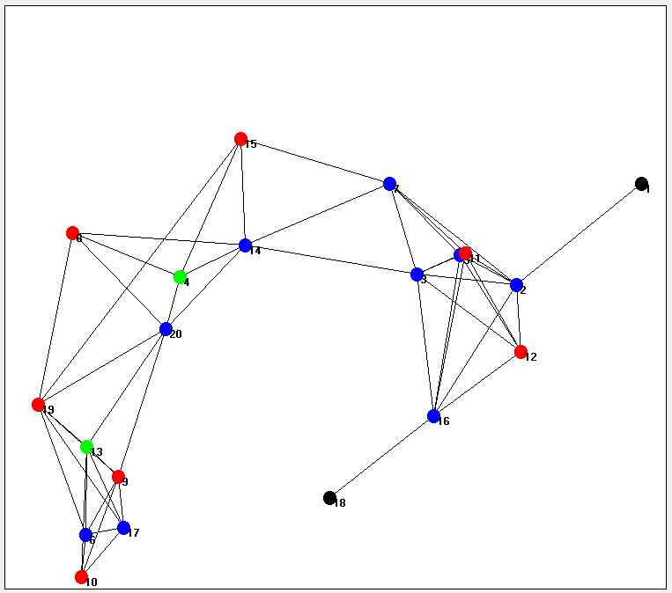 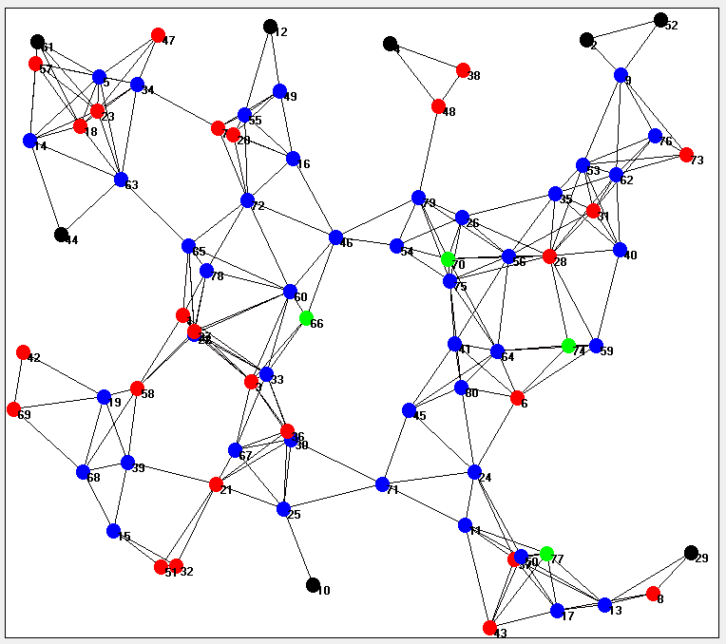

(b) 80 nodes (a) 20 nodes

Figure (5) Avoid low-battery nodes

The above forms may appear different when executed for different preparation of the contract and also vary in execution for the same number of nodes above according to the random distribution of the contract and the number of times of execution and according to the paths between the nodes and the number of jumps per node. This is represented by the nature of ad hoc networks**.**

**8. Simulation results**

Figures (6) show comparison of the connection success probability and the power consumption required for route construction when the transmission range is changed from 100 pixel to 400 pixel. As for the connection success probability, the change in the success probability with respect to the number of terminals becomes gentle with the increase of the transmission range, but when the transmission range is narrow, the existence of one terminal holds the success or failure of the communication, It is thought that it changes abruptly with respect to the number of terminals. In both cases, the proposed method shows the probability of connection success which is almost equal to that in the case of conventional AODV without considering power consumption, and a large shadow in the establishment of communication.

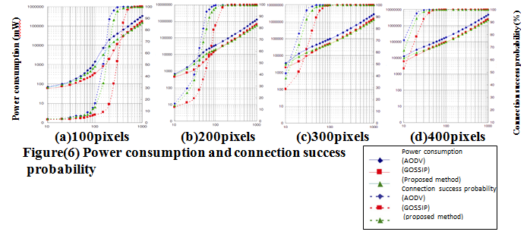

As for the power consumption, it is understood that when the number of terminals is high, the connection success probability is high, it is suppressed to about 60% of the power of Gossip, but when the number of terminals is small and the connection success probability is low.

The same electric power as the conventional AODV case is required.

This is also the case with Gossip, as the route construction becomes more difficult, the RREQ is flooded all over.

Taking the case of a transmission range of 200 pixels as an example, when the number of terminals with high connection success probability, the power consumption of the entire system is reduced to about the same as Gossip, that is, reduced to about 60%.

**References**:

[1] Alhamali Masoud Alfrgani .Ali, Raghav Yadav**,** Hari Mohan Singh,2014,

"Congestion Control Technique for Wireless Networks ", *India.*

[2] A. Modupea , Oludayo. O. Olugbarab , Abiodun , 2013,"Minimizing Energy Consumption in Wireless Ad hoc Networks with Meta heuristics Ibukunola", Tshwane University of Technology, South Africa.

[3] B. Błaszczyszyn (INRIA/ENS Paris, France) based on joint works with F. Baccelli, O. Mirsadeghi and P. Muhlethaler , "Stochastic geometry and wireless ad-hoc networks from the coverage probability to the asymptotic end-to-end delay on long routes" Spatial Network Models for Wireless Communications Isaac Newton Institute, Cambridge, 2010

[4] C. Bettstetter, “On the Connectivity of Wireless Multihop Networks with Homogeneous and Inhomogeneous Range Assignment”, Munich, Germany

Email: <name>@ei.tum.de, Web: http://www.lkn.ei.tum.de, 2002.

[5]Clifton Lin, “AODV Routing Implementation for Scalable Wireless Ad-Hoc Network Simulation (SWANS)”, [cal36@cornell.edu](mailto:cal36@cornell.edu), 2004.

[6] Dmitri A. Moltchanov, 2009 , "Routing Protocols for Ad-Hoc Networks" , http://www.cs.tut.fi/kurssit/TLT-2756.

[7] Giorgos Papadakis & Manolis Surligas, 2011,"Routing Protocols for Ad-Hoc Networks",ppt.

[8] Hemanth Narra, Yufei Cheng, Egemen K. Çetinkaya, Justin P. Rohrer and James P.G. Sterbenz," Destination-Sequenced Distance Vector (DSDV) Routing Protocol Implementation in ns-3",2011, "Information and Telecommunication Technology Center Department of Electrical Engineering and Computer Science", The University of Kansas, Lawrence, http://www.ittc.ku.edu/resilinets

[9] Ian D. Chakere & Elizabeth M. Belding-Royer,2004,"AODV Routing Protocol Implementation Design", University of California, Santa Barbara

# [10] KAPANG LEGO, PRANAV KUMAR SINGH , 3DIPANKAR SUTRADHAR,2010 ," Comparative Study of Adhoc Routing Protocol AODV, DSR and DSDV in Mobile Adhoc NETwork ", India

[11] Krishna Gorantala , Routing Protocols in Mobile Ad-hoc Networks ,2006, Ume˚a University, Department of Computing Science

[12] Maciej Piechowiak and Sebastian Pucek ,"Topology Properties of Ad-Hoc Networks",2013 ,Kazimierz Wielki University, Poland

[13]Ms. Monika G. Ghorale,2015," Wireless Ad-Hoc Networks: Types, Applications, Security Goals".

[14] M.Tarique, K. E. Tepe, and M. Naserian, “Energy Saving Dynamic Source Routinf for Ad Hoc Wireless Networks,”Symposium on Modeling and Optimization in Mobile, Ad Hoc and Wireless Networks, WIOPT 2005, April 2005.

[15] P.Jacquet ,P. Muhlethaler, T. Clausen, A.Laouiti , A.Qayyum , L.Viennot,2003," Optimized Link State Routing Protocol", France

[16] Toqeer Mahmood , Dr. Tabassam Nawaz , Rehan Ashraf and Syed M. Adnan Shah ,2012,"Gossip Based Routing Protocol Design for Ad Hoc Networks" , Taxila , IJCSI International Journal of Computer Science Issues,

[17] X. Hou and D. Tipper, 2004, “Gossip-based Sleep (GSP) for Energy Efficient Routing in Wireless Ad Hoc Networks”, Department of Information Science & Telecommunications University of Pittsburgh, {xiaobing, dtipper}@mail.sis.pitt.edu

[18] Z. J. Haas, J. Y. Halpern, and Li Li, “Gossip-Based Ad Hoc Routing”, IEEE/ACM TRANSACTIONS ON NETWORKING, VOL. 14, NO. 3, JUNE 2006

**محاكاة الشبكة اللاسلكية الخاصة للبحث عن بروتوكول توجيه بأقل استهلاك للطاقة**

**ملخص**

اخذت شبكات الـad hoc بالانتشار بشكل واضح في كثير من التطبيقات لطبيعتها المستقلة واللامركزية في ادارة الشبكة وتأمين عملية الاتصال بين مختلف العقد او الاجهزة المتنقلة حيث لم يعد المضيف نظامًا نهائيًا بل يمكن أيضًا يكون نظام وسيط يعمل فضلا عن امكانية الحصول على العديد من الخدمات من خلال الاتصال بشبكة الانترنت ، والتي اصبح لا غنى عنها في حياتنا اليومية ، وان من اولويات استمرار الاتصال هو توفير الطاقة الكهربائية ، فكان من الضروري ايجاد حل لهذه المشكلة بتصميم بروتوكول توجيه لبناء شبكة لاسلكية خاصة مع انخفاض استهلاك الطاقة للبطاريات ، والذي حقق انخفاضًا في استهلاك الطاقة بنسبة 60٪ مقارنة بالبروتوكول التقليدي.