Middle East Comprehensive Journal
For Education And Science Publications ( MECSJ )

Papers In ISSUE ( 1 )

Table of Content

Title of Paper | Page Number
An overview of the visualization feature in open source data mining tools | 3
Virtual Private Network | 39
Rehabilitation of existing buildings and structures to resist seismic acts | 50
The Effect of Accounting Conservatism and its Impacts on the fair Value of the Corporation | 61
The relationship between domestic violence towards children and psychological loneliness | 78

An overview of the visualization features in open source data mining tools

Sawsan Alodibat
Jordan University for Science and Technology
Irbid, Jordan
smalodibat15@cit.just.edu.jo

Abstract
Typically, data mining tends to predict future patterns and behaviors considering current repositories and warehouses of data [1]. The adoption of open source software provides more independence to the researchers and developers contrasted to the closed source licenses that limit rights [8]. In this research, the authors are going to explore and compare five tools amongst WEKA, Orange, RapidMiner, Tanagra, and KNIME. The main purpose is to distinguish the chief differences between open source software tools and formerly to classify them into different levels of visualization functions: high support, middle support, and low support. At last, the final assumption revealed that the best software amongst the investigated tools in terms of visualization features is RapidMiner.
Keywords—data mining, open source, data mining tool, data visualization.

Introduction
Typically, data mining tends to predict future patterns and behaviors considering current repositories and warehouses of data [10]. The main use of data mining tools enables decision makers to take knowledge driven from historical databases and formulate it into decisions [13]. Many data mining algorithms and techniques have been developed and integrated into data mining tools for a purpose of extracting information, evaluating their efficiency and accuracy, and using it for prediction [14].
The main advantage of open source software is the possibility of free copying, using, running, distributing, modifying, and improving. Thus, the adoption of open source software provides more independence to the researchers and developers contrasted to the closed source licenses that limit rights [15]. On the other hand, the license and constraints of open source software should be understood by the developer to save his/her right associated with the modification on software [17]. Commonly, the open sources licenses are: GNU, GPL, BSD, LGPL, MPL, and NPL [5].
Data visualization refers to the use of representation tools to show a dataset through figures, charts, diagrams, charts, etc. Different data mining tools accomplish data visualization to show the results into visualized charts.
This research is focused on discussing the presence of the mutual visualization techniques in different open source data mining tools. Particularly, different visualization techniques will be applied in these tools to extract information from a dataset through classification techniques, showing the supported techniques in every tool. The primary source of data of this research will be the documentation, tutorials, and user manuals provided by the developers of tools. The secondary source of data will be the actual traversing through each mentioned tool and practicing each supported visualization technique, and hence showing it into charts.
This line of research falls under comparison studies; it creates a discussion of some visualization techniques (supported by open source data mining tools) in order to present an analytical approach given the main specifications and determinations. The authors do not have an intention to compare the advantages or disadvantages of open source data mining tools, but rather the goal is to establish a comparison between the supported visualization techniques in each tool. Lastly but not last, this research will emphasize the presence and absence of common visualization techniques, revealing the survival and the lack of the advanced visualization functionalities for these tools.

related work
In this section, a set of similar works are introduced to review other ultimate remarks of other works and to discriminate this research. The period of the works summarized here ranges from 2009 to 2016.
In the paper of [4], an overview of different open source data mining tools along with their features including RapidMiner, KNIME, and WEKA. Thus, a comparison among these tools is involved in terms of their advantages and disadvantages to provide interested researchers an assistance in selecting the best tool. One revealing point attained by the paper is the efficiency of RapidMiner compared to other two tools, guiding researchers to choose the most relevant data mining tool to any specific area.
The authors in [5] surveyed different open source data mining systems free to download over internet. The study included a comparison of twelve open source systems in terms of general specifications, data mining functions, usability, and data source formats. Thus, the advantages and disadvantages were discussed.

The authors of [6] presented a comparative study of open source data mining software from professionality perspective. They also discussed the real-time challenges associated with available data mining tools and the factors affecting the choice of appropriate software. The paper showed the how the pre-processing tasks can improve the performance of open source data mining tool when it integrated with agent based framework. The results of the work have clarified the functional specifications of open source data mining tools that enable the developers to improve data management through accurate analysis and evaluation.
In [11], the author introduced an implementation of Tanagra and Weka data mining tools in a healthcare dataset in order to determine the most imperative variables that define the diabetes impact on patients using Kidney Function Tests (KFT). The application of C4.5 algorithm was based on decision trees to compare the results of the two selected data mining tools. The author concluded that Tanagra is less error prone and more efficient against classification performance compared to Weka, whereas Weka has best performance when using the mode of use training set.
An expert paper presented in [12] that describes the main characteristics of some open source data mining tools mostly used by community, mainly Weka, RapidMiner, Orange, R, scikit-learn, and KNIME. The paper provides researchers general characteristics of most common open source data mining tools and the corresponding advantages and disadvantages, considering most functions of data mining (clustering, regression, association, classification, visualization, etc.). Therefore, more advanced data mining research areas are also involved such as text mining and big data. At result, the paper exposed that no single open source data mining tool at the top, but rather every tool has cons and pros.
The main purpose of [16] was to describe the open source data mining software that have received much interest in many useful works, considering the advantages and disadvantages of these software. Thus, a list of most relevant web addresses, textbooks, and several manuals was included to help researchers how to find, use and cite related references. The work revealed that the researcher should review the manual of an open source data mining tool to decide which good software relevant to students for educational purpose.
A review of classification algorithms applied on different open source data mining tools is presented in [18]. Weka, RapidMiner, Tanagra, Orange, and KNIME were conducted to elaborate the correlation between them in terms of the accuracy of classification algorithms such as decision tree, naive Bayes, decision stump, and k-nearest neighbour. A dataset named Indian Liver Patient (ILP) was tested with classification algorithm using some open source data mining software to carry out the accuracies generated by each tool and then evaluate their performance.
A comprehensive analysis of some open source data mining tools is provided in [19] from theoretical viewpoint. For each selected tool, several aspects and details such as general characteristics, technical specifications, area of specialization, applications and features were involved. The work helps researchers to gain an insight of the future development of data mining tools through extending more functions to cover more fields efficiently. The result can be an efficient data mining product although of the increasing complexity of the development procedures and mechanisms.
The authors of [23] conducted a comparative study for four open source data mining tools to reveal the tool suitable to apply classification function to support decision making process. The type of dataset affects the performance of classification task carried out by each investigated tool. For this reason, six classification algorithms (decision tree, naïve Bayes, k-nearest neighbour, support vector machine, zero rule, and one rule) were tested on nine different datasets to judge the best tool. The authors revealed that the results of classification task changes with the way of implementation and the dataset conducted, therapy no single tool is best.
The work in [25] explored and overviewed the most commonly used open source data mining tools with respect to the state of the art and knowledge discovery. The work implies that academics, practitioners, and data scientists should select the apt open source data mining tool suitable to the requirements of the specified area and field. A detailed information was presented to describe each investigated open source data mining tool including the history, development, and the capabilities. The available characteristics of the open source data mining tools were organized into a matrix to show their descriptions in detail.
The aim of [26] was to build a predictive model for the probability of default through applying six data mining functions. In the paper, an experiment was conducted to overcome the shortcoming in the accuracy of the predicted default probability based on binary classification by proposing more valuable classification technique based on neural network called “sorting smoothing method”. The proposed technique is based on two variables, X and Y, where X is the independent variable, Y is the response variable, and the simple linear regression is shown as Y = A + B X.
An overview of different approaches in data mining evolution and development is presented in [27], focusing on the user interface aspect. Therefore, a comparison between open source data mining tools was presented in terms of the degree of relevance to biomedical datasets. To achieve the goal, several representations were applied on open source data mining software to show their similarities and dissimilarities in terms of the availability of representative model. At result, many of open source data mining software have been used in multiple studies with the increasing interest in data science and knowledge discovery.

Discussion of related work
The works [4] [11] [12] and [18] have discussed the common characteristics of open source data mining tools mainly Weka, Tanagra, and KNIME. [11] applied the C4.5 algorithm (classification) to analyze the results of decision trees compared to other software. [12] considered the most functions of data mining such as clustering, regression, association, classification, and visualization. [18] discussed the accuracy of classification algorithms: decision tree, naive Bayes, decision stump, and k-nearest neighbor.
Moreover, [23] applied classification algorithms: decision tree, naïve Bayes, k-nearest neighbor, support vector machine, zero rule, and one rule. [5] introduced a comparison of twelve open source systems in terms of general specifications, data mining functions, usability, and data source formats. [6] showed how the pre-processing tasks can improve the performance of open source data mining tool when it integrated with agent based framework. [27] established the degree of relevance of different data mining software to biomedical datasets, while [25] assisted researchers in selecting the open source data mining tool suitable to the requirements belonging to the specified area or field.

review of data mining tools
Several open source data mining tools are listed below as follows: WEKA, Orange, RapidMiner, Tanagra, and KNIME. These tools have general characteristics and descriptions that make them at the top of the most popular and largest packages. For this reason, the selection of these tools leads to choose this small sample of open source data mining tools in addition to the space limitations.
For more information, the readers could be directed to the wide spread website of the most common data mining tools called KDnuggets (http://www.kdnuggets.com/). Therefore, the dataset tested in the experiment of this research is taken from UCI Machine Learning Repository of datasets, namely default of credit card clients. In the next subsection, a list of detailed discussion of the five open source data mining tools is shown providing the direct link for downloading.

WEKA (http://www.cs.waikato.ac.nz/ml/weka/)
WEKA, a short of Waikato Environment for Knowledge Analysis, was developed at University of Waikato in New Zealand [3]. It is a suitable software for general data mining tasks and machine learning algorithms, and well-matched to develop new machine learning algorithms [4]. WEKA was released for free under the General Public License (GNU). Primarily, the first origin of WEKA was non-Java version developed for analysing agricultural data [25]. It has an active community since it is widely used software in academic and business [20]. WEKA is a java based software involves a set of machine learning packages. Therefore, WEKA provides developers with API and add-in packages. Consequently, WEKA is built into java language and this provides the support of .jar files that permit custom programming more than inside WEKA environment [25].

Orange (http://www.ailab.si/orange)
Orange is a python-based software suite for data mining and machine learning, developed under General Public License (GNU) in 2009 [19]. It is a powerful open source data mining tool for beginners and professionals [7]. Hence, it is a python scripting and visual programming tool that supports add-ons for text mining, bioinformatics and machine learning components [18]. Orange is a full package of data analytics, scripting environment, and visualization features. The scripts can be written as an extension of C++ and python. However, it does not support big data processing [25].

RapidMiner(https://my.rapidminer.com/nexus/account/index.html#downloads): formerlyknown YALE
RapidMiner, previously known as Yet Another Learning Environment (YALE), is a data mining software was developed by Ralf Klinkenberg, Ingo Mierswa, and Simon fischer at the technical University of Dortmund. In 2001, the first original version was known YALE [9]. In 2007, the company RapidMiner in Germany developed it and changed its name to RapidMiner under AGPL open source license [4]. RapidMiner supports all steps of data mining, which make it applicable for research, training, education, application development, rapid prototyping, and industrial and business applications [19]. RapidMiner is more than a powerful data mining software; it provides the ability to integrate its learning models, algorithms, and schemes with R and WEKA scripts [18]. There is also a licensed software product of RapidMiner in addition to the open source community version. It provides data transformation, modelling, import and export data, connecting repository, and evaluating results [25].

Tanagra (http://eric.univ-lyon2.fr/~ricco/tanagra/en/contenu_telechargement_logiciel_tanagra.html)
Tanagra is the successor of the SPINA software, which is a classification program including interactive and visualization techniques with several supervised learning algorithms, and it is full featured software of several algorithms implementations [25]. Tanagra was developed in 2004 in France. The main purpose of the development of Tanagra was for research and teaching. It is an open source developed in Delphi. Conversely, it also used for profit activities and commercial use according to the license agreement. Additionally, Tanagra does not support big data processing [25]. Multiple data mining algorithms are supported by Tanagra including data analysis, statistical learning, database area, and machine leaning [18].

KNIME (https://www.knime.org/downloads/overview)
KNIME, a short of Konstant Information Miner, was primarily developed in 2004 (formally released in 2006 under GNU General Public License) by software engineer team at University of Konstanz in Germany for pharmaceutical research purpose [4]. Later, it has been used in other areas such as business intelligence, customer relationship management, financial data analysis and customer data analysis. KNIME provides an integration of data manipulation, reporting and integration platform, data mining algorithms, and visualization models and methods [19]. It was developed through open API modular of the Eclipse platform that enables developers to extend its functionalities. It also has commercial licence extensions for open source software that can be downloaded [25]. Multiple versions of KNIME were emerged capable with different free and open functionalities. KNIME big data extension can be purchased that support big data processing, which is not supported by open source [18].

a comparison of general characteristics
The differences between open source data mining tools have to be determined through analysing their parameters such as product track record, compatibility with different environments, vendor viability, scope of data mining algorithms, usability, and import and export data files. Therefore, general characteristics of open source data mining tools should be recognized such as license, programming language, data source, and operating system. Thus, the supporting of various data formats like Excel, SQL, Access, ARFF, .CSV, ODBC, and MySQL is also very essential to choose a proper data mining software. Moreover, another significant feature of open source data mining tools is the functionality aspect, which is dedicated to data mining problems and solutions.
Further, describing the usability aspect shows how an open source data mining tool support human interaction, extensibility, and interoperability, and whether the user can easily use it in solving real world problems. Additionally, Graphical User Interface (GUI) describes how an open source data mining tool is easy to use, user-friendly, and have meaningful labels to handle users’ actions. In the following subsection, a discussion of the five open source data mining tools is presented considering their specifications.

WEKA
WEKA is free, extensible java-based open source software that offers various valuable features and can run in different platforms. WEKA provides an access to SQL databases, and provides the user two options of usability: command line and interface [20]. One of the main limitations is the data format constraints that do not accept any format of data [4]. The first version of WEKA was released in 1997, and the current version is WEKA 3.6.11. WEKA is independent to the platform. It supports a wide range of data mining algorithms such as pre-processing, clustering, classification, and associations [21]. Three graphical user interfaces are supported by WEKA: explorer, experimenter, and knowledge flow. Therefore, it supports a simple command line [19]. The main areas supported by WEKA are: association rules. WEKA can import data with binary, ARFF, C4.5, and CSV file formats. WEKA cannot be connected to non-java based databases and excel, whereas it can be integrated to other java packages [19].

Orange
Orange is an open source data mining software that supports graphical user interface. The framework of Orange is cross-platform, meaning that it can run on different platforms [7]. The current version of Orange software is 2.7. It is compatible with C, C++, and python languages [19]. The most common data mining and machine learning features are supported by Orange including pre-processing, feature filtering, data modelling, exploration methods, and model evaluation [18]. Orange is easy to use for beginners and professionals, and it contains add-ons for machine learning algorithms. Orange is also specialized for data visualization. On the other hand, Orange has limited capabilities of machine learning algorithms, data models representation and reporting functionalities [7]. Major standard file types such as excel and CSV files are supported by Orange since it can read filed in native tab delimited format. Orange involves data widgets that enable users to manipulate data through different processes including discretization and concatenation [18]. Orange support major classification techniques such as decision trees, K-nearest neighbour, C4.5, Naïve Bayes, support vector machine, and CART. Therefore, orange provides regression trees, linear regression, and logistic regression [25].

RapidMiner
RapidMiner is compatible with different data files such as excel, SPSS, MySQL, SQL server, Oracle, etc. it has an independent, cross-platform, and language independent [4]. The first version of RapidMiner was released in 2006, whereas the current version is RapidMiner 7.2. RapidMiner supports about 22 data input and output file formats [19]. RapidMiner is specialized for business solutions including pre-processing, predictive analysis, statistical computing, predictive analysis, and visualization [9]. RapidMiner is one of the top data mining tools [25].

Tanagra
Tanagra or Tanagra Komercinis pasilymas is a simple, easy to understand and use. It is free open source machine learning software that can be used for research due to its simple user interface. The current version of Tanagra software is 1.4.50, while the most common used versions of Tanagra re 1.4 and 2.0 [11]. Three windows are provided by Tanagra including data mining components, diagram, and outputs. Drag and drop feature makes it usable. Advanced improvements have been presented to Tanagra including hierarchical agglomerative clustering and computing time [18].

KNIME
KNIME is compatible with WEKA, and it contains an embedded use of R through statistical methods [2]. The first version of KNIME has been released in 2004 and the current version is KNIME 2.9. It is compatible with windows, OS X, and Linux. KNIME is a java-based software that enables users to visualize data flows, pipelines, and data models [18]. KNIME provides pre-processing and cleaning, analysis, data mining, and modelling [19]. In addition, it was dedicated for chemical structures, business intelligence, enterprise reporting, and data mining. It can integrate different data sources and databases including CSV, ARFF, SDF, XML, etc. KNIME is written in Java and can be extended to add functionalities and plugins on the go [25]. Advanced functionalities involve univariate statistics, multivariate statistics, time series analysis, data mining, web analytics, image processing, text mining, social media analysis, and network analysis [18].
Table 1 shows the summary the general specifications of the five open source data mining tools. The characteristics can be divided into: Developer, Release Date, Programming language, License, Current version, GUI /command line, Main purpose, Areas, Portability, Usability, Compatibility with database, Operating system Platform, and Visualization.

A comparison of visualization techniques
In this section, a comparison study amongst different data visualization techniques involved in open source data mining tools is introduced. Some of data visualization techniques such as histograms, boxplot, scatter plot, parallel coordinates, etc. are investigated and compared between the five open source data mining tools, WEKA, Orange, RapidMiner, Tanagra, and KNIME. In the following subsection, a description of the dataset selected from UCI website is presented to show dataset schema.

Dataset Description
The dataset downloaded from the UCI repository is named “default of credit card clients”. It purposed at the case of customers’ default payments in Taiwan in order to compare different data mining methods such as classification. The goal of using this dataset in this research is to compare the visualization functionalities among five data mining tools [26]. The dataset consists of 30000 instances and 24 attributes, including the class attribute. Table (2) summarizes the information of this dataset.
Table 1: Dataset description
Data Set Characteristics | Multivariate | Number of Attributes | 24
Number of Instances | 30000 | Date Donated | 2016-01-26
Area | Business | Associated Tasks | Classification
Attribute Characteristics | Integer, Real | Missing Values | N/A

Attributes Information
The first attribute is the class variable named default payment, which is a binary variable (yes=1, no=0). The other 23 attributes are as following: 1) X1: the individual consumer credit and family credit (amount of the given credit). 2) X2: gender (1=male, 2=female). 3) X3: education (1=graduate, 2=university, 3=high school, 4=others). 4) X4: marital status: (1=married, 2=single, 3=others). X5: Age in years. X6-X11: history of past monthly payments (from April to September, 2005) on am measurement scale for the repayment status: -1=pay duly, 1=delayed payment for 1 month, 2=delayed payment for 2 months, and so on. X12-X17: amount of bill statement (from September to April, 2005). X18-X23: amount of previous payment (from September to April, 2005).
Table 2: General information of data mining tools
Criteria | Weka | Orange | RapidMiner | Tanagra | KNIME
Developer | University of Waikato | University of Ljubljana | University of Dortmund | Developed in France | University of Konstanz
Release Date | 1997 | 2009 | 2006 | 2004 | 2006
Programming language | Java | C++ & Python | Java | Java | Java
License | GNU | GNU | AGPL | SDL | GNU
Current version | Weka 3.6.11 | Orange 2.7 | RapidMiner 7.2 | 1.4.50 | KNIME 2.9
GUI/CL | Both | GUI | Both | GUI | GUI
Main purpose | Academic & business | Business solutions | Business and industrial | Academic & research | Pharmaceutical research
Portability | Can be Integrated into other java packages | Interface with other java packages | Flexible input and output file formats | Limited portability | Easy integration of new algorithms
Usability | Easy to use | User-friendly interface | Usable for beginner and experts | Easy drag and drop | Usable, learnable, and interactive
Compatibility  with database | ARFF,CSV, C4.5 | CSV and Excel | Most file format types | CSV, excel, and ARFF | Most file format types
Operating system Platform  Supporting | Independent | Cross the platform | Independent | Cross platform | Independent

This dataset aimed to compare the predictive accuracy of probability of default among six data mining methods at the case of customers; default payments in Taiwan. The estimated probability is predicted to be more useful than simple classification result (credible or no credible) from the risk management perspective. The real portability of default is unknown so the real portability of default needs novel sorting and smoothing method for estimation. The predictive portability of default is X (independent variable), while the real portability of default is Y (response variable). The forecasting model produced by artificial neural network shows a simple linear regression result (Y=A+BX), which has the highest coefficient determination. Based on the results of six data mining methods, the only one algorithm that can accurately estimate the real probability of default is artificial neural network [26].
Data visualization refers to the use of representation tools to show a dataset through figures, charts, diagrams, charts, etc. Different data mining tools accomplish data visualization to show the results into visualized charts [22]. In the next subsection, a comparison between five open source data mining tools is shown in terms of data visualization techniques. Again, the goal is to show the presence of several data visualization techniques in each tool.

WEKA
WEKA contains a set of data analytics, predictive modelling, and visualization tools composed with an easy to use graphical user interface [19]. It provides many visualization techniques such as 1D single attribute, scatterplot 2D, scatterplot 3D, rotate 3D visualization, ROC curves, tree visualizer (decision tree), graph visualizer (Bayesian networks), boundary visualizer, and allows plugins. The graphs can be visualized into different formats: XML, DOT, and BIF [21]. Therefore, visualization of errors, visualization of attributes, and visualization into x and y representation are displayed in Appendix: Figure 1, Figure 2, and Figure 4 respectively.
However, data visualization in WEKA is somewhat limited. Thus, it is not good in interfacing with other software [4]. Moreover, sequence modelling (more powerful technique) is not supported by the WEKA data mining algorithms [3].

Orange
Orange is a featured data analysis, visual programming frontend, and data visualization tool [19]. Orange provides visualization widgets to perform several graphing techniques such as linear projection, bar graphs, and plotting. Other widgets include standard evaluation including confusion matrices and ROC curves. Orange environment includes data, visualize, classify, regression, evaluate, associate, and unsupervised widgets [7]. In addition, association rule mining also includes widgets and unsupervised learning capabilities such as principle component analysis and k-means clustering [25].
Orange contains an array of widgets to support many data visualization techniques. Therefore, workflow creation is supported by Orange through a linkage between different widgets and block [18]. It also supports the following data visualization techniques: scatter plot, box plot (see appendix Figure 4), distributions (see appendix Figure 5), trees, heatmaps (see appendix Figure 6), linear projection (see appendix Figure 7), mosaic display (see appendix Figure 8), bar charts, networks, Pythagorean forest, Pythagorean tree, dendrograms, scatter map (see appendix Figure 9), sieve diagram (see appendix Figure 10), CN2 rule viewer, and silhouette [16].

RapidMiner
RapidMiner is a fully featured data mining tool that composes data mining methods and data visualization techniques through process flow visualization and program control structures visualization [9]. Further, different data modeling techniques are supported such as neural networks, support vector machine, decision trees, Naïve Bayes, clustering, and logistic and linear regression. RapidMiner enables to create well implementation of workflows [25]. Thus, it supports the following data visualization techniques: histogram (see appendix Figure 15), parallel coordinates, bars, bar stacked, SOM, survey, blocks, Pareto, distribution, web, Pie chart, pie chart 3D, ring, box, box 3D, surface 3D [18], andrwes curves (see appendix Figure 11), bubble (see appendix Figure 12) density (see appendix Figure 13), deviation (see appendix Figure 14), quantiles (see appendix Figures 16, 17, and 18), scatter 3D (see appendix Figures 19, 20, 21, and 22), series (see appendix Figures 23 and 24), and Sticks (see appendix Figures 25 and 36).

Tanagra
Tanagra enables data source reading, descriptive statistics, supervised learning, learning assessment, instance selection, feature selection, feature construction, association rules, regression, clustering, meta supervised learning, and factorial analysis [25]. Tanagra supports the following data visualization techniques: correlation scatter plot, multiple scatter plot, with the ability to change the axis (see Figures 27 and 28). Tanagra can show the dataset in grid view, which is read only. It also provides the ability to export dataset into text files. It creates workflows through adding tasks via diagram menu to processed orderly [25].

KNIME
KNIME provides advanced visualization techniques through familiar rich GUI. The traditional diagrams supported by KNIME are: line plots (see appendix Figure 32), box plot (see appendix Figure 29), conditional box plot, histograms (see appendix Figure 30 and 31), scatter plot (see appendix Figure 36), scatter matrices (see appendix Figure 35), parallel coordinates (see appendix Figure 33), radar plot, spark line appender, pie charts (see appendix Figure 34), lift chart, heatmaps, and bubble charts [19]. It provides the ability to export data visualization result through reporting functions to HTML, PNG, SVG, and PDF. It has a convenient platform which make it a suitable of statistical, data mining and visualization tool [25]. It supports workflows [4]. It has a good interfacing with other data mining packages for visualization [19].

Table 3: A comparison of visualization techniques
Tool | Visualization techniques | Workflow | Category
Weka | 1D single attribute, scatterplot 2D, scatterplot 3D, rotate 3D visualization, ROC curves, decision tree, association rules, data clustering, graph visualizer (Bayesian networks), boundary visualizer, visualization of errors, visualization of attributes, and visualization into x and y. | No workflow | High support
Orange | linear projection, bar graphs, plotting, confusion matrices, ROC curves, scatter plot, box plot, distributions, trees, heatmaps, linear projection, mosaic display, bar charts, networks, Pythagorean forest, Pythagorean tree, dendrograms, scatter map, sieve diagram, CN2 rule viewer, and silhouette. | Support workflow | Medium support
RapidMiner | histogram, parallel coordinates, bars, bar stacked, SOM, survey, blocks, Pareto, distribution, web, Pie chart, pie chart 3D, ring, box, box 3D, surface 3D, andrwes curves, bubble, density, deviation, quantiles, scatter 3D, series, and Sticks. | Support workflow | High support
Tanagra | Correlation scatter plot, multiple scatter plot, with the ability to change the axis, and grid view. | Support workflow | Low support
KNIME | Line plots, box plot, conditional box plot, histograms, scatter plot, scatter matrices, parallel coordinates, radar plot, spark line appender, pie charts, lift chart, heatmaps, and bubble charts. | Support workflow | Medium support

conclusion
Based up on the analysis, the main concluding remark can be gained from this research is that most investigated tools have excellent data visualization functionality with some differences. They are in general powerful data mining tools, useful for research, education, training, and academic. More specifically, most of visualization techniques are provided by these tools. We recommend researchers to use the high support visualization tools presented in this research considering the following points: 1) Data sources and data file formats support. 2) The provision of visualized workflows. 3) The provision of more relevant-domain data visualization techniques. 4) The support of decision support and business applications.
According to above analysis, the open source data mining tools provide the proper environment to researchers and developers for data integration, data mining functions development, data and idea exchange, algorithms and methods implementation. The final assumption revealed from this research claims that the best software amongst the investigated tools in terms of visualization features are WEKA and RapidMiner that categorized as high support of visualization features.

Acknowledgment (Heading 5)
We thank Dr. Hasan Njadat to his assistance, and we highly appreciate his efforts. A big thank to our parents for their support.

References
- Achtert, E., Kriegel, H. P., Schubert, E., & Zimek, A. (2013, June). Interactive data mining with 3D-parallel-coordinate-trees. In Proceedings of the 2013 ACM SIGMOD International Conference on Management of Data (pp. 1009-1012). ACM.
- Alcalá-Fdez, J., Sanchez, L., Garcia, S., del Jesus, M. J., Ventura, S., Garrell, J. M., ... & Fernandez, J. C. (2009). KEEL: a software tool to assess evolutionary algorithms for data mining problems. Soft Computing, 13(3), 307-318.
- Bouckaert, R. R., Frank, E., Hall, M., Kirkby, R., Reutemann, P., Seewald, A., & Scuse, D. (2013). WEKA Manual for Version 3-7-8. Hamilton, New Zealand.
- Chauhan, N., & Gautam, N. (2015). PARAMETRIC COMPARISON OF DATA MINING TOOLS. 2nd International conference on recent innovations in science, engineering, and management.
- Chen, X., Ye, Y., Williams, G., & Xu, X. (2007, May). A survey of open source data mining systems. In Pacific-Asia Conference on Knowledge Discovery and Data Mining (pp. 3-14). Springer Berlin Heidelberg.
- Christa, S., Madhuri, K. L., & Suma, V. (2012). A Comparative Analysis of Data Mining Tools in Agent Based Systems. arXiv preprint arXiv:1210.1040.
- Demšar, J., Curk, T., Erjavec, A., Gorup, Č., Hočevar, T., Milutinovič, M., ... & Štajdohar, M. (2013). Orange: data mining toolbox in Python. Journal of Machine Learning Research, 14(1), 2349-2353.
- Grinstein, G., & Thuraisingham, B. (1995, October). Data mining and data visualization: Position paper for the second IEEE workshop on database issues for data visualization. In Workshop on Database Issues for Data Visualization (pp. 54-56). Springer Berlin Heidelberg.
- Hofmann, M., & Klinkenberg, R. (Eds.). (2013). RapidMiner: Data mining use cases and business analytics applications. CRC Press.
- Jacob, S. G., & Ramani, R. G. (2012). Evolving efficient clustering and classification patterns in lymphography data through data mining techniques. International Journal on Soft Computing, 3(3), 119.
- Jain, D. (2014). A Comparison of Data Mining Tools using the implementation of C4. 5 Algorithm. International Journal of Science and Research Vol3, (8).
- Jovic, A., Brkic, K., & Bogunovic, N. (2014, May). An overview of free software tools for general data mining. In Information and Communication Technology, Electronics and Microelectronics (MIPRO), 2014 37th International Convention on (pp. 1112-1117). IEEE.
- Junaini, S. N., Bolhassan, N. A., Mat, A. R., & Huspi, S. H. (2006). A Framework for Data Mining Visualization using Cluster Analysis: An Experimental Study on HIV-AIDS Datasets (pp. 1-4). Universiti Malaysia Sarawak.
- Karthikeyani, V., & Begum, I. P. (2013). Comparison a performance of data mining algorithms (CPDMA) in prediction of diabetes disease. International Journal on Computer Science and Engineering, 5(3), 205.
- Keramati, A., & Yousefi, N. (2011, January). A proposed classification of data mining techniques in credit scoring. In the Proceeding of 2011 International Conference of Industrial Engineering and Operations Management, Kuala Lumpur, Malaysia, Jurnal (pp. 22-4).
- Konjevoda, P., & Štambuk, N. (2012). Open-Source Tools for Data Mining in Social Science. Theoretical and Methodological Approaches to Social Sciences and Knowledge Management, 163-176.
- Lakshmi, K. R., Krishna, M. V., & Kumar, S. P. (2013). Performance comparison of data mining techniques for predicting of heart disease survivability. International Journal of Scientific and Research Publications, 3(6), 1-10.
- Naik, A., & Samant, L. (2016). Correlation Review of Classification Algorithm Using Data Mining Tool: WEKA, Rapidminer, Tanagra, Orange and Knime. Procedia Computer Science, 85, 662-668.
- Rangra, K. and Bansa, L. (2014). Comparative Study of Data Mining Tools. Volume 4, Issue 6, June 2014 ISSN: 2277 128X. International Journal of Advanced Research in Computer Science and Software Engineering Research Paper Available online at: www.ijarcsse.com.
- Singhal, S., & Jena, M. (2013). A study on WEKA tool for data preprocessing, classification and clustering. International Journal of Innovative Technology and Exploring Engineering (IJITEE), 2(6), 250-253.
- Srivastava, S. (2014). Weka: a tool for data preprocessing, classification, ensemble, clustering and association rule mining. International Journal of Computer Applications, 88(10).
- Uhlmann, E., Geisert, C., Hohwieler, E., & Altmann, I. (2013). Data mining and visualization of diagnostic messages for condition monitoring. Procedia CIRP, 11, 225-228.
- Wahbeh, A. H., Al-Radaideh, Q. A., Al-Kabi, M. N., & Al-Shawakfa, E. M. (2011). A comparison study between data mining tools over some classification methods. IJACSA) International Journal of Advanced Computer Science and Applications, Special Issue on Artificial Intelligence, 18-26.
- Walton, J. (1996). Data mining and visualization. Database programming & design, 9(5).
- Wimmer, H., & Powell, L. M. (2016). A Comparison of Open Source Tools for Data Science. Journal of Information Systems Applied Research, 9(2), 4.
- Yeh, I. C., & Lien, C. H. (2009). The comparisons of data mining techniques for the predictive accuracy of probability of default of credit card clients. Expert Systems with Applications, 36(2), 2473-2480.
- Zupan, B., & Demsar, J. (2008). Open-source tools for data mining. Clinics in laboratory medicine, 28(1), 37-54.

APPENDIX

WEKA visualization techniques:
- Visualization errors
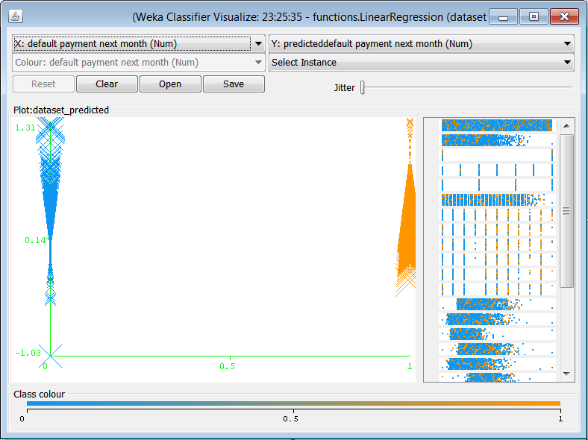
Figure 1: WEKA visualize errors
- Visualization attributes
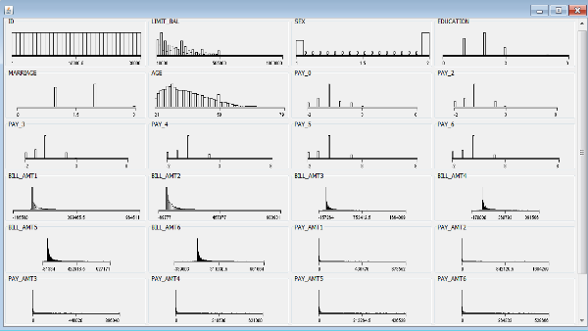
Figure 2: WEKA visualize attributes
- Visualization into x and y representation
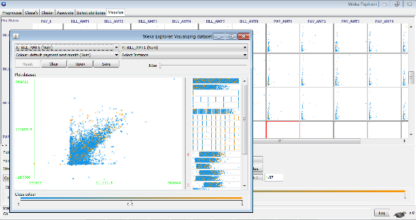
Figure 3: WEKA visualization (x and y)

Orange visualization techniques:
- Box plot
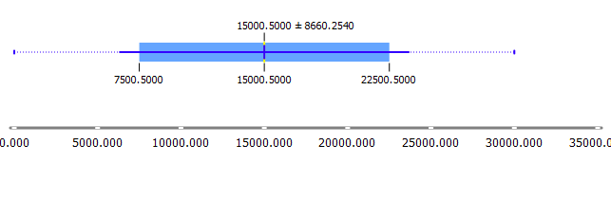
Figure 4: Orange box plot
- Distributions
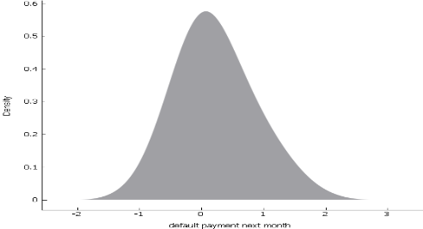
Figure 5: Orange distributions
- Heat map
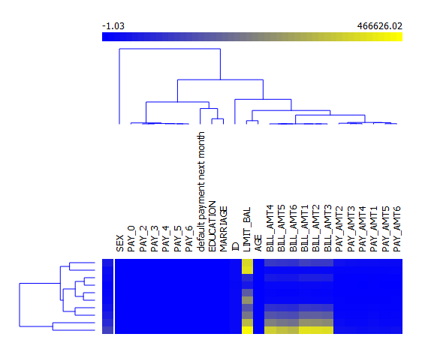
Figure 6: Orange heat map
- Linear projection
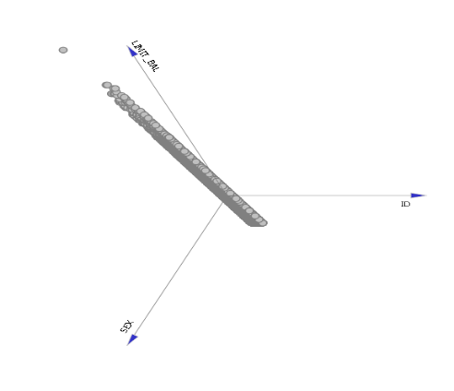
Figure 7: Orange linear projection
- Mosaic display
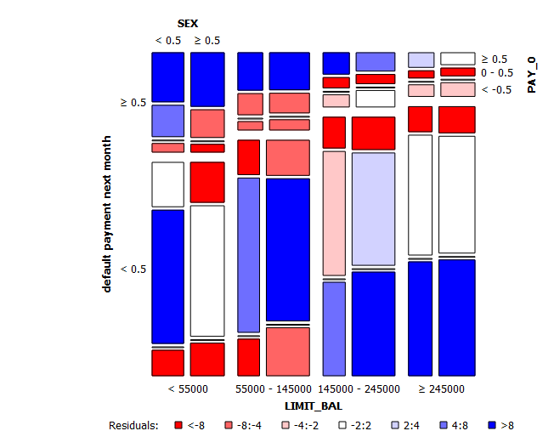
Figure 8: Orange mosaic display
- Scatter map
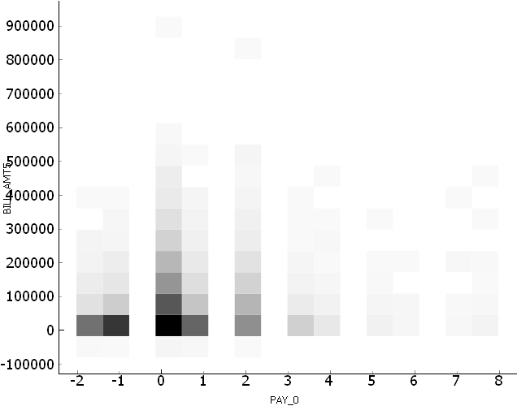
Figure 9: Orange scatter map
- Sieve diagram
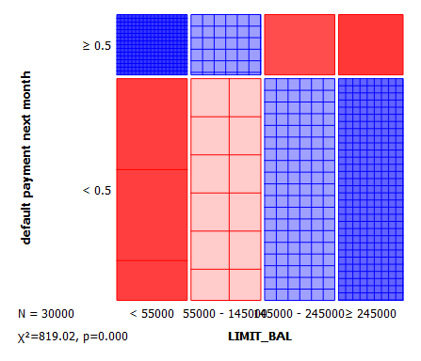
Figure 10: Orange sieve diagram

RapidMiner visualization techniques
- Andrwes curves
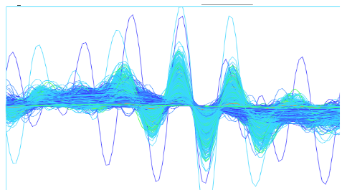
Figure 11: RapidMiner andrwes curves
- Bubble
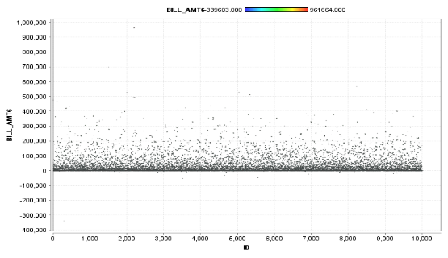
Figure 12: RapidMiner bubble
- Density

Figure 13: RapidMiner density
- Deviation
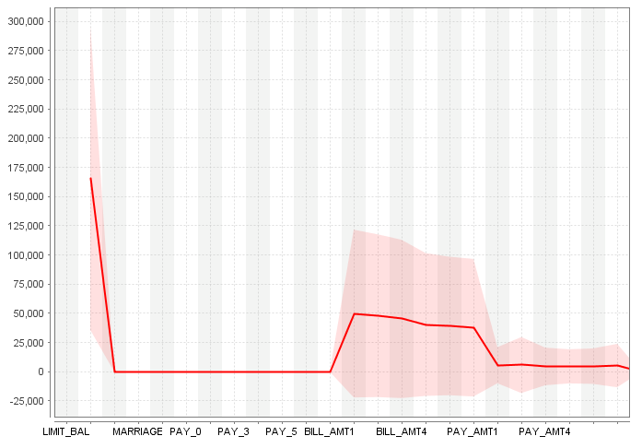
Figure 14: RapidMiner deviation
- Histograms
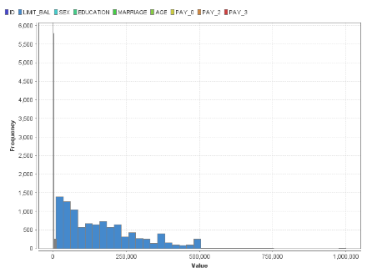
Figure 15: RapidMiner histograms
- Quantile colour matrix
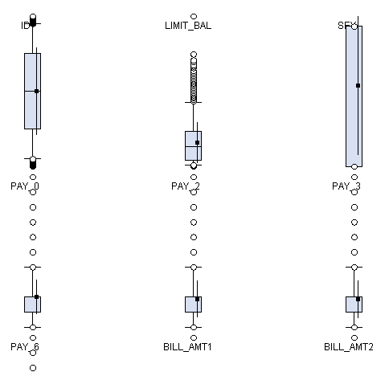
Figure 16: RapidMiner quantiles color marix
- Quantile colour
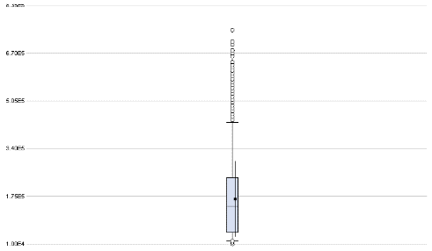
Figure 17: RapidMiner quantiles color
- Quantiles
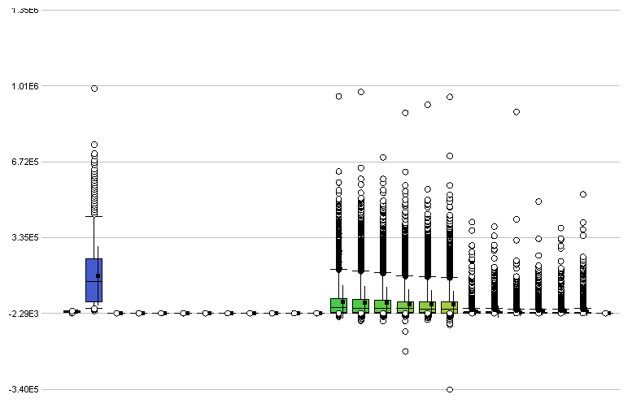
Figure 18: RapidMiner quantiles
- Scatter 3D colour
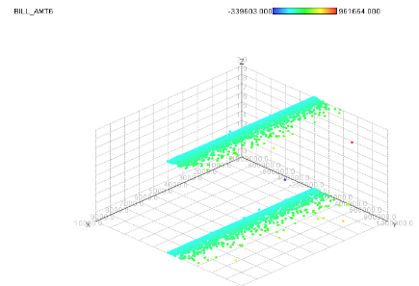
Figure 19: Rapidminer scatter 3D color
- Scatter 3D
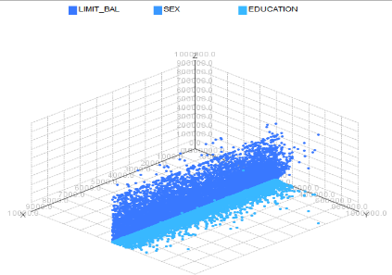
Figure 20: Rapidminer scatter 3D
- Scatter multiple
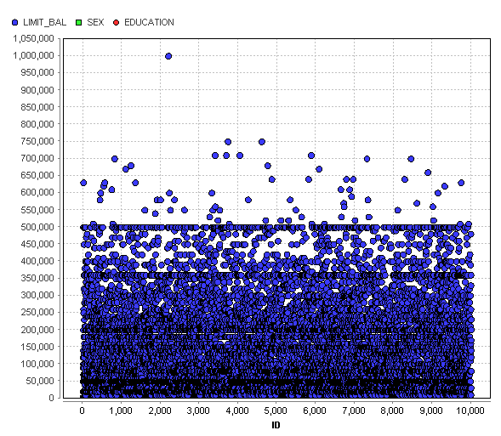
Figure 21: Rapidminer scatter multiple
- Scatter plot
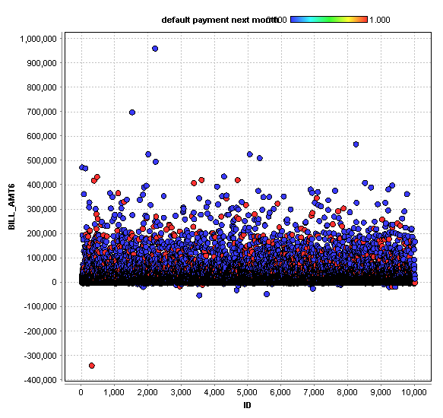
Figure 22: Rapidminer scatter plot
- Series multiple
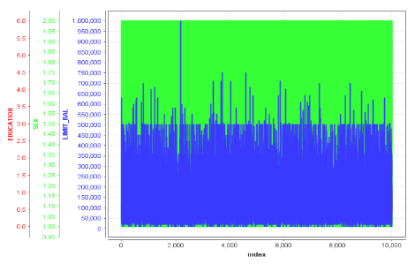
Figure 23: RapidMiner series multiple
- Series
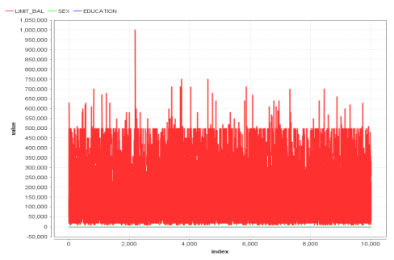
Figure 24: RapidMiner series
- Sticks 3D
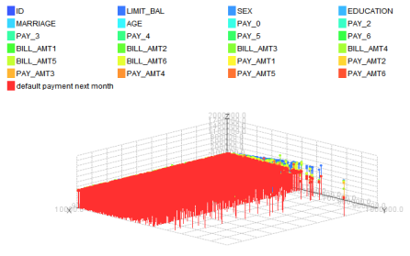
Figure 25: RapidMiner sticks 3D
- Sticks
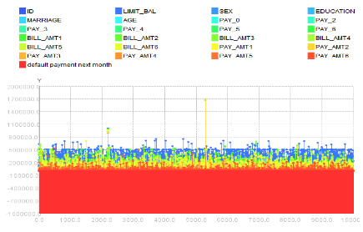
Figure 26: RapidMiner sticks

Tanagra visualization techniques
- Scatter plot
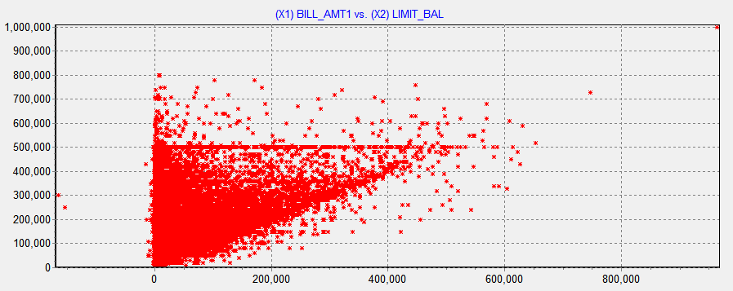
Figure 27: tanagra scatter plot
- Scatter plot with labels
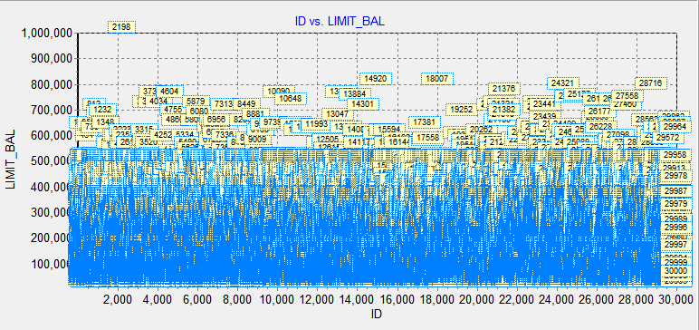
Figure 28: tanagra scatter plot with labels

KNIME visualization techniques
- Box plot
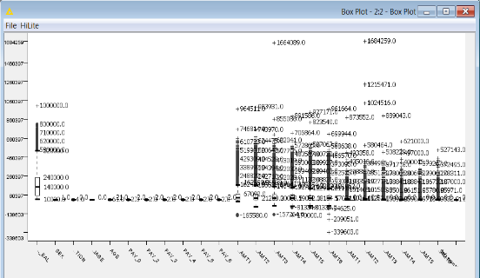
Figure 29: KNIME boxplot
- Histograms
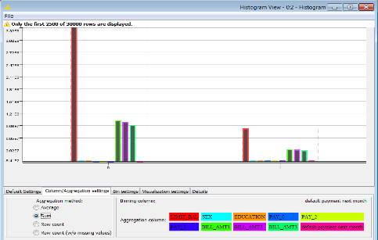
Figure 30: KNIME histogram
- Interactive histograms
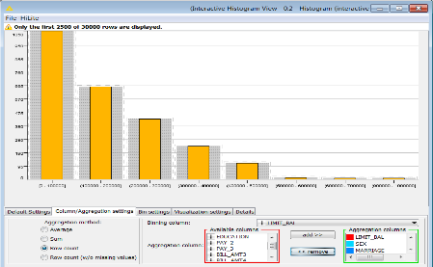
Figure 31: KNIME interactive histogram
- Line plot
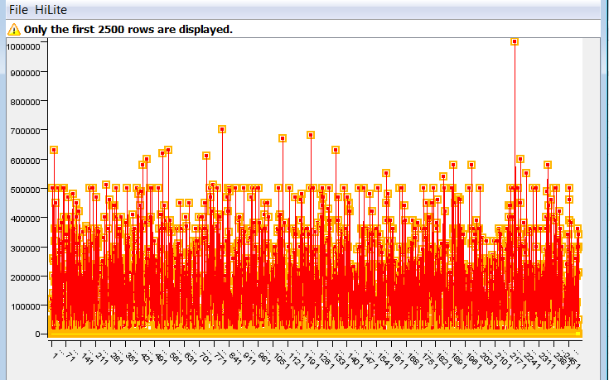
Figure 32: KNIME line plot
- Parallel coordinates
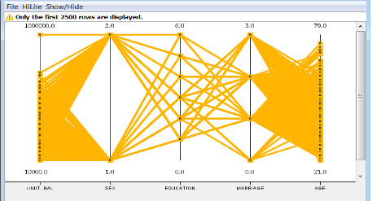
Figure 33: KNIME parallel coordinates
- Pie chart
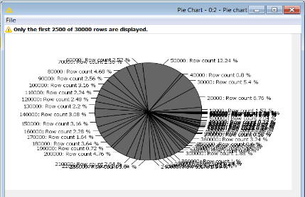
Figure 34: KNIME pie chart
- Scatter matrix
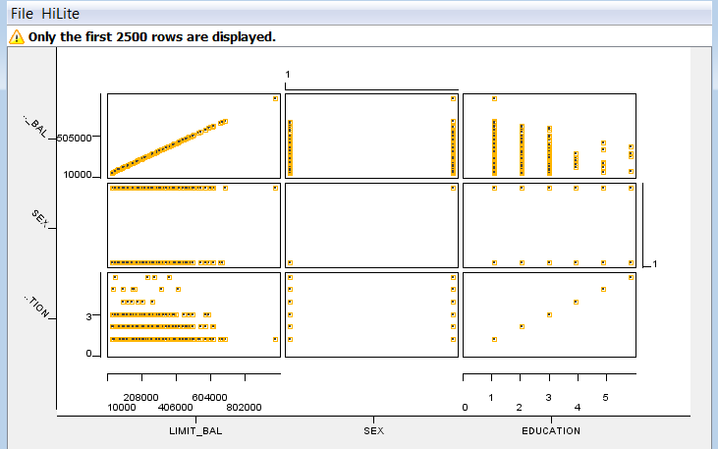
Figure 35: KNIME scatter matrix
- Scatter plot
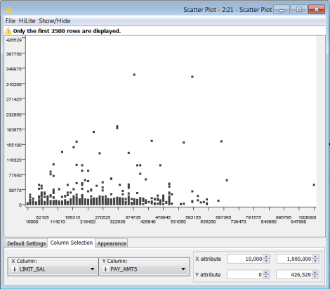
Figure 36: KNIME scatter plot

Virtual Private Network (VPN) Management and IPSec Tunneling Technology
Lana Ibrahim
Email:lana.ebra.94@gmail.com
Abstract
Virtual private network (VPN) technology takes place for creating an encrypted connection on a lower network security. The advantage of VPN relies on ensuring the suitable security level to the connected systems.
This paper concerns on security issues of virtual private network (VPN), by reviewing the Cisco Easy VPN Server for managing these networks, and reviewing IPsec tunneling technology for enhancing the security level, based on security-related problems that networks may face while connected to the Internet, and VPN's ability in providing a high productivity, security, and flexibility features.
First, VPN categories, benefits, and limitations were reviewed by concerning on its technique. After that, IPsec Tunneling Technology was reviewed by illustrating its technique and characteristics. Also, the role of Cisco Easy VPN Server in VPN management was clarified due to its importance for all sizes of businesses especially the large enterprise networks with Cisco Router and Security Device Manager (SDM).
Keywords: Virtual private network, IPsec ,tunneling technology .

- Introduction
Virtual Private Network (VPN) is a virtual network that is created under a public network infrastructure, such as the World Wide Web. Companies can use VPN to establish a secure connection to remote offices and remote users by accessing the Internet through a third party at an affordable cost, rather than creating expensive custom WAN links or long distance telephone links (Milanovic & Petrovic, 2001).
VPN provides the highest possible level of security through authentication technologies, IP-based VPNs, encrypted IPsec, or Secure Sockets Layer (SSL). All of these technologies protect data transmitted over VPN networks from unauthorized access.
Businesses can take advantage of the easy-to-save infrastructure of VPNs to quickly add new sites or users. Besides, it can also increase access to VPNs without having to invest heavily in infrastructure expansion (CCNA Security 1.0. Cisco Network Academy, 2010).
There are two types of encrypted VPNs: the IPsec VPN-based from a site location, which represent an alternative choice to WAN based on the migration of leased lines, which allows companies to extend network resources to Branch offices, home offices, and business partner sites. The second type is Remote Access VPN, which can connect any data, audio, or video application to the remote desktop. A VPN can be deployed for remote access using SSL VPN, IPsec, or both, depending on deployment requirements (Heninger, Kari, Rippon & Rubinshtein, 2011).
As the high importance of a security issue between any connections which directly affects the productivity, Cisco Easy VPN Server will be discussed in this paper as a way of troubleshooting complicated network and VPN connectivity issues. As well as, IPsec tunneling technology will be studied here as way of enhancing VPN security and confidentiality.

1.1 Study Objectives
The basic aim of this study is to:
Study methods of managing Virtual Private Network (VPN) and the tole of IPsec Tunneling Technology in enhancing security level
The study sub-aims are to:
- Highlight the role of VPNs in enhancing communications security for all sizes of businesses, especially the large enterprise networks with Cisco Router and Security Device Manager (SDM).
- Illustrate the role of IPsec tunneling technology in VPN connection between two LANs (site-to-site VPN) or a remote dial-up user and a LAN.
- Study the role of Cisco Easy VPN server in facilitating the deployment process of virtual private network (VPN) for remote offices.

- VPN Categories, Benefits, and Limitations
VPNs provide a high productivity, security, and flexibility, which authorize a remote secure connection by sites and teleworkers to the corporate network from almost any area, by encrypting data on a VPN and denying any unauthorized access to it (Jalava, 2003), as shown in figure [1].
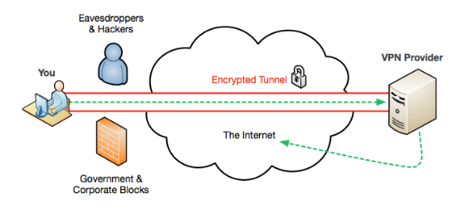
Figure [1]: VPNs technique overview (Lawrence, 2017)

Efficiency is one of the most important benefits in VPNs. without VPN, corporations waste high costs in leasing the dedicated expensive WAN links from ISPs and may without an effective speed in intercompany transportation. It enables the using of cost-effective, third-party Internet transport for connecting remotely, in addition to its role in eliminating the traditional costly dedicated WAN links. It also supports high-bandwidth technologies, like Digital Subscriber Loop (DSL); decrease the organization's connectivity costs, and raising the bandwidth of remote connection (Mason, 2004).
The second important benefit of VPNs is the scalability, which decrease wasting time in creating a new link between headquarter and new branch buildings, by using Internet Service Providers (ISPs) infrastructure. This process eases adding and modifying the number of connected users, so that companies can add important capacity without needing to add infrastructure (Singh, Samaddar, & Misra, 2012).
Telecommuters and mobile workers are allowed to gain a broadband connectivity for accessing to their networks, providing them high efficiency and flexibility, which directly enhancing the productivity.
VPNs supply the highest level of security through using advanced encryption and authentication protocols that provide a protection of data from unauthorized access, such as Password Authentication Protocol (PAP), Challenge-handshake authentication protocol (CHAP), and Extensible Authentication Protocol (EAP).
In the other side, there are different limitations of VPNs. attackers may target client machine, and different bugs or miss-configuration could be exploited using different attacking ways, like VPN hijacking, malwares, or man-in-the-middle attacks (Singh, Samaddar, & Misra, 2012).
In addition, VPN supports limited authentication methods, like PAP, and password is in a clear text. Establishing connection should be done by an authenticated user only, and if this authentication is not robust for denying any unauthorized access, network and its resources can be attacked (Galán-Jiménez & Gazo-Cervero, 2011).

- IPsec Tunneling Technology
A secure network must begin with robust security policies that dictate the security deployment in the network, and IPsec protocol is one of examples for securing the transfer process of information at the OSI layer.
The job of IPsec suite takes placed at the Network Layer, for protecting and authenticating aim of IP packets between sharable IPsec peers. So, the function of this protocol relies on protecting all application traffic virtually, due to the protection ability to be implemented from Layer 4 through Layer 7 (Yang, 2011).
For providing the framework and the network administrator in IPsec, there is just a need to select the appropriate algorithms for being sure that the similar algorithms are used between two parts, and for investigating the security services. Without obligation of IPsec to particular algorithms, novel and better algorithms will be allowed to be performed in the IPsec frame. It has the ability to secure the track between site-to-site gateways, the couple of hosts, or to secure a track between gateway and host, which implemented the remote access. Figure [2] shows IPsec framework (Muirhead & Page, 2010).

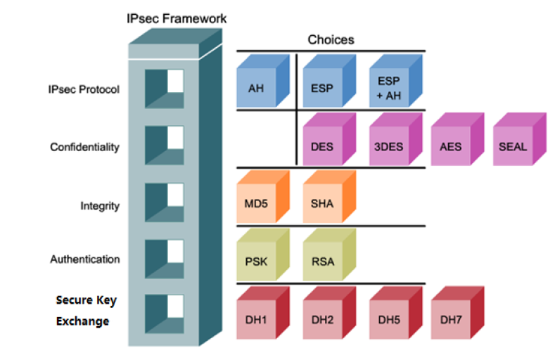
Figure [2]: IPsec Framework (Yang, 2011)

A VPN connection connects two LANs (site-to-site VPN) or a remote dial-up user and a LAN. Flowing traffic between connected points passes out of shared resources. So, IPsec tunnel is used for securing VPN communication at passing time.
IPsec tunneling technology protects entire IP packets, by encrypting the original packets after wrapping it, then it sends new IP header after adding it to the other side of the VPN tunnel (IPsec peer) (Muirhead & Page, 2010).
Figure [3] shows an example of IPsec tunneling mode between a connected Cisco VPN Client and an IPsec Gateway. First, the traffic from the client is encrypted, and then encapsulated in a novel IP packet, after that it sent to the other end. When the traffic is decrypted by the firewall, the original IP packet of the client is sent to the local network (Snader, 2015).
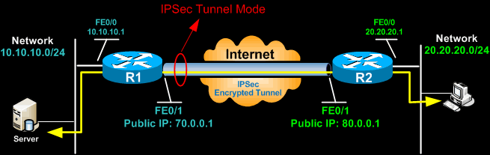
Figure [3]: IPsec-VPN Tunneling Technology (Snader, 2015)

AH or ESP header of IPsec is inserted between both header of the IP and the upper layer protocol. ESP is used more that AH in Tunneling configuration of IPsec-VPN.

- Cisco Easy VPN Server in VPN Management
Cisco Easy VPN server facilitates the deployment process of virtual private network (VPN) for remote offices. The solution of this server localizes the management of VPN across all Cisco VPN devices. So, it will reduce VPN's deployments management complexity.
Cisco Easy VPN contains both Cisco Easy VPN Remote and Cisco Easy VPN Server components. The remote characteristics permit Cisco IOS routers to extradite security policies over a connection of VPN tunnel from a Server of Cisco Easy VPN. Also, the remote characteristics have the ability to minimize configuration needs at the remote location (Bibraj, Chug, Nath, & Singh, 2018).
This server permits routers of Cisco IOS to work as VPN head end device in remote-access VPNs and in site-to-site VPNs. This characteristic raises security policies defined on the side of central site to the remote VPN device, which assist in ensuring that these connections have up-to-date policies before establishing the connection.
Cisco Easy VPN supplies automatic configuration and management for parleying tunnel parameters and establishing IPsec tunnels. When the user asked for IPsec connection, the extended authentication (Xauth) will adds another level of authentication that distinguishes the user. Partition tunneling allows the remote router to route the Internet-destined traffic immediately without needing to forward it over the encrypted tunnel. So, this process is easier now for all sizes of businesses especially the large enterprise networks with Cisco Router and Security Device Manager (SDM) (Bibraj et al., 2018).
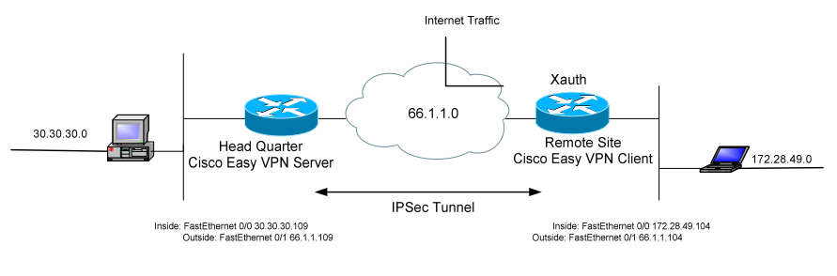
Figure [4]: Example of Cisco Easy VPN Server and Xauth ()

In addition to the authentication process which is done by shared key, Xauth provides an extra level of authentication for recognizing the user who asks a request of IPsec connection, as shown in the example in figure [4]. The remote site waits for a challenge of “username/password” after establishing the Internet Key Exchange (IKE) Security Association (Khalid, Asati, Patil & Akhter, 2011).
Using Cisco Easy VPN Server, configuration of Split Tunneling is done, and is loaded on the Cisco Easy VPN Remote dynamically. This type of tunneling allows a direct Internet intended traffic's routing of the remote router without needing to forward it through the encrypted tunnel.

- Conclusion
Virtual Private Networks (VPNs) divided into two categories, depending on the security characteristics in place: IPsec or SSL. IPsec-based VPNs allow the security layer to be a portion of the network, which will increase protection for all traffics flowing in and out of the network.
IPsec tunneling has a big important role in enhancing VPNs' security, because it based on the network level, and it is totally hidden in its operation. So, there is no need to learn about it by end users and they never interact with it directly. This is an added security layer for the VPNs running on IPsec.
In addition to IPsec tunneling Cisco Easy VPN was reviewed. Basic configuration and management of Cisco routers are configured with Command Line Interface (CLI). but, Cisco presented Graphical User Interface (GUI) tools for management objectives, like Cisco Easy VPN, it can deals with all network managers, essentially the large enterprise networks with Cisco Router and Security Device Manager (SDM). This server added another security feature by enhancing authentication method by splitting tunneling.

References

Lawrence, J. (2017). Get a VPN today, Electronic Frontiers Australia. Retrieve from: https://www.efa.org.au/2017/04/13/get-a-vpn-today/
Jalava, M. (2003). U.S. Patent Application No. 10/151,319.
CCNA Security 1.0. Cisco Network Academy. Available in online books. Require user account. Updated 21.7.2010. Referred 15.5.2011. URL: http://www.cisco.com/web/learning/netacad/index.html
Mason, A. (2004). CCSP Self-Study: Cisco Secure Virtual Private Networks (CSVPN). Pearson Higher Education.
Galán-Jiménez, J., & Gazo-Cervero, A. (2011). Overview and challenges of overlay networks: A survey. Int J Comput Sci Eng Surv (IJCSES), 2, 19-37.
Milanovic, S., & Petrovic, Z. (2001). Deploying IP-based Virtual Private Network across the Global Corporation. Communications World, 13-17.
Heninger, I. M., Kari, J. D., Rippon, W. J., & Rubinshtein, G. (2011). U.S. Patent No. 7,975,294. Washington, DC: U.S. Patent and Trademark Office.
Singh, A. K., Samaddar, S. G., & Misra, A. K. (2012, March). Enhancing VPN security through security policy management. In Recent Advances in Information Technology (RAIT), 2012 1st International Conference on (pp. 137-142). IEEE.
Yang, Y. (2011). Virtual Private Network Management, Bachelor of Information Technology Network Optionion.
Muirhead, C. S., & Page, D. J. (2010). U.S. Patent No. 7,684,321. Washington, DC: U.S. Patent and Trademark Office.
Snader, J. C. (2015). VPNs Illustrated: Tunnels, VPNs, and IPsec: Tunnels, VPNs, and IPsec. Addison-Wesley Professional.
Khalid, M., Asati, R., Patil, S. P., & Akhter, A. (2011). Methods and systems for dynamically updating a routing table in a virtual private network U.S. Patent No. 7,987,506. Washington, DC: U.S. Patent and Trademark Office.
Bibraj, R., Chug, S., Nath, S., & Singh, S. L. (2018). Technical study of remote access VPN and its advantages over site to site VPN to analyze the possibility of hybrid setups at radar stations with evolving mobile communication technology. MAUSAM, 69(1), 97-102.

Rehabilitation of existing buildings and structures to resist seismic acts
Aseel Mousa Ahmad Matar
Civil Engineer, Al-Balqaa Applied University/Faculty of Engineering Technology
E-mail: aseel.mattar@yahoo.com

Abstract
This research aimed to explain a set of concepts that reduce the seismic hazard of existing buildings and structures by clarifying the philosophy of earthquake-resistant design, and to clarify the descriptive or detailed descriptive methods adopted in references and codes. The researcher has used the descriptive approach to achieve the objectives of the study. This approach is based on reference to studies, articles and books related to the current subject to achieve the objectives of the study. The research concluded that there are many methods used in strengthening existing buildings and installations in earthquake-prone areas. The most important of these methods are making the necessary corrections related to the general structural configuration such as reducing the wicks by removing and adding the cutters, and reducing the vertical order by adding structural walls and repairing the shear in the structural elements by reinforcing the columns by adding steel shirts or layers of pure concrete.
Key words: Rehabilitation, Existing buildings, Resist seismic.

1.0 Introduction
Many countries of the world are exposed to earthquakes of various degrees (large, medium, weak). And the Middle East region is considered from the areas that are exposed to seismic hazard. Hence, the subject of seismic protection should be addressed in designing the subsequent structures to resist earthquakes and protect existing buildings and installations. Hwaija (2005) stressed that this protection can be guaranteed by strengthening buildings and structures and rehabilitating them to make them able to withstand seismic forces.
The concept of seismic protection strives to preserve human life, protect the structure of construction fundamentally, and the safety of non-structural elements comes in the second order. Holmes (2000) clarified that when an earthquake of relatively high magnitude can occur, the structure of the building can remain intact without damage, while the non-structural elements are almost completely destroyed.
Rai (2005) stressed that the non-structural elements are very expensive elements, and its collapse will result in a temporary suspension of investment building, which in turn causes material and vital losses for vital institutions, whether service or productive, and therefore the attention to these elements is essential.
2.0 Research importance
The aim of this research is to explain a set of concepts that reduce the seismic hazard of existing buildings and structures by clarifying the philosophy of earthquake-resistant design, and clarifying the descriptive or detailed descriptive methods adopted in references and codes. And then take the appropriate decision for the reform or restoration process in order to:
- Prevent the collapse of buildings during the earthquake to maintain the integrity of the investor.
- Reduce damage to ensure continuity of work during and after the earthquake.
It is very important to distinguish between the concept of rehabilitation and the concept of reform or restoration, since the last one is concerned with damaged facilities, while rehabilitation may not necessarily concerned with damaged facilities. Seismic rehabilitation is a procedure used by the structural engineer to strengthen existing facilities to resist future earthquakes (Gülkan and Wasti, 2009).
3.0 Research methodology
The researcher will use the descriptive approach to achieve the objectives of the study. This approach is based on reference to studies, articles and books related to the current subject to achieve the objectives of the study.
4.0 Literature review
4.1 Seismic Design Philosophy
Seismic design is certainly different from the classic design that is resistant to other loads that other installations are exposed to, such as gravity and wind. Despite the rapid development and good understanding of the structural behavior of buildings prone to seismic events, there are significant differences in most countries between the theories of seismic engineering and their applications at the design and applied levels (Wenk, 2008).
It is noted that there are many buildings damaged or collapsed due to non-application of what is stated in the international seismic codes. Rutherford & Chekene (2006) pointed out that the most prominent collapses to buildings are collapses due to the bad enclosure of the longitudinal armament in the columns and collapses in the weak link.
The various mechanisms of collapse do not agree with the philosophy of seismic design, which aims to raise the structural efficiency and improve the behavior of elements by focusing on the concept of mutability rather than relying on the concept of resistance only (Wenk, 2008). The inflexible construction response has become a reality in the earthquake-resistant construction design. Sahin (2014) indicated that the most important factors affecting the design of buildings and buildings resistant to earthquakes are:
- Acceptable hazard associated with earthquake frequency: it includes designing the important installations such as bridges and hospitals on large seismic shocks, unlike residential buildings.
- Economic considerations: The choice of design intensity varies from country to country for various reasons such as the initial cost of construction, maintenance costs, loss due to deteriorating construction condition under investment.
- The importance of construction and the consequences of its collapse.
Stratan (2015) clarified that the shear factor is associated with a combination of factors such as the seismic zone studied, the importance of origin, the behavior of the origin, the dynamic response of the vibrations produced during a particular earthquake, and the interaction between origin and foundation soil. Ersoy et al. (2015) stated that the effect of seismic forces can be improved by improving the seismic response of the origin by selecting the appropriate architectural form, which includes simplicity, symmetry, avoidance of sediment in U. L, T, and the hardness of the floors.
4.2 The evaluation of existing buildings and structures for earthquake resistance
The process of evaluating the existing buildings and facilities aims to determine the degree of public safety and to demonstrate the efficiency of the resistance to the seismic acts of the site studied, and then take the appropriate decision to strengthen or demolish (Dubina et al., 2014). Vulcu et al. (2012) noted that the assessment process is a major primary step in the seismic risk mitigation program and includes the following phases:
- Identifying and classifying building models, clarifying all modifications (if any), and developing a plan to study seismic safety of existing buildings according to their importance.
- Investing the data of the previous step to develop a set of procedures and qualitative requirements so that the program is implemented based on a set of questions related to the properties of buildings and facilities erected.
- Analyzing the buildings with their damaged condition, taking into account the properties of actual materials and loads.
4.3 Strengthening and rehabilitating existing buildings and facilities - strengthening techniques
Strengthening and rehabilitating existing buildings and facilities - strengthening techniques
When an existing building must be strengthened, attention must be paid to the following factors (Hwaija, 2005):
- The level required for the structural resistance of the building
- General structure and change required.
- Materials of reinforcing elements and their degree of contact with the existing construction.
- The condition of the foundations and the possibility of building above them.
- Period of time for non-investment of construction
- The cost of reinforcement
The efficiency of existing buildings and facilities can be increased by one of the following methods (Vulcu et al., 2012):
- Minimizing the effect of seismic action.
- Improving the mechanical properties of the building (resistance, hardness, the role of vibration), through:
- Reducing the building block by removing a certain number of floors or by reducing the weight of the walls and the density of their distribution.
- Minimizing the distance between the center of gravity and the center of hardness to minimize the effects of the wick.
- Increasing moderation by connecting the structural elements of horizontal forces to each other.
- Increasing the number of elements resistant to horizontal forces, this contributes to reducing the risk of collapse of one.
4.4 State of unarmed stone buildings
This type of building has many weaknesses in terms of seismic resistance and can be strengthened in the following ways (Hwaija, 2005):
- Make adjustments in the construction mismatch to reduce asymmetry.
- Improved communication when orthogonal walls converge by means of steel bolts.
- Strengthen the wooden hulls by increasing their hardness by covering them with a thin layer of reinforced concrete, or removing the roof, thereby improving their connection to the bearing walls.
- Reinforcing the walls especially when they are cracked with cement.
- Strengthening foundations.
The following Figures (Figure 1, Figure 2) represent examples for methods used for strengthening seismic resistance.

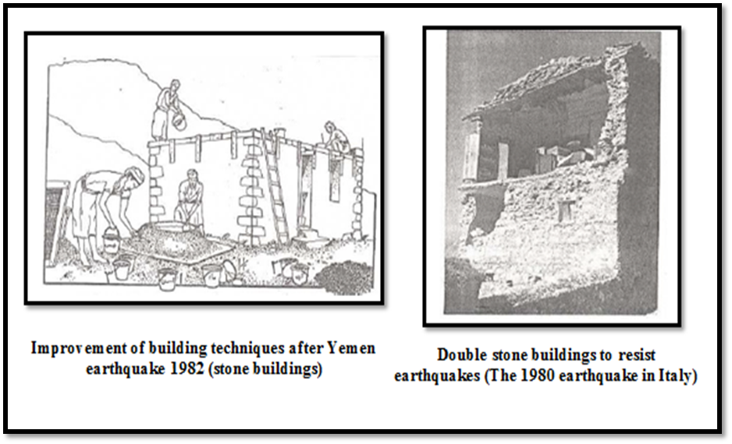Figure 37: Methods used for strengthening seismic resistance (Hwaija, 2005)

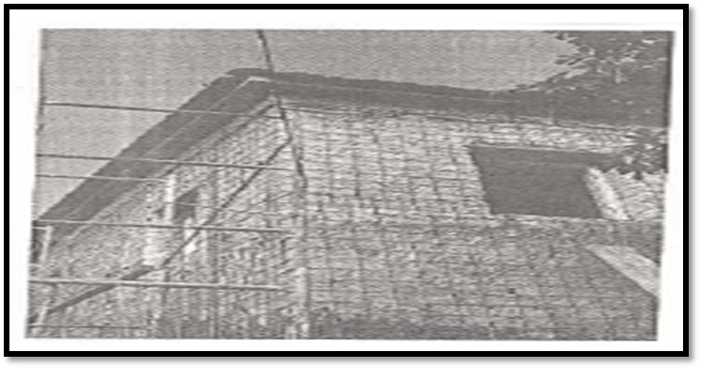

Figure 2: Reinforcement of old or damaged stone building using internal and external reinforcement coated with a layer of soft concrete (Hwaija, 2005)

4.5 Status of existing buildings of reinforced concrete
There are many methods used for seismic rehabilitation of existing concrete structures, including:
- Provide the columns with armed concrete or steel: This solution is economical, and contributes to the lifting of resistance of origin. In contrast, this work affects the mechanical properties of the origin when used alone.

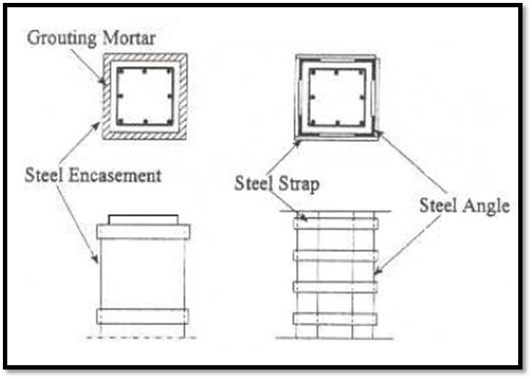
Figure 38: Reinforcing columns using steel sections (Hwaija, 2005)

- Add reinforced concrete walls: these walls increase the side hardness and resistance of origin.
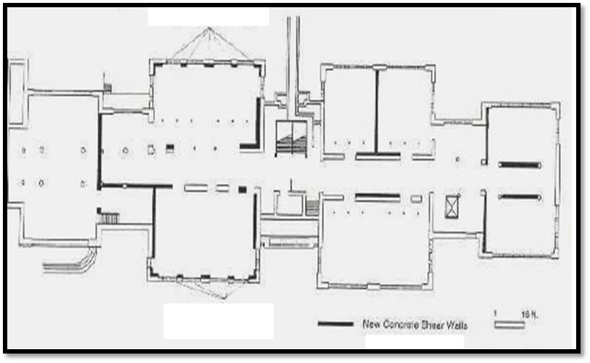
Figure 39: Rehabilitation of a school in Chicago by adding walls to resist earthquakes (Gajanan et al., 1996)

- Use walls filled with external tires to reduce horizontal transitions.
- Remove or redesign non-structural walls.
- Increase the hardness of high construction built on soft soil.
- Add surrounding frames that improve lateral hardness and resistance.
5.0 Conclusion
The study aimed to explain a number of basic factors that reduce seismic risk. The study also aimed to explain the methods of earthquake-resistant reinforcement and offer appropriate techniques in strengthening existing buildings and installations in earthquake-prone areas, which can be summarized as follows:
- Making the necessary corrections related to the general structural configuration such as reducing the wicks by removing and adding the cutters, and reducing the vertical order by adding structural walls.
- Repairing the shear in the structural elements by reinforcing the columns by adding steel shirts or layers of pure concrete.
Finally, the choice of seismic technology requires engineering wisdom linked to various factors, including economic considerations, the nature of an enterprise's investment, and architectural considerations.

References
- Dubina, D., Stratan, A., Vulcu, C., Ciutina, A. (2014). "High strength steel in seismic resistant bu
- Ersoy, U., Tankut, T., Gülkan, P. and Sucuoglu, H. (2015). SEISMIC ASSESSMENT AND REHABILITATION OF EXISTING BUILDINGS. CERTH (Center of Research and Technology), Department of Civil Engineering, Middle East Technical University, Thessaloniki, Greece.
- Gajanan, M. et al. (1996). -Seismic Rehabilitation of Concrete Structures- ACI, SP-160.
- Gülkan, P. and Wasti, S. T. (2009). Seismic Assessment and Rehabilitation of Historic Structures. Tech Science Press SL, vol.1, no.2, pp.111-134.
- Holmes, W. (2000). RISK ASSESSMENT AND RETROFIT OF EXISTING BUILDINGS. Structural Engineer, Rutherford & Chekene, San Francisco, CA. Available at: http://www.iitk.ac.in/nicee/wcee/article/2826.pdf.
- Hwaija, B. (2005). Seismic Evaluation & Rehabilitation Requirements of Existing Buildings in Seismic Zones Rehabilitation Techniques. Tishreen University Journal for Studies and Scientific Research- Engineering Sciences Series Vol. (27) No (2) 2005.
- Rai, D. (2005). Seismic Evaluation and Strengthening of Existing Buildings. Department of Civil Engineering, Indian Institute of Technology Kanpur Kanpur.
- Rutherford, R. & Chekene, C. (2006). Techniques for the Seismic Rehabilitation of Existing Buildings. National Institute of Standards and Technology (NIST). FEMA 547.
- Sahin, C. (2014). Seismic Retrofitting of Existing Structures. Civil and Environmental Engineering Master's Project Reports. Portland State University.
- Stratan, A. (2015). SO L U T I O N S F O R I M P R O V E D S E I S M I C PE R F O R M A N C E O F N E W A N D E X I S T I N G S T R U C T U R E S. Habilitation thesis.
- Vulcu, C., Stratan, A. and Dubina, D. (2012). "Seismic resistant welded connections for MRF of CFT columns and I beams", Proceedings of the 7th International Workshop on Connections in Steel Structures, May 30 - June 2, 2012, Timisoara, Romania, ECCS, Dan Dubina and Daniel Grecea (Eds), ISBN 978-92-9147-114-0, pp. 275-290.
- Wenk, T. (2008). Seismic retrofitting of structures strategies and collection of examples in Switzerland. Environmental studies. Published by the Federal Office for the Environment FOEN Bern.

The Effect of Accounting Conservatism and its Impacts on the fair Value of the Corporation
Inkiläinen, Zianee Anand
Email: study_plans@outlook.com

Abstract
This study mainly aims to elaborate the impact of the conservatism accounting on the fair value accounting. Therefore, we are motivated to shed light on the concept of accounting conservatism and fair value in financial accounting. Second goal is to illustrate the main characteristics of accounting conservatism and fair value. Third goal is to explain the impact of the accounting conservatism on the fair value.
This study attempts to investigate whether the accounting conservatism is related to firms’ fair value and their financial decisions. We intend to use the descriptive approach in order to achieve the objectives of the study, to review the relevant literature on conservatism accounting and fair value, and to test the validity of the formulated hypotheses. The descriptive approach is reliable in this type of research, and the design of the questionnaire will be included in the study as the main adaptable component dependent to this methodology. Certainly, we have a set of variables: the reliability of accounting conservatism, the relevance of accounting information, and the benefits to fair value.
Keywords: conservatism accounting, fair value, financial accounting, firms.

INTRODUCTION
Many researchers suggested to adopt a number of accounting conservatism measures to realize its effect on many interesting areas in the corporation (Bandyopadhyay et al, 2010). Typically, the current methods used to determine estimates and ensures of reasonable assurance on fair value and performance of business were investigated in many researches. Thus, the financial audit requirements and management capabilities have been conducted relevant to the position, value, and performance estimates of the business (Mrša et al, 2012).
Financial statement is found to provide the useful information to the users to help them in making economic decisions. For example, financial statement provides information of financial position, changes in financial position, and the performance of the enterprise. The employees, investors, suppliers, lenders, customers, and the governmental organizations and agencies are the major users of the financial statements (Bertoni and Rosa, 2005). Accounting conservatism refers to the outcome of uncertainty in earnings presentation of the firms that measured by the difference between returns on investment and earnings or the Earnings Response Coefficient (ERC). Particularly, accounting conservatism also is called the information asymmetry in accounting; higher implication in ERC information asymmetry leads to higher level of conservatism (Mrša et al, 2012).
The concept of fair value refers to the amount of assets, stable liability, and responsible parts in the financial transactions. Fair value could be the market value of an item if the market is efficient considered, independent parties, and no information asymmetries (Bertoni and Rosa, 2005). Computing fair value requires calculating the current asset value by recognizing the income or loss of the asset over period to reflect the value of the company. The accounting conservatism is different than fair value with respect to the speed of recognizing the financial statement profits; fair value produces asymmetry timing realization of unrecognized profits. The caution principle should be neglected in calculating fair value, whereas the accounting conservatism should not be low in firms to avoid dangerous dimensions to the investors and firms. Hence, the accounting conservatism is safely value beside the urgent and unexpected replications of the revenues and asset values. In contrast, relying on fair value extremely might increase the potentiality of carrying prices risks suddenly (Al-Awawdeh, 2015). The increasing fair value yields more generated revenues of the assets, as well as the income will increase in the assess management. Sometimes, the changes in fair value of liabilities and assets have not an impact on earning; some standards need to involve the encountered changes equally once they are realized and show them in the income statement (Bertoni and Rosa, 2005).
Different factors reflect the market prices, i.e. transaction costs, present value of future prices, insufficient market liquidity, and solvency risk (Bertoni and Rosa, 2005).The factors of the strong impact of the accounting conservative are: ownership, low market liquidity, pre-mature revenue recognition, underestimation of bad debt, and transfers of risks (Mrša et al, 2012).Several methods can be used to determine the fair value if the market value cannot be attuned to find item’s fair value or if they are unavailable. Some of these methods are (Bertoni and Rosa, 2005):
- Disconnected cash flows: the measurements that are employed by appropriate discount rate to measure the liabilities and financial assets.
- Carrying amount: the measurement of short period financial assets such as accounts receivable or payable that live in short period of time from the origination to the realization, as well as the loans that their prices change repeatedly at market over time and do not require a new measuring and calculating in the fair value.
- Valuation models: the measurements measure the derivative financial assets in excessively active markets such as stock market that hold an option to gran the employees to use derivatives in hedging.
Based on the disclosures of the fair value measurements stated under the Statement of Financial Accounting Standards (SFAS), the authors of the study identified the extent of the choice of firms in terms of fair value measurements. In general, the narrow meeting of earning targets conflicted with the conditional conservatism yields less conditionally conservative fair value measurements (Badia et al, 2016).
OBJECTIVES
This study mainly aims to elaborate the impact of the conservatism accounting on the fair value accounting. Therefore, we are motivated to achieve this goal by accomplishing the following sub-objectives:
- To shed light on the concept of accounting conservatism and fair value in financial accounting.
- To illustrate the main characteristics of accounting conservatism and fair value.
- To explain the impact of the accounting conservatism on the fair value.
QUESTIONS
This research attempts to investigate whether the accounting conservatism is related to firms’ fair value and their financial decisions. Based on the outlined objectives we carry out, the main questions we carry to answer are:
- Are the effects and consequences associated with accounting conservatism certainly recognized?
- Does the accounting conservatism affect the fair value?
- What are the effects of control variables on accounting conservatism and fair value?
- What is the type of the relationship between accounting conservatism and fair value?
HYPOTHESES
The researcher in this study seeks to test and validate the following hypothesis:
- There is no impact of statistical significance of the accounting conservatism on the fair value.
- There is no significant impact of the control variables of decision supporting and financial reporting on accounting conservatism and fair value.
Moreover, these hypotheses are also divided into two hypotheses:
- Accounting conservatism contributes to provide the benefits to fair value.
- There is no relationship between the accounting conservatism and fair value.
LITERATURE REVIEW
Most of researches on the accounting conservatism measured the assumption of accounting conservatism theoretically by detecting the methods that rely on accounting reaction to bad news about the capital market and business risk assessment to adjust financial reporting positions. Other literatures described the accounting conservatism as an internal generated predictive measure of future cash flows. However, the researchers interested in the accounting conservatism should pay a special attention to the direct impact of accounting conservatism particularly with respect to the risk mitigation and management. Referring to the research on management forecasts and accounting conservatism, many researches have argued that the accounting conservatism should provide the prediction power to the firms to predict future performance, as well as should provide a significant tool for accounting management.
In (Lee, 2011), the author has examined the association between conservatism and the financial flexibility and financial decisions. In other words, the study explored the pay-out policies, liquidity management, investment cash flow sensitivity, and choice of debt or equity financing. The main findings of the study demonstrated that firms with larger conservatism showed lower flexible financial decisions. Therefore, the accounting conservatism declines the presence and the strength of firms’ balance sheet that let managers to behave more conservatively and financially constrained in more financial decisions. The paper has been developed due to the lack of the evidence on the effect of conservatism on corporate decisions in the literature. The suggestions presented by the paper confirmed that if debt contracting is more costly, the firms report more conservatively behave. Moreover, the firms exhibit less flexible finance particularly in financial decisions. In conclusion, the study provided a defence to the reasons that let standard setters desire free of bias and neutral accounting information, and the causes of avoiding the concept of conservatism in the conceptual framework.
The authors of (Elkotayni et al, 2014) intended to show the relation between the financial failures and the accounting conservatism in 60 industrial corporations listed on the Amman Stock Exchange (ASE) in order to build a prediction of the failure in early and advanced stages. The focus was on the measuring the level of the conservatism documented by the investigated corporations. The authors used two models: Basu, 1997 and Altman and mccough, 1995 to forecast the financial failures to achieve their intended objectives. They used multiple linear regression model in testing the study hypotheses. The study was conducted in the period from 2008 to 2012. The results of the study have confirmed previous studies that their results are consistent with the result saying that there is an accepted degree of accounting conservatism in the conducted corporations and there is a weak influence of the accounting conservatism on the prediction of financial failures in these corporations. The accuracy of the proposed prediction model was 88%. The authors recommended the governmental organizations in Amman Financial Market compel corporations to follow the universal average of the accounting conservatism to reduce the risks of the financial failures. Moreover, they argued to monitor operating in Jordan to increase audit procedures and verifications that yield more transparency, fairness, activated control, customers commitment, and accurate financial reports. Finally, the accounting conservatism is one of the indicators of failures and leads the corporation to financial failures.
The study of (Elfaki and Hammad, 2015), addressed the effect of the application fair value accounting on the characteristics of accounting information. Three approaches: descriptive, inductive, and deductive have been followed to achieve the objectives of the study. From literature, many studies have reviewed the impact of fair value accounting and analysed its components using the inductive approach, whereas the researcher adopted the deductive approach to formulate the hypotheses of the study. Therefore, the researcher used the descriptive and statistical approach to analyse questionnaire data in social studies. The study recognized a positive relationship of the fair value accounting; it produces useful information for financial statements creation, reliability of accounting information and decision-making.
The study of (Al-Awawdeh, 2015) aimed to check the impact of the accounting conservatism on the fair value in Jordan. The study has accompanied a survey on a sample of 30 Jordanian industrial companies over six years from 2006 to 2013. The study selected fair value as a dependent variable, whereas the accounting conservatism was selected as an independent variable. In addition, there were five control variables, specifically the proportion of fixed assets, the size of the company, the ratio of ownership, the rate of assets realization, and distributed dividends. The results of the study showed that there is a difference between the degree of incorporating accounting conservatism in the operations of the conducted industrial Jordanian companies and the state of accounting conservatism. Therefore, the authors noticed the presence of a variation in the conducted companies size, the responsibility percentage, and the distributed profits rates. In general, the fixed assets ratio of the conducted companies is closer. In conclusion, the study demonstrated the reverse relation between the accounting conservatism and the fair value. Moreover, the critical role of the low accounting conservatism in fair value was clarified, therefore. the relationship between the accounting conservatism and fair value is negative. The results also revealed that control variables have an impact on fair value, i.e. the company profitability and assets showed a positive relationship, and the ratio of debts showed a negative impact on fair value.
In the paper of (Mrša et al, 2012), a survey of the related accounting approaches that deal with information asymmetry, harmonization, and uncertainties implications was piloted for fewer developments of the capital markets. More conservative and aggressive accounting policy approaches lead to more quality of accounting information. The paper added a special interest in the latest updates on International Financial Reporting Standards (IFRS) conjunction, mainly for United States Generally Accepted Accounting Principles (US GAAPs) and consistent with the Financial Accounting Standards (FAS) Boards statement that reported comprehensive income and fair value measurement. The paper recommended to follow the accounting standard setters principles regarding the uncertainty and accounting conservatism for better quality in financial reporting quality measurement. Additionally, the firm’s management is not able to follow these standards and principles.
In (Manganaris et al, 2011), the authors examined the status of the conservatism and fair value existing in four European countries namely British, Greece, France, and Germany. The study has covered the existing conservatism over the period of 1999-2008, and the level of the change over the same period in order to determine the impact of conservatism on the earnings value. The approach implemented by the study was regression model using Basu’s and Easton and Harris’s model to measure the conservatism and fair value. The results were derived for each country and for each level of conservatism. The main evidence was inferred is that the conservatism was located in four countries. However, the conservatism in Germany and France was decreased after the IFRS adoption after 2005. Therefore, the perception of the fair value in all countries reduced except in UK. In conclusion, several institutional factors in European countries have continued to exist even after IFRS implementation, whereas the used models by the approach were not effectively working in the next time.
In the paper of (Badia et al, 2016), an examination of the incorporating financial instruments was presented. The common belief in unbiased fair value measurements was disinterested. The paper added evidence that the higher proportion of financial instruments reported higher conservative comprehensive income attributable to fair value measurements. The study was conducted on the fair value measurements and reserves of the oil and gas companies in order to gain reliable results. When the instruments have not price in the market, the market discipline will be limited over the measurements. The measurement of fair values was done based on level 2 or 3 inputs. The findings of the study are in the same line of the other studies; the fair values with measures level 2 and 3 are predictably to avoid discounting the measurements by the investors. Thus, the study concluded that the conditional conservatism can increase under control and governance mechanism, as well as the strength of the firm will increase with respect to the conservative reporting. While the earning management incentives will be decreased under these conditions. In contrary, there was no relationship between the level proportion of fair value measurement and conditional conservatism.
The authors of the paper (Bertoni and Rosa, 2005) aimed to establish a conceptual outline of the decisions made by the International Accounting Standards Broad that set rules of financial performance measurement. The paper was established and dominated based on the emphasis of accounting conservatism in literature and tradition in Europe. The paper examined the problems and challenges rising by the advent of assorted model of accounting conservatism outlined in a strongly developed framework with respect of cultural and legal factors. The authors of the paper have argued that there was inconsistency in some aspects of the IASB standards, therefore, they believe in the neediness to improve the model by involving a comprehensive income in that model.
An investigation of the effect of accounting conservatism on financial indicators of the performance of 12 Jordanian insurance companies listed in Jordan Securities Exchange Commission (SEC) was introduced in (Sana’a, 2016). The independent variable was the accounting conservatism, while the control variable was the size of the company. The study was conducted over the period of 2007 to 2014 based on the market value of the share, return on assets, and Earnings Per Share (EPS). The aim of the study was to examine the effect of the independent variable namely accounting conservatism and the control variable namely the size of the corporation on the financial performance of the corporation. The study was conducted in the Jordanian insurance corporations. The authors used the annual reports of the companies to collect the necessary data to determine the practice of the accounting conservatism policies in that companies. The results of the study have confirmed that the Jordanian insurance companies practiced the accounting conservatism policies, thereby the impact of the practice of the accounting conservatism is positive and significant to the financial performance of that companies. The authors concluded that the regulators and official supervisors of the accounting in Jordan adopt the proper policies that motivate the companies to accept the level of the accounting conservatism with increased their oversight of the Securities Exchange Commission.
METHODOLOGY
The accounting policy options should take accounting conservatism as a dependent variable for explaining the reaction of the firms to uncertainty and future cash flows prediction (Mrša et al, 2012). We attempt to specify the trade-off in the cost benefits of the accounting conservatism with respect to the financial reports and reporting firms’ users. Therefore, we attempt to model the accounting related determinations of the liability and asset liquidity. In other words, we want to identify whether the accounting conservatism and fair value measurements can interrelate or overlap.
We intend to use the descriptive approach in order to achieve the objectives of the study, to review the relevant literature on conservatism accounting and fair value, and to test the validity of the formulated hypotheses. The descriptive approach is reliable in this type of research, and the design of the questionnaire will be included in the study as the main adaptable component dependent to this methodology. Certainly, we have a set of variables: the reliability of accounting conservatism, the relevance of accounting information, and the benefits to fair value.
In our analytical method, we will provide a description of our vision and insight in order to follow the right steps to achieve our goals. In this section, we should identify the sample of the study, population, data collection tool, and statistical methods that we will use for data analysis. We will select a sample of the 100 companies from the period of 2016-2018 to review the financial reports published by these companies. We will use different statistical tests and methods to validate our hypotheses; T-test, White-test, linear regression, F-statistics value, etc. will be used in our analysis. The independent variables and control variables will be tested to link them to the accounting conservatism and fair value. This study involves a sample of a number of companies working in investment firms and banks sector to conduct the survey and collect desired data.
For evaluation method, we use the regression equations to assess our results based on our experiment. Certainly, the use of regression analysis has proved a significant contribution to evaluating the impact of different variables on the accounting conservatism. The author of this study intends to apply multiple linear regression to test the hypotheses. The study uses the multiple regression analysis to test the hypotheses of the study and to determine the practice of accounting policies. In addition to multiple linear regression, we will use the least squares approach in the form of regression equations to link the independent variable accounting conservatism and control the dependent variables.
Discussion and Results
The importance of conservatism appears in the lower cost of debt benefits to borrowers, therapy providing lenders interventions and covenant violations that yield more power (Lee, 2011). The significance of this study comes from the importance of fair value accounting in financial institutions and the role of conservatism accounting in supporting fair value to strengthen the positions of the enterprise.
The importance of this study refers to the following facts:
- The importance studying and analysing the accounting conservatism and their principles and standards to help people interested in, and to identify the effects of the accounting conservatism on the fair value of the corporation based on the financial reports and earnings.
- The significance of submitting useful information to the main users of financial reports regarding accounting conservatism as a base in decision-making, as well as the need of having reliable, objective, and credible financial reports.
- The lack of providing useful knowledge about the effect of the accounting conservatism on the performance of the corporation as one of the important indicators of the improved performance and enhanced competitive advantage for the corporation.
- The need of measuring the role of the accounting conservatism in detecting the efficiency of the insurance companies.
- The provision of an added vision to the accounting conservatism investors about the developments, regulations, and benefits of incorporating high levels of the accounting conservatism especially in terms of the fair value.
New accounting standards have been adopted by the accounting standard setters over the past time to enhance the practicality of financial information reporting. In particular, most of the developed standards include the early realization of the losses and expenses, requiring the involvement of current earnings for future estimates (Bandyopadhyay et al, 2010). We are motivated from the result of the increasing interest in the accounting conservatism and therefore the increasing association between the accounting conservatism and the fair value of the corporation. We intend to improve the literature relevance to accounting conservatism and its future reflections on the fair value of the firms.
Certainly, this study is not concerned with distinguishing between the effects of the conditional against unconditional accounting conservatism. This research will conduct both firm-level and industry level analysis through the assessment of the correlations between financial reporting information, the indicators of the performance of the firm, the accounting conservatism and the fair value.
The effect of the accounting conservatism has received extensive attention form literature, professional, international and regional perspectives. Many researches have revealed that the accounting conservatism can improve the performance of the corporation and limit the behaviours of the managers. In contrast, other researches have reached that the accounting conservatism results negatives to the corporation and therefore decreases their performance.
The impact of accounting conservatism has been explored on many other components of the accounting system. The problem of determining the type of the impact of the accounting conservatism on the fair value should be investigated, especially manufacturing organizations. In this research, we contribute to the discussion the benefits and costs of the accounting conservatism through viewing the role of the increasing or decreasing accounting conservatism in enhancing the fair value of the corporation.
Conclusion
In this research, we contributed to the discussion the benefits and costs of the accounting conservatism through viewing the role of the increasing or decreasing accounting conservatism in enhancing the fair value of the corporation. The descriptive approach is reliable in this type of research, and the design of the questionnaire was included in the study as a main adaptable component dependent to this methodology. Certainly, we have specified a set of variables: the reliability of accounting conservatism, the relevance of accounting information, and the benefits to fair value.

REFERENCES
Al-Awawdeh, H. (2015). The Effect of Accounting Conservatism and its Impacts on the fair Value of the Corporation: an empirical study on Jordanian Public Joint-stock Industrial Companies.IJBSSNET journals Vol_6_No_7.
Badia, M., Duro, M., Penalva, F., & Ryan, S. G. (2016).Conditionally conservative fair value measurements.Available at SSRN 2575264.
Bandyopadhyay, S. P., Chen, C., Huang, A. G., &Jha, R. (2010). Accounting Conservatism and the Temporal Trends in Current Earnings’ Ability to Predict Future Cash Flows versus Future Earnings: Evidence on the Trade‐off between Relevance and Reliability. Contemporary Accounting Research, 27(2), 413-460.
Bertoni, M., & De Rosa, B. (2005, March).Comprehensive income, fair value, and conservatism: A conceptual framework for reporting financial performance. In 5th International Conference «Economic Integration, competition and cooperation», Croatia, Opatija.
Elfaki, A. A. A., &Hammad, S. M. E. (2015).The Impact of the Application of Fair Value Accounting on the Quality of Accounting Information. An Empirical Study on a Group of Companies Listed on the Khartoum Stock Exchange. International Journal of Academic Research in Accounting, Finance and Management Sciences, 5(1), 148-160.
Elkotayni, K., Swaileh, A., and Aljumaili, T. (1014).Accounting Conservatism and its Impact on the ForecastingFinancial Failure in Industrial Companies Listed on the Amman Stock Exchange: an Analytical Study Research. Journal of Finance and Accounting Vol.5, No.21, 2014
Lee, J. (2011). The Role of Accounting Conservatism in Firms' Financial Decisions (Doctoral dissertation, NORTHWESTERN UNIVERSITY).
Manganaris, P., Floropoulos, J., &Smaragdi, I. (2011).Conservatism and value relevance: evidence from the European financial sector.American Journal of Economics and Business Administration, 3(2), 259.
Mrša, J., Serdarević, N., &Mance, D. (2012, January).Conservatism and Accounting Assymetry in Internatioal Accounting. In 8th International conference Economic integrations, competition and cooperation.
Sana'a, N. M. (2016). The Effect of Accounting Conservatism on Financial Performance Indicators in the Jordanian Insurance Companies.Journal of Internet Banking and Commerce, 21(1), 1.

BIBLIOGRAPHY
André, P., Filip, A., &Paugam, L. (2012). Accounting conservatism in Europe and the impact of mandatory IFRS adoption: Do country, institutional and legal differences survive. ESSEC Business School Cergy-Pontoise, 95021.
Balakrishnan, K., WATTS, R., &Zuo, L. (2016).The effect of accounting conservatism on corporate investment during the global financial crisis.Journal of Business Finance & Accounting.
Beaver, W. H., & Ryan, S. G. (2005). Conditional and unconditional conservatism: Concepts and modeling.Review of Accounting Studies, 10(2-3), 269-309.
Hamdan, A. M. M., Abzakh, M. H., & Al-Ataibi, M. H. (2011).Factors influencing the level of accounting conservatism in the financial statements.International Business Research, 4(3), 145.
Ishida, S., & Ito, K. (2014).The Effect of Accounting Conservatism on Corporate Investment Behavior.In International Perspectives on Accounting and Corporate Behavior (pp. 59-80).Springer Japan.
Macve, R. H. (2015). Fair value vs conservatism?Aspects of the history of accounting, auditing, business and finance from ancient Mesopotamia to modern China.The British Accounting Review, 47(2), 124-141.
Mohammadi, M. H. K., Heyrani, F., &Golestani, N. (2013). Impact of Conservatism on the Accounting Information Quality and Decision Making of the Shareholders and the Firms Listed on the Tehran Stock Exchange. International Journal of Academic Research in Accounting, Finance and Management Sciences, 3(3), 186-197.
Watts, R. L. (2003). Conservatism in accounting part I: Explanations and implications.Accounting horizons, 17(3), 207-221.
Wier, H. A. (2009). Fair value or conservatism: The case of the gold industry.Contemporary Accounting Research, 26(4), 1207-1233.

The relationship between domestic violence towards children and psychological loneliness
Ahmed Rashid
E-mail: researcher.201800@gmail.com

Abstract
Domestic violence towards children is a serious societal problem because of its negative impact on the individual and society. Domestic violence directed at children has negative reactions to the environment and individuals surrounding them, such as violence against others, theft, crime, lawlessness, drug and alcohol abuse. In view of the seriousness of the phenomenon of domestic violence, which has negative effects on the adolescent and his/her psychological health, and the devastating effects it has on society, the researcher felt the need to study the phenomenon of family violence directed at children and its impact on their sense of psychological loneliness. The researcher has used the descriptive approach to achieve the objectives of the study. This approach is based on reference to studies, articles and books related to the current subject to achieve the objectives of the study. The study concluded that there is an inverse correlation between the sense of security and the forms of domestic violence. Through the results of the current study, the researcher recommends in conducting further studies on domestic violence against other age groups and inviting governmental and non-governmental institutions to promote the social culture that is a source of domestic violence.
Key words: Domestic violence, children, psychological loneliness

- Introduction
The family is the first brick in building human beings and society. It plays a fundamental role in shaping the personality of human beings and in shaping their behavior in various stages of life. The family is a social institution that performs social, educational and psychological functions. Through the family, children acquire the general standards imposed by the prevailing culture patterns in society. This emphasizes the importance role of parents in shaping the personality of children, as they have a key role in the early socialization process, leaving clear fingerprints on the personality of children.
A teenager needs a family that does not only provide him with physiological needs, but also needs a family that provides him with his psychological, social, cultural and economic needs through human communication with them, and not by dealing with abuse, humiliation, beatings, neglect and isolation that lead to losing the family loses of its important as a place of love, peace and emotional support, and will be a source of many problems for adolescents (Jeevasutha and Hatta, 2013). Family in this situation can be more dangerous for children and adolescents than anywhere else.
Although domestic violence directed at children is not an old subject, it has only recently been given proper attention. The whole world is living a historic stage of global concern at the level of countries and peoples with children. This phenomenon emphasized that domestic violence directed at children is a recent term used to refer to direct and indirect acts directed by parents or guardians towards a child with the aim of causing psychological, verbal, physical or sexual harm (Alderson and Morrow, 2004). Family-oriented domestic violence involves many consequences and effects that take many forms, including physical, health and psychological. The most important of these consequences are the most serious psychological consequences of domestic violence directed at children, since they may not be manifest and their effects extend to the rest of the individual's life (Turner and Finkelhor, 2006). The current research is concerned with studying a topic of great importance and touching one of the most important categories of society which is examining the relationship between domestic violence towards children and psychological loneliness.
- Study Problem
Domestic violence towards children is a serious societal problem because of its negative impact on the individual and society. Domestic violence directed at children has negative reactions to the environment and individuals surrounding them, such as violence against others, theft, crime, lawlessness, drug and alcohol abuse.
This violence can extend to the psychological construction of a teenager where adolescents who are exposed to domestic violence have many problems and mental disorders such as anxiety disorders, depression, sleep and eating disorders, and speech disorders such as stuttering. Children may also lose the sense of security, and may be incapacitated and frustrated and failure to be able to communicate and build relationships with others (Kanchiputu and Mwale, 2016). Thus, family violence toward children can lead to increasing their sense of psychological loneliness. The sense of psychological loneliness expresses the feeling of the existence of a psychological gap separating the child from people to the extent that the child feels the lack of acceptance and love on the part of others or the consequent inability to form fruitful relationships and saturated with others (Cater and Overlien, 2013).
In view of the seriousness of the phenomenon of domestic violence, which has negative effects on the adolescent and his/her psychological health, and the devastating effects it has on society, the researcher felt the need to study the phenomenon of family violence directed at children and its impact on their sense of psychological loneliness.
- Methodology
The researcher will use the descriptive approach to achieve the objectives of the study. This approach is based on reference to studies, articles and books related to the current subject to achieve the objectives of the study.
- Literature review
  - Domestic violence
    - The definitions of domestic violence
The concept of domestic violence is one of the concepts that are not agreed upon. It is difficult to define this definition theoretically because it is related to the social, cultural and temporal context of the violence behavior. The behavior of domestic violence is related to custom and consensus and the social acceptance of a group within a social context. Thus, the frame of reference for judging these behaviors is variable and culturally governed, making it socially different, and the concept itself has multiple meanings. What is committed by parents for the purpose of education is different from what is committed by parents for satisfactory purposes, to satisfy sexual deviations, and what is committed in a culture and considered as a violence is not necessarily to be like that in another culture or in another society or even within the same society between the subculture and the mother culture (Alho, 2015).
Berry (1995) defined domestic violence as the unlawful use of force by an adult family member against another member of the family, who is the victim of domestic violence. Family violence is also defined as physical or psychological abuse of persons, which has a material or moral effect and is contrary to the law and punishable by law (Каtby, 2012).
    - Forms of domestic violence directed towards children
There are several types of domestic violence directed towards children, including (Garbarino, 1980; English, 1998; Каtby, 2012):
- Physical violence: is the behavior that is characterized by physical abuse, such as punching, biting, burning, or any other method that harms the child. The father or guardian may not intend to harm the child, and the injury may be through overstatement or inappropriate corporal punishment of the child's age. Physical abuse includes the use of force Inappropriate and detrimental to growth.
- Psychological and emotional violence: it is difficult to define emotional abuse in theory and practice. Emotional abuse ranges from refusing to smile at a child, to respond to his words by negligence, and to punish normal behavior, especially with regard to self-esteem in the child. Also it means preventing the child from become socially and psychologically. This type can lead to the concept of self-low and format the concept of negative self.
- Neglect: the excessive neglect associated with physical and psychological violence may lead to death. Child neglect means failure to meet the basic needs of the child.
- Sexual violence: is the exploitation of the child by the adult, and the acts of this type of violence range from insult to non-touch, such as pornography and infidelity and urging them to the actual sex practice.
4.2 Psychological loneliness
4.2.1 The concept of psychological loneliness
The concept of psychological loneliness is a relatively modern concept. In 1973, the book Weiss had the greatest psychological impact, and most researchers were later influenced by Weiss's writings on psychological loneliness (Seepersad, 1997). Psychological loneliness has been defined as painful personal experience experienced by the individual due to his/her lack of acceptance, love and attention on the part of others, resulting in the inability to establish social relations saturated with intimacy, affection and intimate friendship (Rokach, 2004).
Psychological loneliness is also defined as a psychologically static state of painful feelings arising from the individual's sense of alienation, lack of understanding and rejection of others, or the loss of an appropriate partner for a loved one (Zysberg, 2015). These activities include the establishment of social relationships saturated with intimacy, affection and intimate friendship. Rook (1984) defined psychological loneliness as the individual's feeling of a psychological gap that distinguishes him/her from the individuals around him/her as a result of his/her lack of the possibility of engaging or entering into meaningful saturated relationships, which leads to his/her feeling of non-acceptance and rejection and neglect of others even though he/her is surrounded by them (Rook, 1984).
It is clear from the above that the sense of psychological loneliness is a situation that mainly arises from a deficiency in the social relations of the individual with others, which makes the individual feel pain and suffering because of his/her sense of non-acceptance and neglect of others. It also shows that the meaning of psychological loneliness does not agree with the objective isolation that compels such as incommunicado detention, and other cases in which a person loses his/her freedom and is isolated from others despite his/her will.
4.2.2 Reasons of feeling with psychological loneliness
Psychological loneliness has multiple causes, some of which are due to the nature of the people themselves and others to quantitative or qualitative disturbances in the form of social relations. The views of scientists differ about the factors responsible for psychological loneliness, whether they belong to the individual himself or to the surrounding social environment or both. Каtby (2012) refered to two sets of reasons behind the individual's sense of loneliness:
- Painful social attitudes.
- Gender differences in different stages of life.
Rubinstein and Schaeffer hypothesized that the psychological loneliness of adolescents is related to their childhood. If a child experiences in his early years to separation case from parents because of divorce or loss of one of them, he or she has the highest level of psychological loneliness (Peach, 2002). And if the child is exposed to abandon, neglect and cruelty of parents, her/she will have an average level of feeling of psychological loneliness, but if children lived with their parents and knew that they are a source of security and confidence, they do not have any sense of psychological loneliness (Rokach and Neto, 2005). Peach (2002) noted that one of the most important reasons for loneliness is the loss of death to a person of importance. The experience of losing a child to a parent in childhood with death or divorce makes him a target of psychological loneliness.
The modern technological has weakened the social ties among the members of society, which has reduced the importance of the family role eliminated its format. The individual has lost many of the elements of normal personality, which makes the individual acquire values that may violate the habits of his family (Abdel Hamid, 1998).

  - Domestic violence towards children and psychological loneliness
The researchers noted that adolescents with domestic violence often impede their growth and psychological development in one form or another. Many of the negative effects of these behaviors on adolescents have been observed in all aspects of development, such as psychological, physical, cognitive, emotional and social development. These changes have been exacerbated over time, while there is evidence that these negative effects can be modified. However, this amendment requires time and effort, particularly early detection and intervention, and may not be available in many cases. Psychological, emotional and physical harm resulting from the child's vulnerability to violence depend on the nature and type of violence suffered by the child.
A series of studies were conducted to find the relationship between family violence against children and psychological loneliness. Al-Faraya (2006) conducted a study aimed at testing the definition of family violence directed towards children and its relation to the sense of security on a sample of 1248 students from the tenth grade in the governorate of Karak, Jordan. The study concluded that there is an inverse correlation between the sense of security and the forms of domestic violence.
Al-Dulaim (2008) conducted a study aimed at revealing the nature of the relationship between the sense of psychological reassurance and psychological loneliness among students of King Saud University in Riyadh. The study concluded that there is a significant correlation between psychological sense of feeling and psychological loneliness. Каtby (2012) also conducted a study aimed at revealing the nature of the relationship between family violence directed towards children and the sense of psychological loneliness among the members of the research sample. The study found a statistically significant correlation between the levels of family violence directed at children and the degrees of psychological loneliness.
- Conclusion
The results showed that individuals with a high sense of psychological loneliness acknowledged that their parents did not spend enough time with them, did not understand their problems, did not try to help them when needed, and that adolescents who felt lonely felt that they lived in families that were emotionally cold in relations with parents severe cruelty, neglect, and the raising of psychological pain and parental domination. The results of the current research have found a correlation between the levels of family violence directed at children and the degrees of psychological loneliness. This means that the increase in the volume of domestic violence directed at children leads to the creation of a state of psychological loneliness in children.
Through the results of the current study, the researcher recommends the following:
- Conduct further studies on domestic violence against other age groups.
- Inviting governmental and non-governmental institutions to promote the social culture that is a source of domestic violence.
- Increase family counseling centers and work to activate and develop their role in line with the changes in the family and society.
- Activating dialogue and discussion among the family members to give the children an opportunity to express their opinions and work to meet their physical and psychological needs.
References
- Abdel Hamid, M. (1998). Psychological unity and its relation to some personality traits: A field study on the sexes of university students. Journal of Psychological Studies, N. 4.
- Alderson, P. and Morrow, V. (2004). Ethics, Social Research and Consulting with Children and Young People. Ilford: Barnardo’s.
- Al-Dulaim, F. (2008). Psychological reassurance and its relation to the psychological unity of the university students, publications of the Faculty of Education, King Saud University, Riyadh
- Al-Fariyah, O. (2006). Family-oriented violence and its relationship to psychological security, unpublished master thesis, Mutah University, Jordan.
- Alho, C. (2015). THE SOCIAL EFFECTS OF THE EXPOSURE TO DOMESTIC VIOLENCE DURING CHILDHOOD: A SOCIO-EDUCATIONAL PERSPECTIVE. submitted in accordance with the requirements for the degree of MASTER OF EDUCATION, at the UNIVERSITY OF SOUTH AFRICA.
- Berry, D. B. (1995) The Domestic violence: Source book everything you need to know (3rd). Lowell House, NTc, contem Porary Publishing Group, Inc, Los Angeles, U.S.A.
- Cater, A. and Overlien, C. (2013). Children exposed to domestic violence: a discussion about research ethics and researchers’ responsibilities. Journal Nordic Social Work Research Volume 4, 2014 - Issue 1, p. 67-79.
- English, J.(1998):The Future of Children PROTECTING CHILDREN FROM ABUSE AND NEGLECT Vol. 8 • No. 1 – Spring 1998,pp.39-53.
- Garbarino, J. (1980). Future directions’, in R.T. Ammerman and M. Hersen (eds), Children at Risk: An Evaluation of Factors Contributing to Child Abuse and Neglect, Plenum Press, New York.
- Jeevasutha, S. and Hatta, Z. (2013). Behavioral problems of children exposed to domestic violence in Rural Villages: A micro social work inquiry in Piranpattru Village ant Chankanai Divisional Secretariat, Jaffna, Sri Lanka. Procedia - Social and Behavioral Sciences 91 ( 2013 ) 201 – 207.
- Kanchiputu, P.G. and Mwale, M. (2016) Effects of Domestic Violence on Children’s Education: The Case Study of Mpemba, in Blantyre District [Malawi]. J Psychol Abnorm 5:152.
- Peach, A. (2002). Shyness and its relation to both psychological sense of unity and methods of parental treatment in a sample of students of the intermediate stage in the city of Mecca. Master Thesis, Umm Al Qura University.
- Rokach, A. (2004): Loneliness the and now: Reflections on social and emotional alienation in everyday life, Current Psychology, Vol. 23, No. (1), 24-40.
- Rokach, A., & Neto, F. (2005). Age, culture, and the antecedents of loneliness. Social Behavior and Personality: an international journal, 33(5), 477-494.
- Rook, K. (1984): Promoting social bonding: Strategies for helping the lonely and socially isolated, American Psychologist, Vol. 39, No. (12) 1389-1407.
- Seepersad, S. (1997): Analysis of the relationship between loneliness , coping strategies and the internet, unpublished Master Thesis, University of Illinois at Urbana- Champaign.
- Turner, H. and Finkelhor, D. (2006). The Effect of Lifetime Victimization on the Mental Health of Children and Adolescents. Social Science and Medicine 62 (1): 13–27.
- Zysberg, L. (2015). Emotional antecedents of psychological loneliness: A review and an emerging model. ResearchGate, Available at: https://www.researchgate.net/publication/272178300_Emotional_antecedents_of_psychological_loneliness_A_review_and_an_emerging_model .
- Каtby, М. (2012). Family Violence towards Children and its Relation to Psychological loneliness (Field Study on a Sample of First Grade Students in Damascus Rural Governorate). Damascus University Journal - Volume 28 - First Issue.

