Capital Letter, Bold, Times New Roman; Size-16
Ali abdelrahman (Corresponding author)
School of Management, Manchester University
E-mail: anna.smith@ncu.ca

Reem Zaidan
Engineering department, 6th October University
E-mail: xinzhou.song@pku.edu.cn

Abstract
text text text text text text text text text text text text text text text text text text text text text text text text text text text text text text text text text text text text text text text text text text text text text text text text text text
Keywords: Industry, Construction sector, Employees
1. Heading 1
text text text text text text text text text text text text text text text text text text text text text text text text text text text text text text text text text text text text text text text text text text text text text text text text text text (Note 1)
1.1 Heading 2
text text text text text text text text text text text text text text text text text text text text text text text text text text text text text text text text text text text text text text text text text text text text text text text text text text (Note 2)
text text text text text text text text text text text text text text text text text text text text text text text text text text text text text text text text text text text text text text text text text text text text text text text text text text

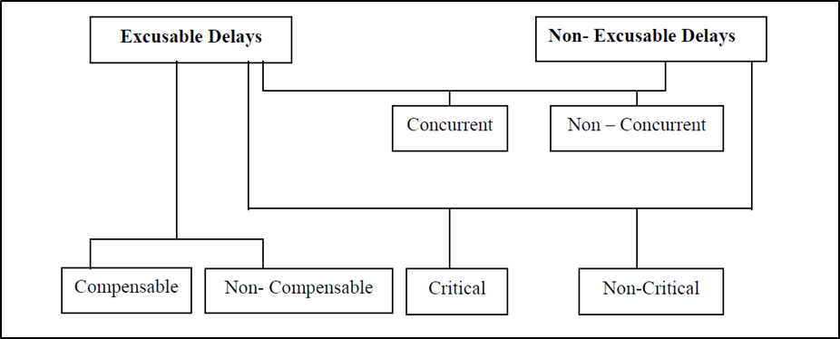

Figure (1): the sequential relationships between different groups of delays (Vidalis and Najafi, 2002).

1.1.1 Heading 3
text text text text text text text text text text text text text text text text text text text text text text text text text text text text text text text text text text text text text text text text text text text text text text text text text text
text text text text text text text text text text text text text text text text text text text text text text text text text text text text text text text text text text text text text text text text text text text text text text text text text text
1.1.2 Heading 3
text text text text text text text text text text text text text text text text text text text text text text text text text text text text text text text text text text text text text text text text text text text text text text text text text text
text text text text text text text text text text text text text text text text text text text text text text text text text text text text text text text text text text text text text text text text text text text text text text text text text text
text text text text text text text text text text text text text text text text text text text text text text text text text text text text text text text text text text text text text text text text text text text text text text text text text text
text text text text text text text text text text text text text text text text text text text text text text text text text text text text text text text text text text text text text text text text text text text text text text text text text text
text text text text text text text text text text text text text text text text text text text text text text text text text text text text text text text text text text text text text text text text text text text text text text text text text text
text text text text text text text text text text text text text text text text text text text text text text text text text text text text text text text text text text text text text text text text text text text text text text text text text text
text text text text text text text text text text text text text text text text text text text text text text text text text text text text text text text text text text text text text text text text text text text text text text text text text text
text text text text text text text text text text text text text text text text text text text text text text text text text text text text text text text text text text text text text text text text text text text text text text text text text text

References
- Duran, O. (2006). Current risk management applications in Turkish construction industry, an unpublished Master thesis. Gaziantep University, Gaziantep.
- Dvir, D., & Lechler, T. (2004). Plans are nothing, changing plans is everything: the impact of changes on project success. Research policy, 33(1), 1-15.
- Lawrence, S. et al. (2001). Persistence of Web References in Scientific Research. Doloi, H., Sawhney, A., Iyer, K. C., & Rentala, S. (2012). Analysing factors affecting delays in Indian construction projects. International Journal of Project Management, 30(4), 479-489.
Notes
Note 1. This is an example.

